
CHILDREN AND FAMILIES

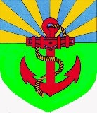
PILRIG PARK SCHOOL

21st August 2026

Childsmile Toothbrushing Programme

Dear Parent / Carer,

This year, as part of our Personal and Social Education curriculum, we are continuing with the Childsmile Toothbrushing Programme. Toothbrushing in school will begin on Monday 24th August, and will take place once a day, in class, as part of your child’s daily routine in school.

I have attached information regarding the Childsmile programme with this letter. If you have any questions, please contact me via the school office.

If you do not wish your child to take part in toothbrushing at school, please let us know via their school diary.

Best wishes,

Ann M. O’Hagan
Head Teacher

