Pilrig Park School


P7 Transition Welcome Pack

June 2026


CHILDREN AND FAMILIES

PILRIG PARK SCHOOL

11th May 2026

Dear Parent / Carer,

P7 / S1 Transition days at Pilrig Park School

Now that we have completed our Welcome meetings and started the successful transition to Pilrig Park School in August 2026, I am pleased to invite your young person for a three-day visit on Tuesday 16th, Wednesday 17th and Thursday 18th June. The transition days will run from 9:30am until 2.30pm.

Our school colours are black trousers/skirt, white shirt/polo neck, black jumper and we would encourage pupils to wear this where possible. However, for the transition days your young person can wear what they feel comfortable in. We would be very grateful if your child’s name is on their school jumper, coat, bag, lunchbox, and water bottle.

We ask that your young person comes to school with a snack for the three transition days, free school lunches will be provided but your child is more than welcome to bring their own packed lunch. From August you will be able to choose from either school lunch or packed lunch for your young person. All our pupils are entitled to a school lunch free of charge.

On Thursday 18th June from 1.15pm until 2.00pm we will be hosting a “Welcome Café” to which we extend a warm welcome to you. Your child can leave with you at 2pm.

If you require any further information please contact Ruth McLarty, Principal Teacher, who is has responsibility for the P7 transition, or Scott Mitchell, Principal Teacher, who will be Year Head for S1 and S2 from August 2026.

We look forward to welcoming you and your young person to our school.

With every best wish,

Ms Ann M. O’Hagan, Ms Ruth McLarty and Scott Mitchell
Head Teacher Principal Teachers

Timetable for Transition days

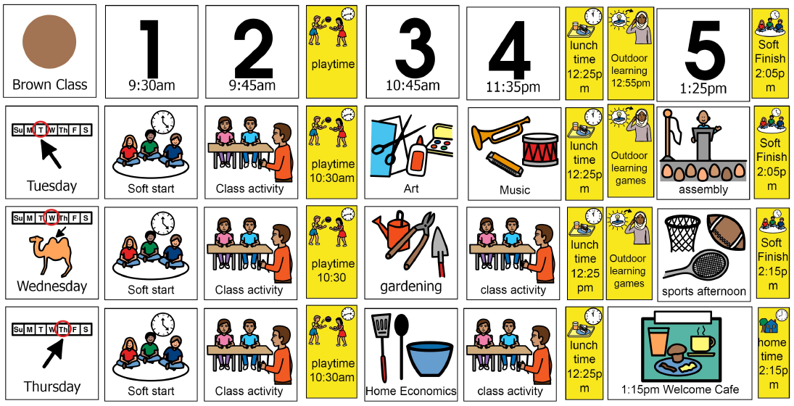

My new school
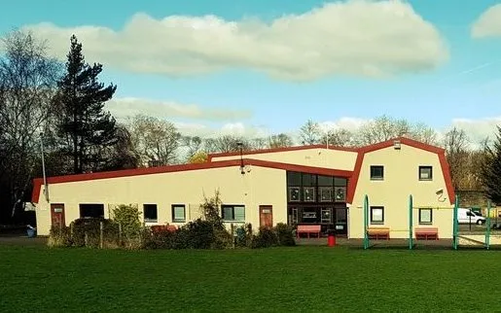

This is my new school. It is called Pilrig Park School.
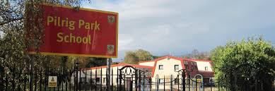

This is the front door where I go into my school.
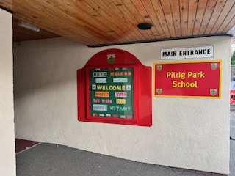

This is my Year Head whose name is Mr Mitchell. My teacher and the other teachers at school will look after me while I am at school. I can ask my teacher to help me if I need help. My teachers care about me and like to know about me.


I can have a lot of fun at school and learn a lot of things. I might see some old friends there and make some new friends.
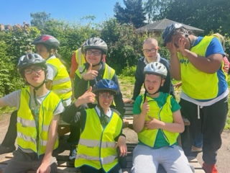
Sometimes I might miss my old school while I am at Pilrig Park School. Some pupils might even cry a little bit because they miss their old school, but the teachers will help them to feel better.


I wear my school colours to school. I wear my jacket outside when it is cold or wet.
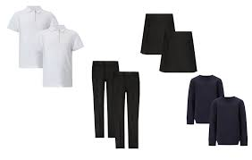
I have a school bag with my snack, a drink and maybe my lunch inside. My name is on everything.
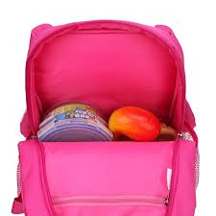

This is the Head Teacher whose name is Ms O’Hagan. The Head Teacher looks after all the pupils and the Staff at the school.
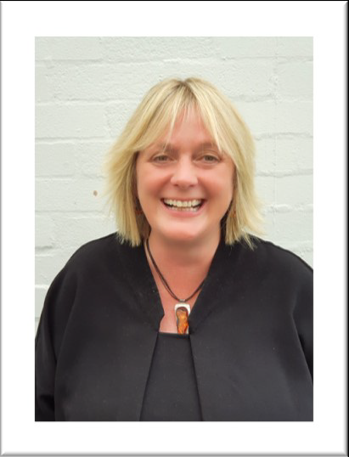

I know how to do a lot of things at school because I have done them before. I draw, paint, paste, count, play, listen to stories and sing songs at school.


There are lots of different types of classrooms at my new school. Some of these are the PE hall, Home Economics Kitchen, Music room, and Art room.
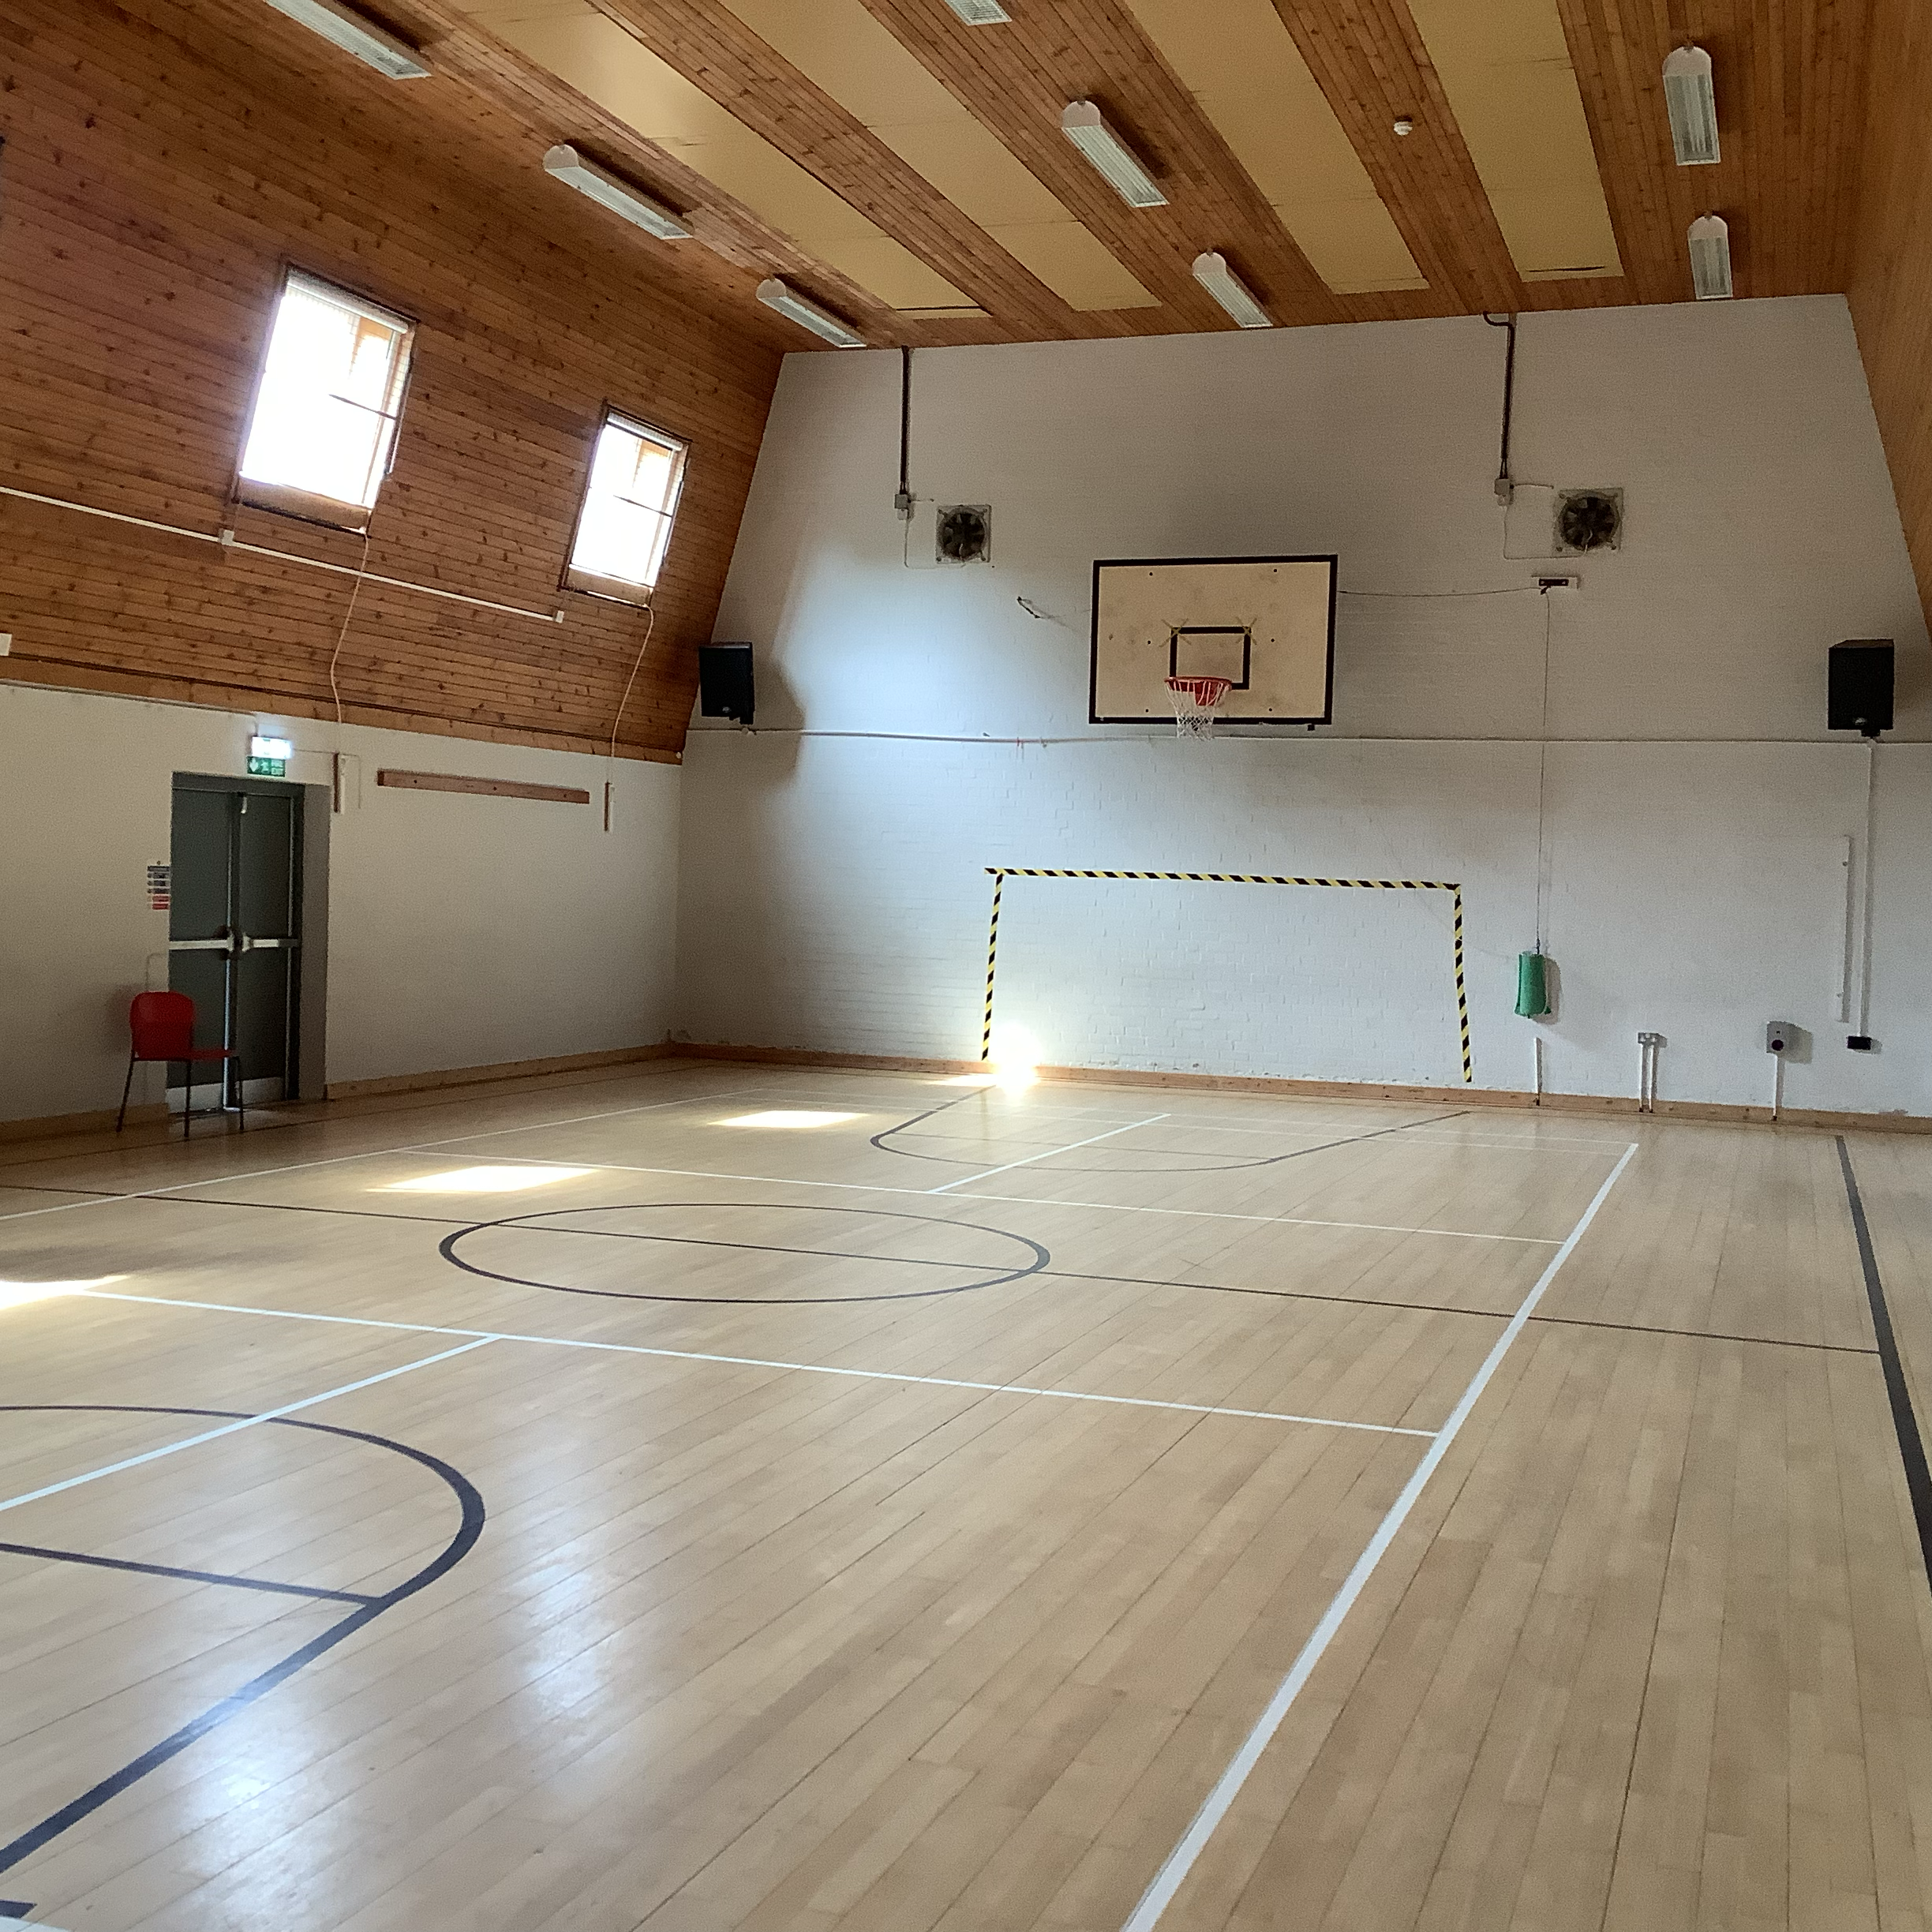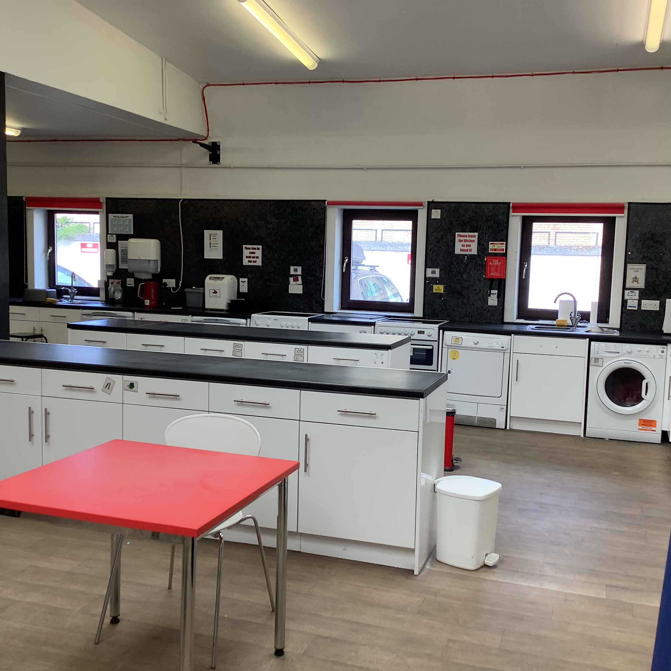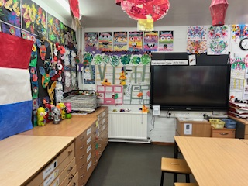
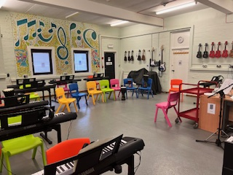

This is the playground. It is fun to talk and laugh and play with my friends in the playground at playtime and lunch time.
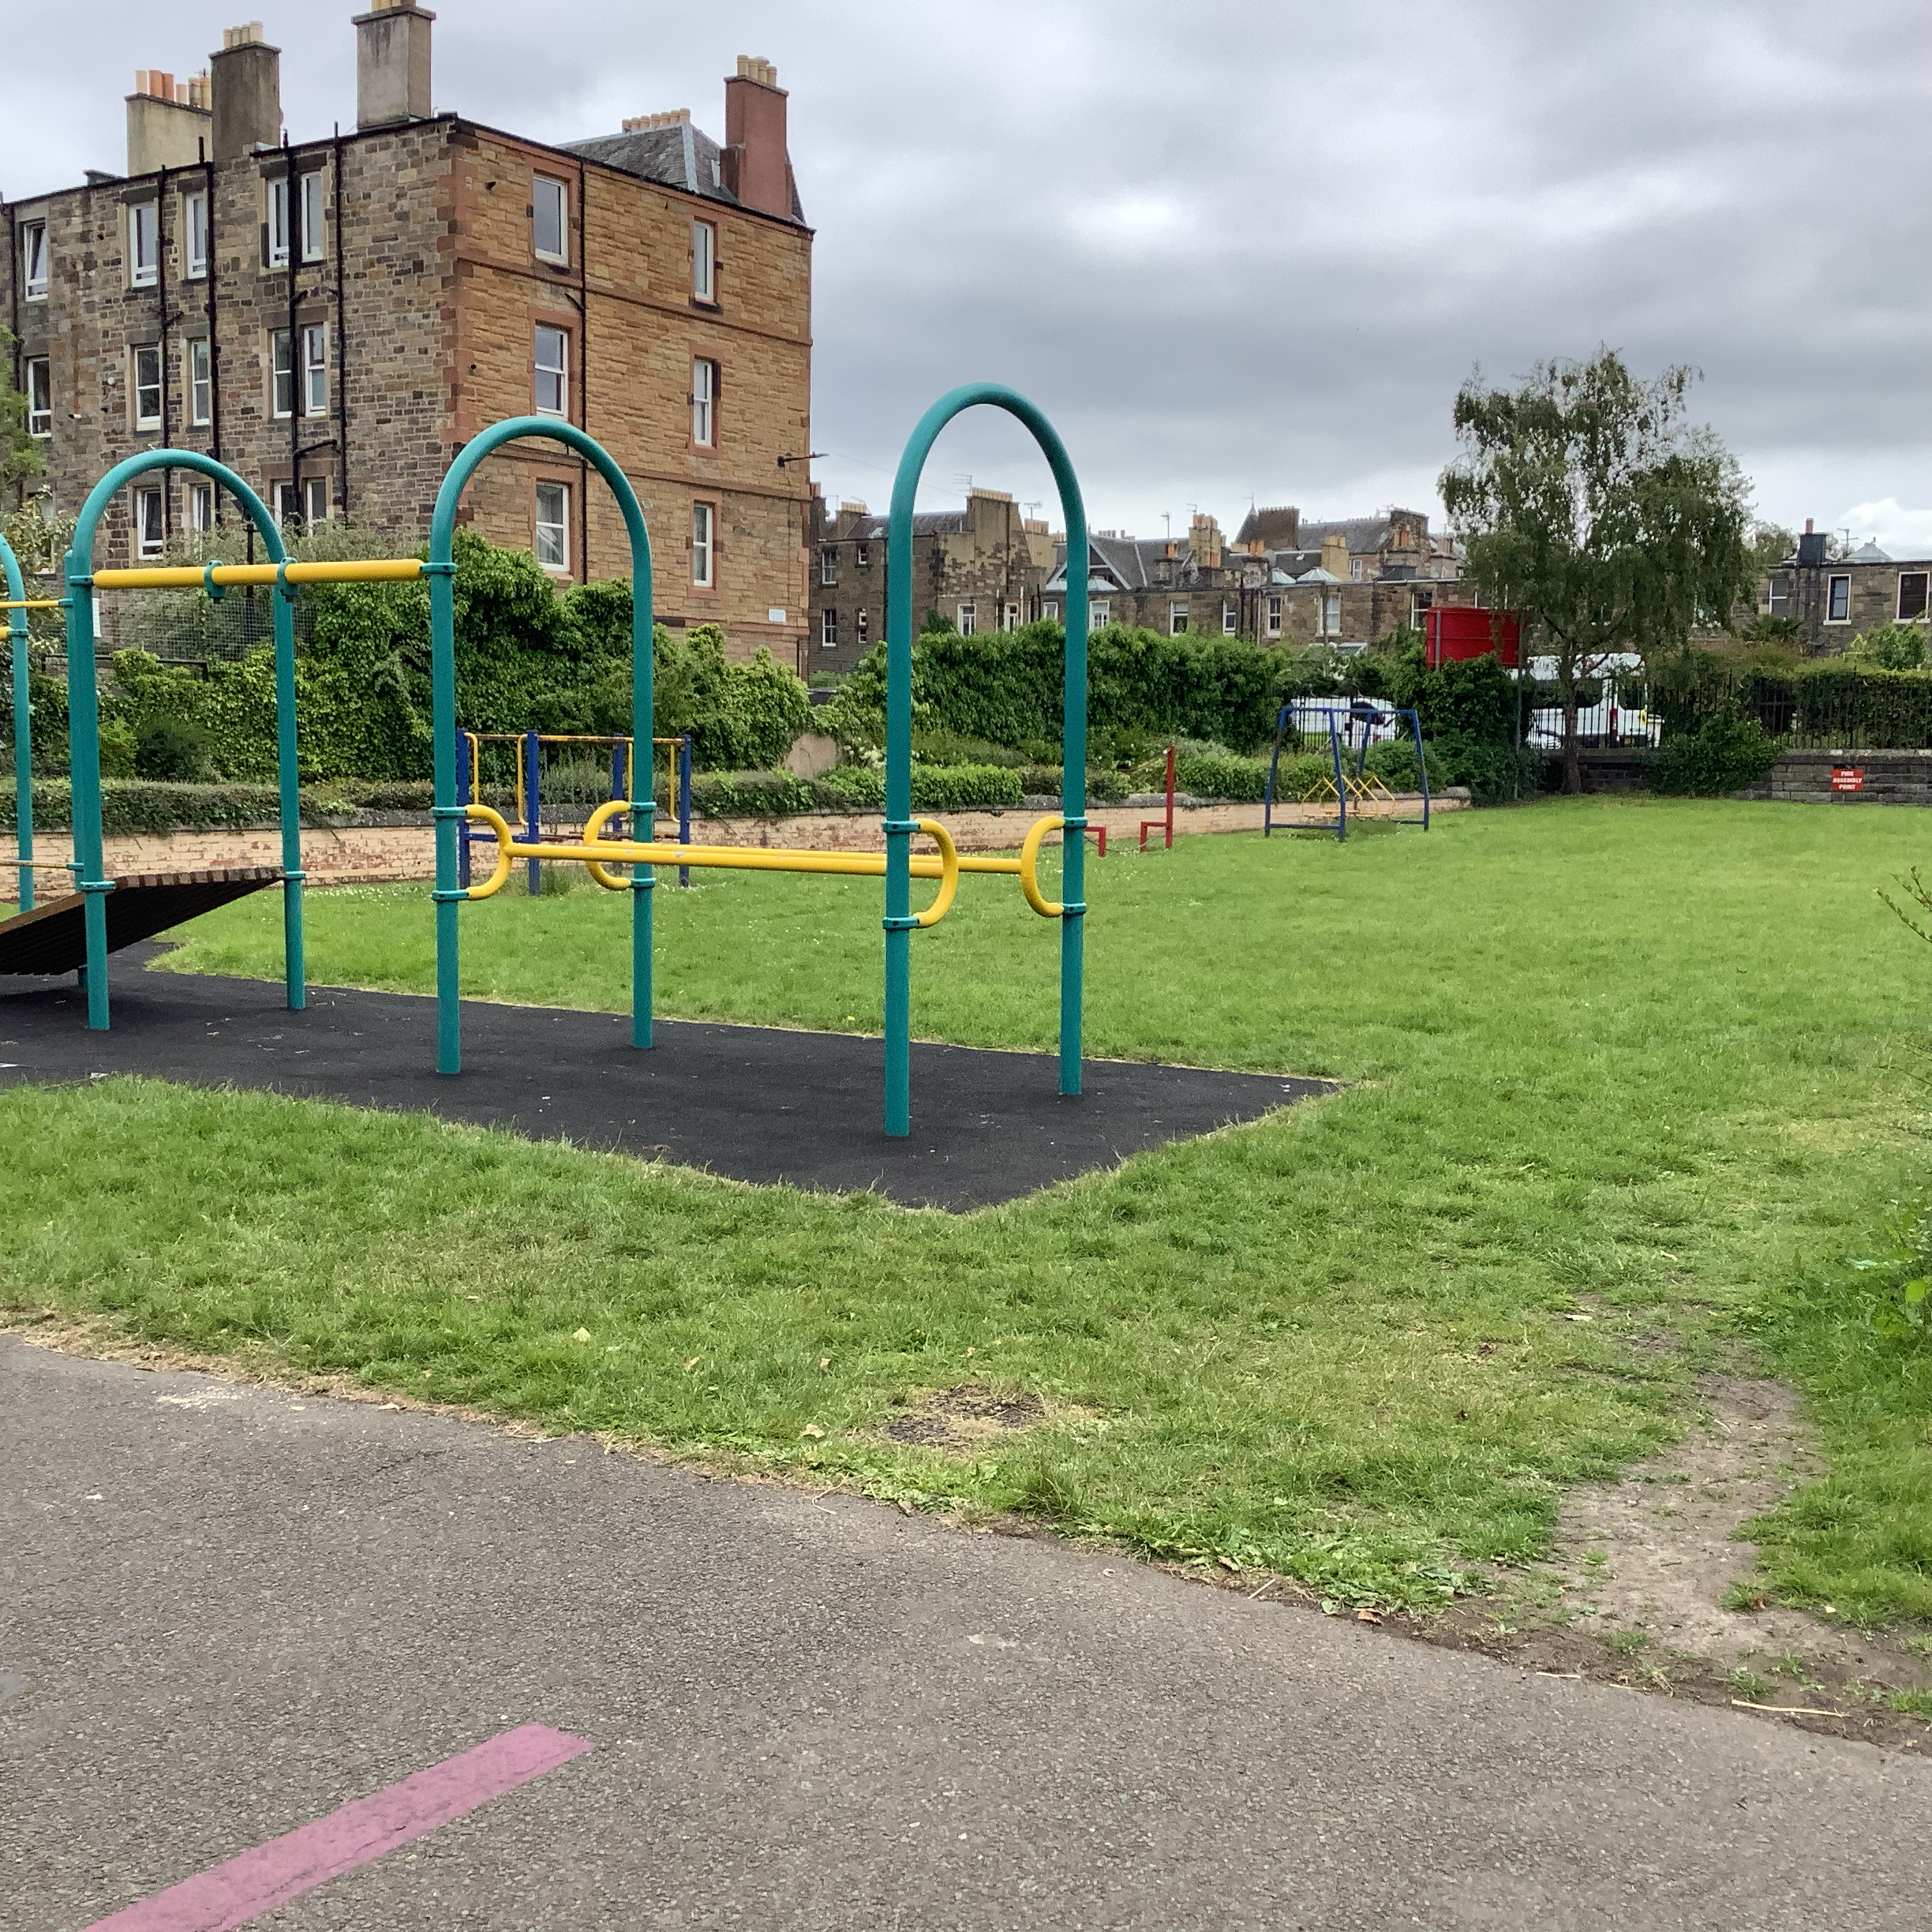

There are big kids at school. The pupils in S6 are the oldest and they look really big. Sometimes some of these older pupils can be your friend or buddy at school and help you and play with you.

This is the school office. This is Natalie who works in the office. Sometimes pupils take messages to the office.
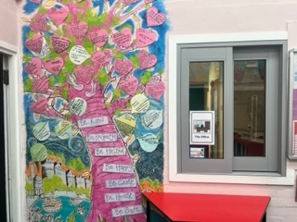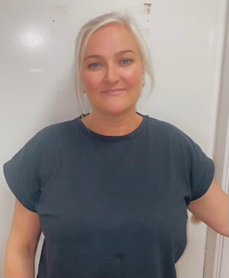

My school has a special room called a sensory room with lots of wonderful lights and soft items. This is a good place to relax.
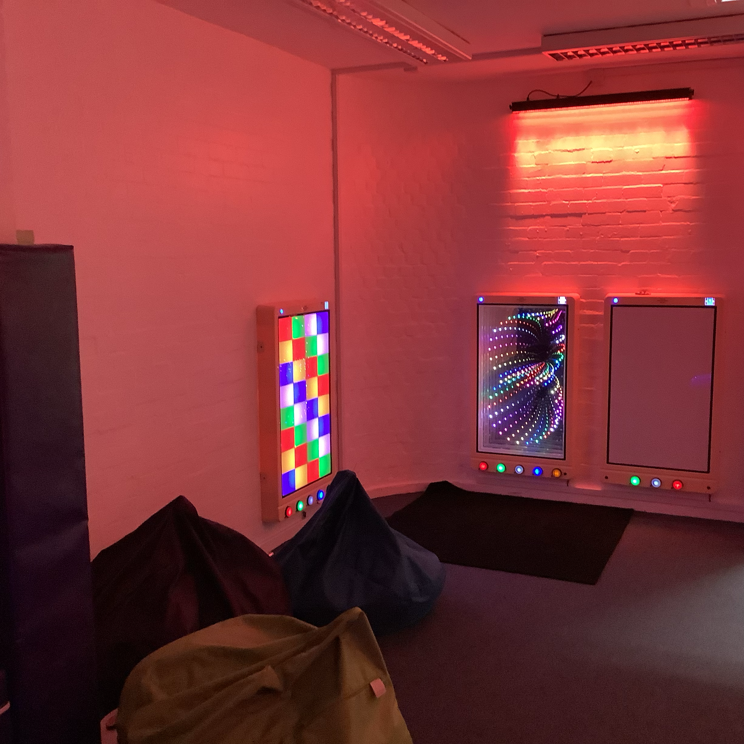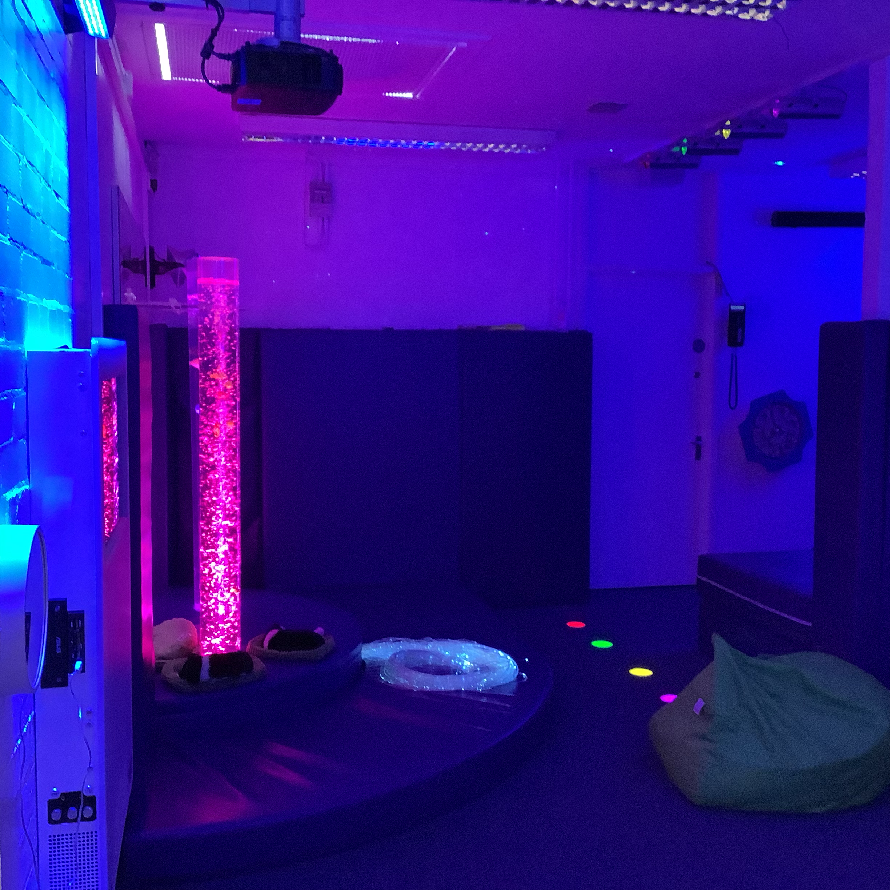

There are toilets at my school. The teachers teach all of the new pupils about where the toilets are. I am glad about that because it is very important to know about the toilets. There are toilets for the boys and toilets for the girls. I always flush and wash my hands after I use the toilet.
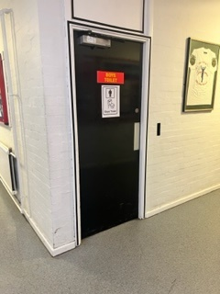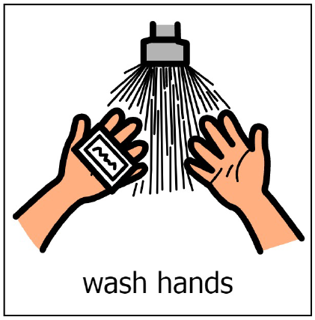

At the end of the school day all pupils go to transport groups to wait for their bus home. Some pupils get picked up by parents or carers.


When I am going home I say goodbye and smile and wave to the teachers, PSWs and the other pupils.


