
CHILDREN AND FAMILIES


PILRIG PARK SCHOOL
23rd April 2026
Dear Parent/Carer,
NSPCC’s Speak out. Stay safe. SEND/ASN/ALN programme
I am pleased to inform you that this term we are participating in the NSPCC’s Speak out. Stay safe. programme for children with additional needs and disabilities. This child friendly programme, which we have reviewed, is made up of 6 sessions. It supports children to understand what abuse is and helps them feel supported and able to talk to safe adults if they are sad or worried about anything. If you would like to know more about the Speak out. Stay safe. programme please visit www.nspcc.org.uk/speakout.
Additional NSPCC resources for families to help keep children safe. The NSPCC have shared some important information below on wider NSPCC resources and support to help keep children safe.
Parent/Carer support  Take a look at information, support, advice and activities from NSPCC for parent and carers.  www.nspcc.org.uk/parents | Activities to extend learning at home  Take part in games and activities at home to help children learn about speaking out and staying safe.  www.nspcc.org.uk/activities

Online Safety Hub  We have worked with Ambitious about Autism and parents and carers who have children with additional needs and disabilities to create activities to help talk about online safety.  https://www.nspcc.org.uk/send-onlinesafety | Childline – under 12’s  Childline have an accessible website with advice, support, games and activities. Children can change the language, enlarge text and also listen to the content.  www.childline.org.uk/buddy  (for ages 5-7)  www.childline.org.uk/kids  (for ages 7-11)
Talk PANTS with your children
Talk PANTS is a simple conversation to help keep children safe from sexual abuse. From P through to S, each letter of PANTS provides simple but important messages.
Download the free resources at www.nspcc.org.uk/pantsguides

I hope you find this information about the NSPCC and the Speak out. Stay safe. programme helpful. Please do contact me if you have any further questions.

Best wishes,

Ann M. O’Hagan
Head Teacher
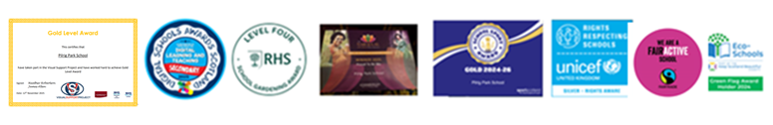
Pilrig Park School
12 Balfour Place Edinburgh
EH6 5DW
Tel 0131 467 7960

E-Mail: Admin@pilrigpark.edin.sch.uk

