
CHILDREN AND FAMILIES


PILRIG PARK SCHOOL
25th November 2025
Dear Parents and Carers,

We are delighted to let you know that Pilrig Park School will be taking part in the Leith Creative Trail on the 29th & 30thNovember and 3rd & 4th December. The trail starts at Leith Makers Market 105 Leith Walk, Edinburgh, EH6 8NP.

As part of this community event, the pupils have been working hard to create a range of wonderful crafts. These will be on sale during the trail, with all funds raised going to support the Friends of Pilrig Park School charity. This is a fantastic opportunity to celebrate our young people’s creativity while helping to raise money for resources and activities that benefit the whole school community.

We warmly encourage you to come along, explore the trail, and support the pupils’ work. Your involvement makes a real difference, and we would love to see as many families as possible taking part.

Thank you, as always, for your continued support.
Kind regards,
Lesley McArthur

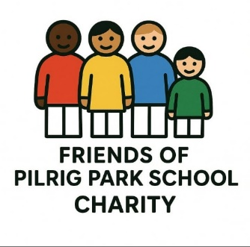
Friends of Pilrig Park School
Registered charity no:SC047854
Lesley McArthur, Treasurer - lesleymcarthur.friendsofpps@gmail.com

