
Relationships, Learning and Behaviour
Policy and Procedure
Session 2024 / 25
__________________________
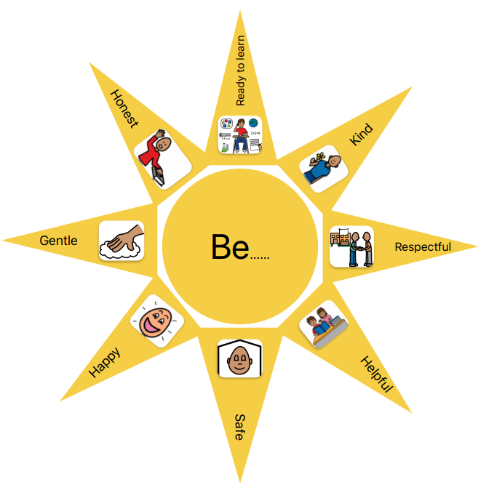
Rational
At Pilrig Park School we believe in creating a culture that builds good relationships, supports positive behaviour, and strives for successful learning.
The Getting It Right for Every Child (GIRFEC) child planning process and working with our partner services, such as Psychological Services, Health, Social Work, and Additional Support for Learning Service (ASL), help us to create this culture, which we underpin with wider training and development opportunities around positive relationships.
This position paper will set out to establish and maintain positive relationships and mutual respect resulting in a positive learning community and a supportive and restorative ethos.

- Purpose
This policy and procedure is based on City of Edinburgh Council policy and procedure and the views of staff, parents and pupils within our learning community. In Edinburgh every child or young person irrespective of identity, background or ability is part of a resilient and positive learning community where they feel:
- We belong,
- We contribute,
- We learn,
- We are supported and we help others.
Every child should feel secure; nurtured, valued, included, and supported within our learning community. Our aim is that every child is present, participating, achieving, and supported. This policy and procedure should help to establish and maintain positive relationships and mutual respect resulting in a positive learning community and a supportive and restorative ethos.

- SCOPE
All staff in our learning community are covered by this policy and procedure. It encompasses:
- Whole school approaches
- Clear expectations
- Building skills
- Additional Support Needs
- Responding to (Di)stressed Behaviour
- Our Staged Approach to Positive Behaviour
- Professional Development

- DEFINITIONS
Family: Describes those considered to be related to the child by birth, affinity, choice or close personal ties and who can be contributors to the wider care and wellbeing of the child.
Parent/s: Describes any person who has parental responsibilities and any person who has custody of a child, including foster carers and a parent who shares custody of a child.
Children’s rights: are protected by the UN Convention of the Rights of the Child and the Children and Young People Act 2014. There is a shared understanding that these rights are unalienable entitlements which cannot be taken from children. These rights are not dependent on the child accepting certain responsibilities or on them feeling or behaving in a certain way. Children’s rights will not be withdrawn as a consequence of behaviour.
Logical consequence: This is a consequence which is directly linked to the behaviour or choice for example if a child has refused to complete work (appropriately set) they may have to work for part of break. A logical consequence is meaningful and links cause and effect, it is not a punishment.
Natural consequence: This is a consequence that is a natural result of a behaviour or choice for example if a toy is broken it can’t be played with.
Physical contact: An active process which involves no greater activity than the action of touch to:
- Guide, sooth, comfort, encourage or protect a child.
- Provide intimate care for a child with complex additional support needs or a disability where this is provided for in the child’s care plan.
- Restore relationships between staff and children after a distressing incident or event where physical intervention was used.
- Support learning for example in hand over hand approaches.
Physical interventions: Describes a range of approaches, which include restraint and strategies where restrictive holding is not used, such as physical guiding an individual away from a harmful situation.
Restrictive physical intervention is justifiable only when a child or young person is at risk of inflicting serious physical harm on themselves or another individual. In some special schools, due to frequency of incidents, staff are trained to used planned physical intervention in the form of CALM this is not the case in mainstream schools or early years settings.
Seclusion: The act of isolating a child from their peers to prevent harm. This is distinguishable from agreed use of ‘safe space’ or ‘cool down’ strategies with children. It is carried out without the child or parent’s consent (compliance is not considered to be consent), it is for not a negligible amount of time (e.g. 5 mins thinking time is not considered to be seclusion) and it is carried out at the direction of staff. It is a form of physical intervention and should only be used as a last resort.

- POLICY CONTENT
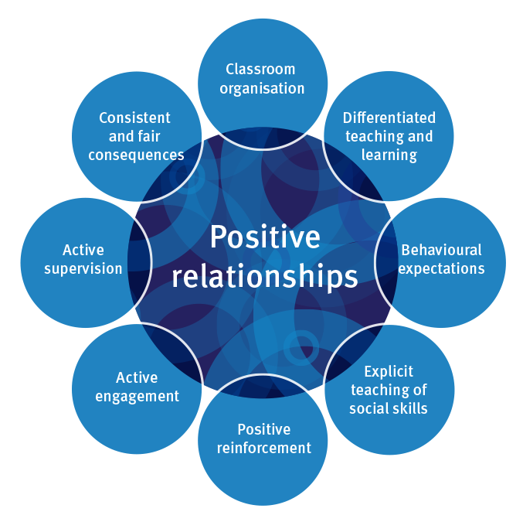
Every child and young person have the right to a high-quality education. Positive relationships are fundamental to enable effective teaching and learning to take place. We have adopted the following key principles to create a caring, supportive, learning environment:
• an ethos that values positive, restorative, and respectful relationships and promotes shared values
• an inclusive and safe learning environment which supports children and develops their skills and resilience enabling them to become responsible for their own behaviour
• recognising that all behaviour is communication and that understanding what is being communicated and the underlying needs is crucial for assessing and meeting children’s needs and finding solutions.

- IMPLEMENTATION
Whole School Approach
Good organisation, lesson planning and preparation will help to create the right learning environment. Flexibility, choice and, where appropriate, differentiation will also help to support individual needs and promote positive relationships and behaviour.
However, even in these conditions, some children and young people will present with behaviour that challenges or is difficult to interpret. The school uses approaches and strategies which are designed to help prevent and de-escalate difficult situations and identify and support individual support needs.
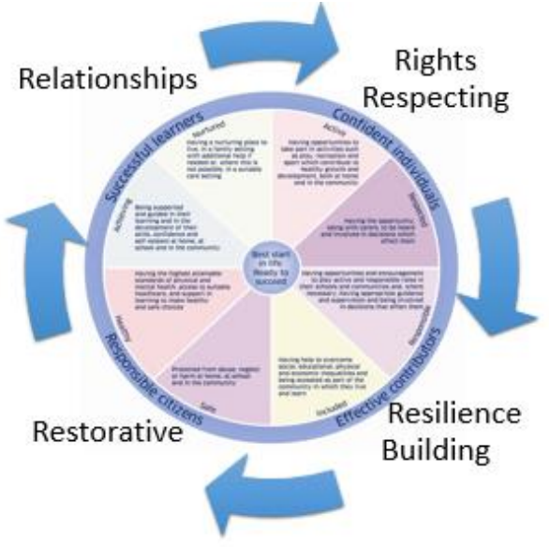
We understand that everyone learns best when they feel good about themselves. Punishments can make children feel bad about themselves. This can hinder their ability to engage in their learning, including their behaviour. Positive approaches to support behaviour focusses on relationships, skills building, restoration and when appropriate logical or natural consequences appropriate to the child, rather than the implementation of punishments.

To achieve this positive ethos all staff are committed to;
  - Relationships - Developing positive relationships and being positive role models
  - Rights Respecting - Respecting and protecting the rights of all children
  - Resilience building - Through identifying strengths and developing skills
  - Restorative - Acting restoratively to prevent difficulties and repair relationships when difficulties do arise

We want to engage directly with parents to foster and develop our positive ethos. To work together to maintain and support shared learning community values and excellent home/school communication. We want to address, prevent, and resolve any difficulties should they arise and to build on our strengths together.

Clear Expectations
We have a small number of easily remembered values which everyone in our learning community knows. These are summarised in short phrases with symbols to support communication:
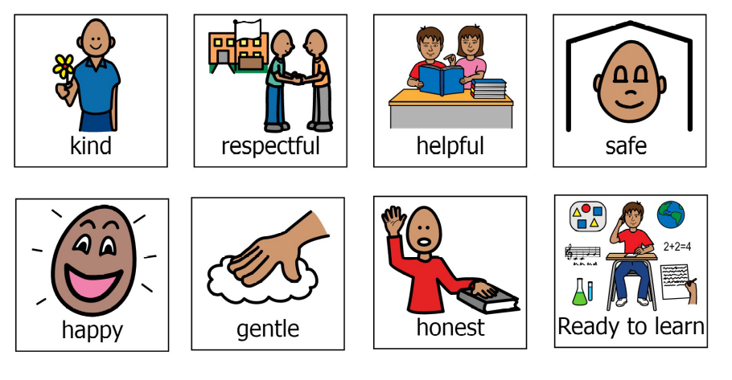

These form the basis of all our conversations in relation to behavioural expectations. It is helpful if parents can also discuss these values with their children if there has been an incident in school. The purpose of these conversations is to find solutions and develop skills that will prevent problems in the future. Our values and ethos are summarised in a one page visual that is displayed throughout our building, shared with parents and discussed regularly.

Building Skills for Relationships
The school uses lessons and activities that contribute to positive relationships and behaviour and support children to build the skills they need to develop positive relationships, resilience, be rights respecting and act restoratively. This includes:
- Emotional regulation techniques
- Rights Respecting Schools
- CIRCLE document

Additional Support Needs
We provide support that meets children’s needs and identifies additional support needs as early as possible in order to prevent further difficulties developing later. The needs of most children can be met in class however for a small number of children an individual child’s plan will outline additional supports that should be put in place. This is co-ordinated with parents through a child planning meeting and may involve partner services like our Educational Psychologist or Additional Support for Learning Service link. The school uses the following targeted supports:
- Sensory rooms / areas for emotional regulation
- Break and lunch time clubs to support social skills and friendships
- Quiet workspaces
- Support for Learning intervention timetable
- The Yard
- Music therapy
- School counsellor
- Nurturing ethos
- Social stories
- Symbol routine support

Responding to (Di)stressed Behaviour
The school recognises that supporting children and young people with their behaviour requires:
  - acknowledgement that all behaviour is communication
  - understanding how a child’s needs and setting might impact on behaviour
  - identifying any known 'triggers' and early warning signs
  - considering the environment, body language and speech in this process
  - intervening early if warning signs are detected to prevent a situation from escalating
We explore and establish “what’s happened” with children. To do this we listen to their response whether that is given verbally or expressed non-verbally and act appropriately. Once the reason and purpose for the child’s behaviour is known we explore how we can develop appropriate support or adaptations to address the issue by promoting well-being, offering coping strategies and agreeing constructive solutions.

Our Staged Approach to Positive Behaviour
Positive Relationships and Encouragement
All staff focus on positive relationships by looking for opportunities to encourage learner skills, recognise effort and build on strengths. Positive relationships form a foundation that minimises difficulties occurring. This includes:
- Break and lunch time clubs to support peer relationships at social times.
- Different types of play supported in the playground to help develop skills for playing together.
- Notes in pupil diaries to inform parents of ‘wee / big wins’.
- Pilrig Park Praise cards filled out by staff and pupils which are delivered weekly and recipient photos displayed on school notice boards.
- Head and Deputy Head Teacher Awards, nominated by any member of staff, presented at once-a-month assemblies and copies displayed on school notice boards.
- Whole-school Special Badges initiative.

When a difficulty does occur, we have an inclusive and consistent staged approach that all learners can engage with, see below.
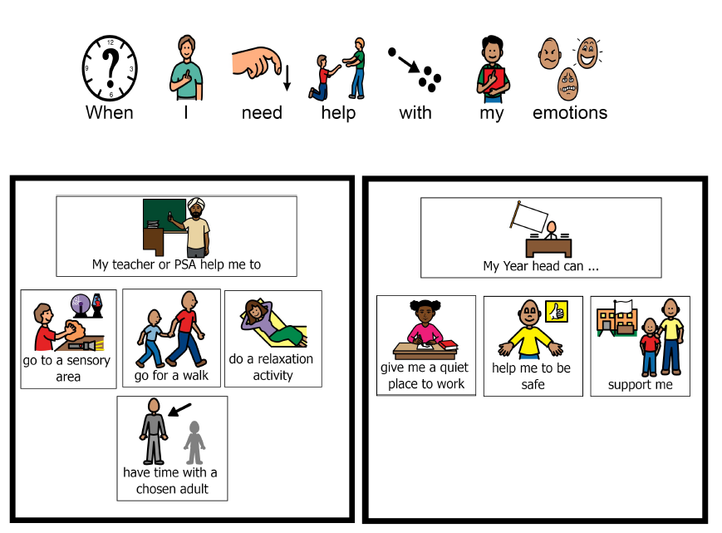
Staff have an ‘observed emotional dis-regulation’ flow chart to refer to found in appendix 1.
When a challenging situation develops our main objective is to reduce the level of arousal or distress. The school uses De-escalation Techniques found in appendix 2. All physical intervention to prevent harm is strictly in accordance with the city of Edinburgh Relationships, Learning and Behaviour Procedure. If a child has been supported through physical intervention from an adult to prevent harm, parents will always be informed, and this will be recorded in pastoral notes.

Professional development
We support staff to develop their skills to support relationships learning and behaviour, this includes but is not limited to:
- Use of the CIRCLE inclusive classroom resource – my learning hub
- Understanding and implementing Edinburgh’s Getting it Right for Every Child approach – my learning hub
- Implementing strategies outlined in the CEC Procedure Relationships, Learning and Behaviour – in house training
- Promoting positive relationships for learning and behaviour – my learning hub
- City of Edinburgh Council Nurture training
- City of Edinburgh Council Autism Training
- Inclusive communication training –school Speech and Language link
- CALM physical intervention training - accredited online theory course and accredited physical intervention trainers (training record available)
- Sensory Processing – in house training

- ROLES AND RESPONSIBILITIES
The headteacher has overall responsibility for ensuring the effective implementation of this policy. In particular, the headteacher ensures that the concerns of pupils are elicited, listened to, and appropriately addressed and that the provisions of ‘Getting it Right for Every Child’ are considered when working in partnership with children, families, and other professionals on issues of communication and behaviour.
To do this they have delegated roles to:
- Deputy Head Teacher is the Behaviour of Concern Co-ordinator and has responsibility for SHE portal reporting.
- Year Heads have responsibility for the Young Person planning process, implementing of interventions to support pupils, and writing of risk assessment / positive behaviour support plans. As well as main point of contact for parents and other professionals.
- Principal Teacher Support for Learning has responsibility for supporting interventions and leading training in sensory processing.
All staff are responsible for ensuring that the policy and procedures are followed. All staff encourage positive relationships and act as role models within our learning community.
Parents and families are regarded by the school as key partners who are asked to work in partnership with the school. Parents are expected to assist in maintaining positive relationships and support restorative approaches and high expectations for positive behaviour. Parents are invited to raise with the school any issues arising from the operation of the policy.
Learners participate in supporting this procedure and contribute to our positive school ethos.
All learners know our school values. Learners are supported to ensure that incidents of disruption, violence, bullying and any form of harassment are reported. The implementation of this procedure allows learners to be supported in understanding the cause and effect of their behaviour.


- EQUALITIES AND RIGHTS
All staff implementing these procedures have responsibilities under The Equality Act 2010. Having due regard for advancing equality includes:
- Removing or minimising disadvantages suffered by people due to their protected characteristics.
- Taking steps to meet the needs of people with protected characteristics where these are different from the needs of other people.
- Addressing and preventing discrimination arising from disability
- Making reasonable adjustments in relation to the implications of a learner’s additional support needs or disability and the impact this may have on their relationships and behaviour.
- Paying due regard to cultural factors that are relevant in ensuring that the school’s ethos is inclusive.
- Implementing the local authority framework for preventing and responding to bullying.

Concerns can be reported to / by staff and recorded on Wellbeing Concern forms which are then processed by Year Heads.

Complaints can be made to school SLT via email or phone call.

Compliments can be given through pupil diaries, emailing the school or by phoning the school.

- RECORD KEEPING
Reflection, evaluation and de-briefing strategies
The school records any incidents of behaviour requiring significant support on the school database called SEEMIS. Details will include an interpretation of events by different parties (including the child), possible factors of settings, triggers, reasonable adjustments in place, an evaluation of how the incident was managed and ‘lessons learned’ to help prevent or better deal with a similar incident arising again.
Incidents that have resulted in physical harm or physical intervention being used to prevent harm are recorded on the council health and safety database (SHE portal).
The Extended Management Team reviews these records of incidents on a regular basis. Please find below a list of all Records, including completed forms that may be generated or amended by this procedure.
- Wellbeing Concern form and Wellbeing Concern chronology
- Child Protection records if applicable
- Seemis pastoral notes
- SHE Portal reports
- ABC Chart
- Risk assessment and positive behaviour support plan
- CALM physical intervention record

- SELF EVALUATION AND REVIEW
This position paper will be published on our school website, and all stakeholders will be made aware of its contents and where to find it.
It will be evaluated through our “End of Year Consultation Session 2024/25: Parents & Carers” questionnaire.
The position paper will be reviewed August 2025

- RELATED DOCUMENTS
Scottish Government
- Standards in Scotland’s Schools etc Act (2000)
- Included, Engaged, Involved 2 (2017)
- Guidance on the Presumption to Provide Education in a Mainstream Setting (2019)
- Developing a Positive Whole School Ethos and Culture: relationships, learning and behaviour (2018)
- Additional Support for Learning Act (2004) - amended 2009
- Parental Involvement Act 2006
- The Equality Act 2010
- UN Convention of the Rights of the Child
- Children and Young People Act 2014
City of Edinburgh Council
- Edinburgh Learns Framework: Inclusion (2019)
- Included, Engaged, Involved in Edinburgh Policy (2018)
- Relationships, Learning, Behaviour Procedure (2019)
- Managing and Reducing Risk Procedure (2019)
- Preventing and Responding to Bullying in Children and Young People (2019)
- City of Edinburgh Council Equalities and Rights Framework www.edinburgh.gov.uk/downloads/file/9516/equality_diversity_and_rights_framework_2017-21

Appendix 1: Observed emotional dis-regulation flow chart
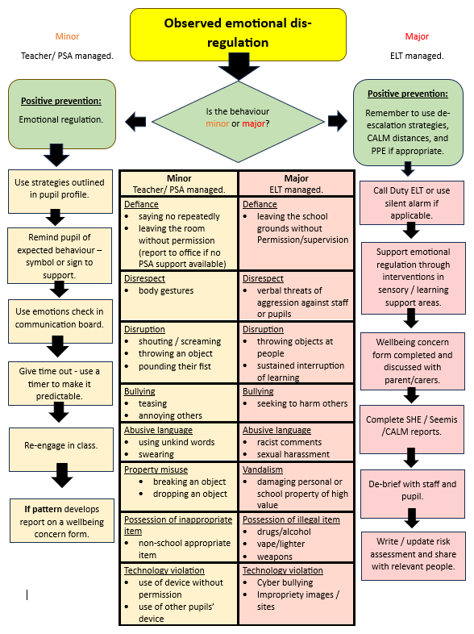
Appendix 2: De-escalation Techniques
Physical
- Think about your position in the room – make sure you are closest to the door. But do not stand across the doorway to block someone’s exit.
- Respect personal space by keeping your distance (up to 4x more than normal) and turn your body so that you are presenting at an angle to the other person.
- Be aware of your body language – try to present with a relaxed and non-threatening stance with your hands open and visible.
- Stand on the same side as their dominant hand (reducing the likelihood that they will try to grab or hit out).
- Make only intermittent eye contact – more than this is threatening.
- Adopt a ‘slow motion’ mode to offset the natural tendency to match the other person’s behaviour – i.e., talk slowly, walk slowly, move your hands slowly.
- Lower your voice and try to retain a warm and empathic tone.
- Make sure your facial expression is congruent with what you say.
- Remain calm.
- Make use of familiar objects, sign language, emotion talks symbols, places of refuge and visual timetables as appropriate.
- Where possible separate them from the others / or remove the audience.
- Get everyone to sit down – sitting helps you to calm down.
Communication
- Calm tone of voice - self-monitor pitch, pace and volume of voice.
- Use simple short clear language and give extra time for the child to process.
- Listen.
- Use the young person’s name.
- Remember that all behaviour is communication.
- Take into consideration preferred communication and communication needs e.g. use of visuals and signing.
- Ensure the dignity of all concerned. Try to offer the child a legitimate way out of the situation for example offering a controlled choice.
- Ask onlookers to ignore an escalating situation, in some circumstances requesting they leave the scene.
- Cue others to what to do 'Continue working on X I'll just be a moment or two'.
- Ask ‘What’s happened’.
- Give them a way out/offer ‘time out’ – “Would you like to take a break?”.
- Respond empathically - recognise the emotions and feelings that the child has by naming them.
- It can be useful to acknowledge distress or wonder aloud e.g. 'I can see you are really upset, I wonder if you are feeling frustrated'.
- Tell them that it’s ok to have these feelings.
- Separate the behaviour from the person.
- Tell them that you want to hear what they have to say – “Help me to understand what you’re saying to me”.
- Reflect back to them – “Can I just check? I think what you’re saying to me is that you are unhappy about.... Have I got that right?”.
- Encourage them to reflect on the situation when calm, consider the impact on others and how to resolve the situation.
- Model and support problem-solving skills “What would help right now?” (This might only be possible once they have started to calm down).
- Offer praise where you can – “Well done! You’re doing really well to control yourself. Keep on taking deep breaths.”.
- Soothing reassuring words can help the child to feel calmer.
Personal attributes that will help

- Always show warmth and positive regard for children and young people.
- Try to be consistent and predictable.
- Be calm and reassuring, model respectful interactions.
- Know your limits - don’t make promises you can’t keep and get help if you need it.

Feelings

Issues affecting the child / young person:
- All behaviour is a form of communication. The young person has something to communicate to you. Let them know that you want to listen to what they have to say and value them as an individual and their viewpoint. Make it clear that it is the way that they are communicating that is problematic and not them as a person.
- ‘Challenging behaviour’ often meets a need for the young person. For them it is a solution – a means to an end - and not a problem.
- Under stress, the young person’s survival response may dominate their actions.

Issues affecting you:
- In response to a potential threat your defence/survival system may also have been activated – your brain will be sending signals to you to fight, flight or freeze.
- The use of de-escalation techniques is therefore counter intuitive. It goes against our natural instinct in a threatening situation.
- You must try to appear to be calm and in control of yourself and try to engage the ‘thinking’ part of your brain.

What’s not helpful?

Physical - avoid
- Adopting a threatening stance or standing across the doorway to block someone’s exit.
- Invading the young person’s space (unless you are moving towards them to restrain them).
- Compromising your own safety.
Communication – avoid
- Shouting, threatening, preaching, arguing etc.
- Pointing or shaking your finger.
- Continuing to discuss the ‘issue’ or to ask ‘why did you do that’?
- Trying to ‘win’ or have the last word.
- Interrupting e.g. “No, you listen to what I’m saying for a change…”.
- Saying anything that might connect the young person to strong feelings of guilt or shame. This is not the time.
- Dealing with issues publicly where possible.
Feelings - avoid
- Telling them you know how they feel.
- Dismissing their feelings.
- Taking it personally. Even when comments or insults are directed at you, they are not really about you. Try not to respond to them and concentrate on calming the situation down.
Appendix 3
Supporting pupils and staff during and following the need for physical intervention, physical harm or pupil isolation from peers to prevent harm:
Immediate Support to Pupil
Follow strategies and procedures specific to the child or general principles of the establishment about staying with them or allowing them space.

Move the pupil to a calm environment or remove the danger/hazard, where possible and safe to do so.

Help them to calm down using agreed strategies, calming words or, where considered appropriate, touch.

See, ask and check whether the child is hurt, needs first aid or any other practical help e.g. offering a drink, seek medical help immediately if required.

Reassure through actions and what is said that the child knows staff still care for them and want to continue to help.

Decide who should work with the child and the amount of discussion/reflection reasonable to undertake, be aware the child may need time to fully regulate (even after they appear calm).

Decide whether the child needs time away from the rest of the group or if the group needs time away from them.

Ensure agreed, local processes are followed by relevant staff to inform parents or carers of any incident that has involved their child, what happened and what the next steps will be.

Following Immediate Supports
Seek the view of the child at a developmentally appropriate level (consider the use of Emotion Talks, Talking Mats, Wellbeing Web, Solution Focussed Conversation).

The head teacher should ensure investigation of the incident where appropriate to establish the facts and circumstances.

Investigate the likely cause of the incident e.g. was the child or young person:
• Affected by the environment, routine, behaviour of others or other circumstances
• Under stress
• Frustrated by the inability to express feelings or to complete task
• Angry with another child, staff or him/herself
• Acting in self defence
• Affected by family or personal circumstances
• Missing support or adjustments
• Bullied or provoked
Communicate what has happened to the parents of the child at the earliest opportunity on the day it has occurred.
If appropriate review Child’s Plan and / or Risk Management Plan.
Engage those involved in restorative approaches where appropriate.

Look after the needs of the other children or young people and work to get the group back together, provide appropriate explanations and reassurance.

Where appropriate, get back to planned activities but be open to the possibility of change. Try to honour commitment to other children so that an individual child’s needs do not continue to take priority over all others.

Stay in tune with the mood of the group listening closely to what is being said and be sensitive to how the incident may have affected them.

Ensure agreed, timely, local processes are followed by relevant staff to inform parents or carers of any incident that has involved their child, what happened and what the next steps will be.

If appropriate review Child’s Plan and / or Risk Management / Safety Plan for individuals who have been most affected.

Engage those involved in restorative approaches where appropriate.

Relevant staff should conduct an internal review of the incident itself to consider investigation findings and identify the need for revised strategies including measures to reinforce positive behaviour, prevent or reduce the risk and level of intervention required to manage unavoidable risk in the future.

Support to Staff
Inform the head teacher about the nature of any physical intervention (including seclusion) used to keep child or others safe.

Make sure no staff are physically hurt/need medical attention; take appropriate steps to help them deal with the current situation; check how they are feeling.

Ensure the incident has been recorded and reported in line with council procedures (SHE portal, pastoral notes and where appropriate critical incident form).

Arrange a debriefing meeting - the head teacher should ensure that emotional support and practical information/guidance is offered automatically without an individual having to ask, they should be assured they will receive sympathetic and sensitive treatment and can express anxiety without fear of criticism.

Reassure staff of appropriate risk management and safety planning. Take care to avoid immediate comment on measures that will be taken.

Consider the impact on the relationship between staff and the child and give them the time, space, support and contact they need to restore good relationships over time.

Engage those involved in restorative approaches where appropriate.

Examples of further staff support may include:
- Arrange for staff to talk about the incident individually / in a group, with a member of staff who understands the likely impact; offer access to the Council’s counselling service if required.
- Appropriate time to ensure that wellbeing issues were assessed and any actions put in place to support staff

- Follow-up action after a period of time to ensure that staff affected have fully recovered and do not require any additional assistance or support.
- Offering staff at risk from physical harm protective clothing e.g. arm/shin guards/hats.
- Refer staff to the Procedure for Protection against infection and Blood-borne Viruses in all Children and Families Educational and Child Care Settings, if required.

Headteachers can seek support and advice from Psychological Services.

