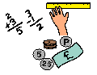
Learning Grid 6
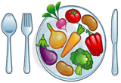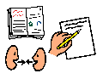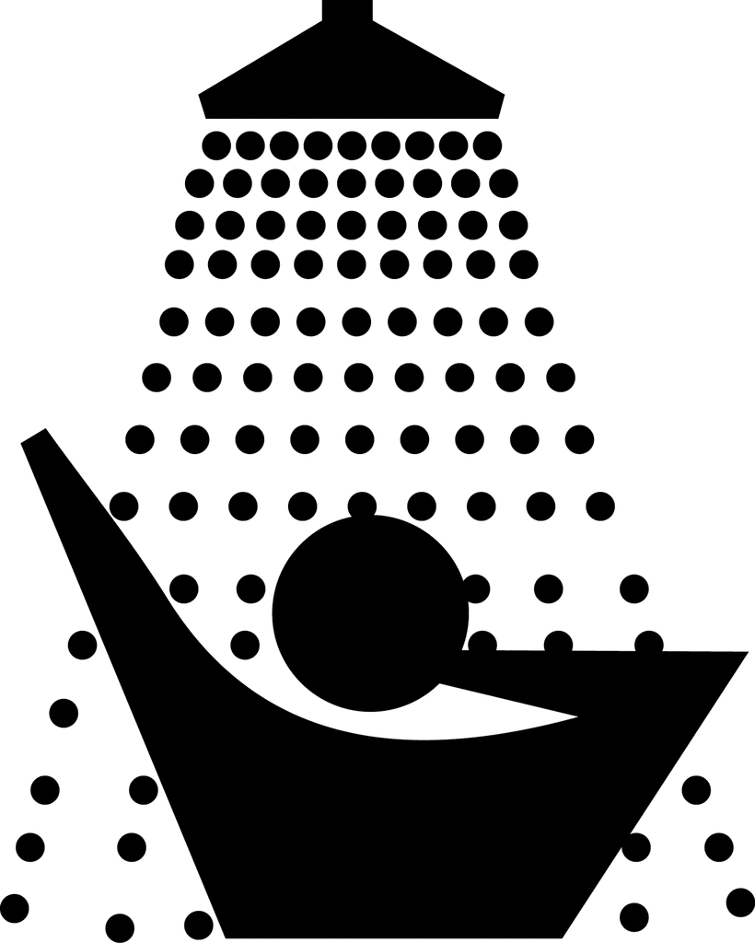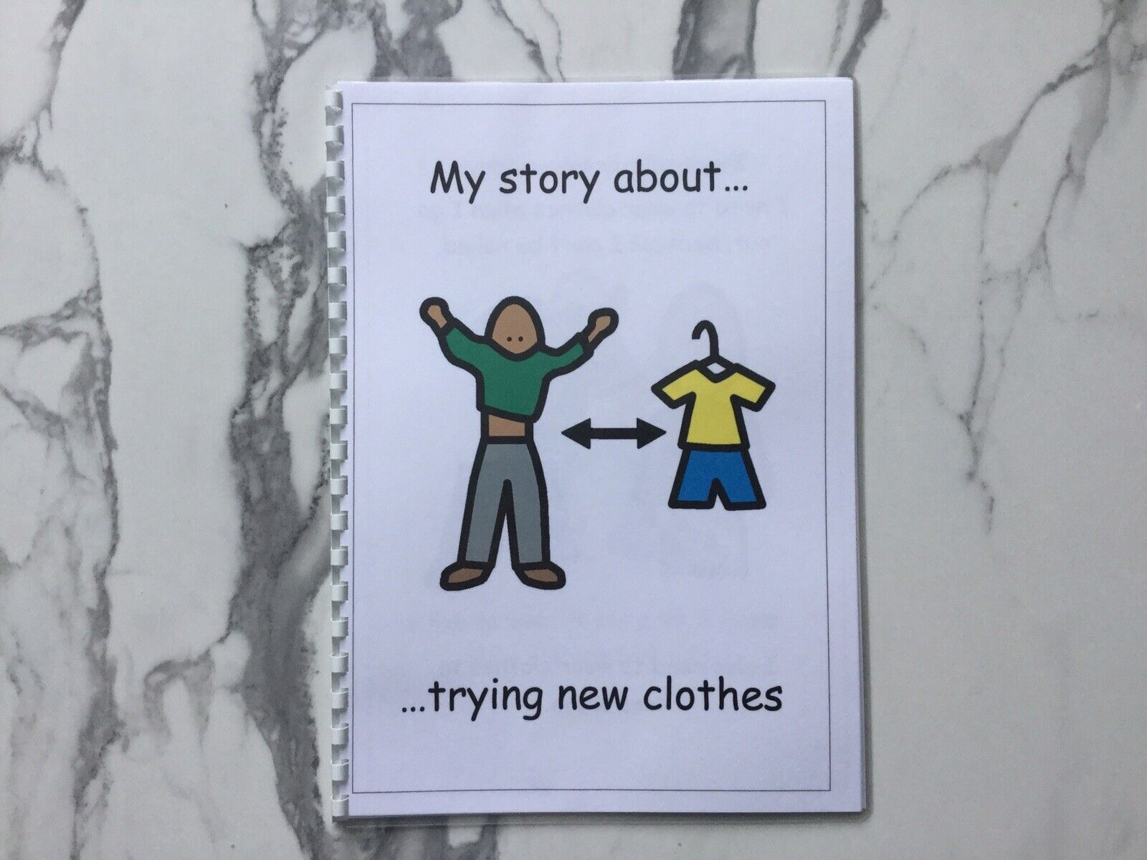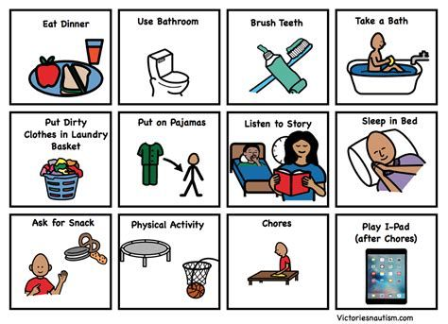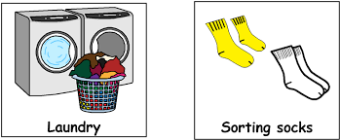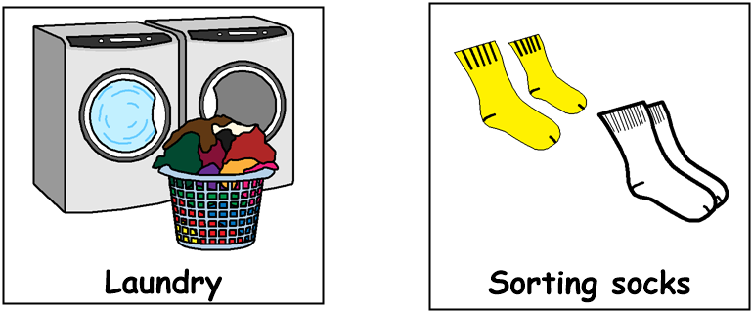

Good morning! Get dressed, have something to eat and drink for breakfast then brush your teeth. Choose some tasks from each of the following sections, through the day:
11am – 12.30pm Numeracy
- Count how many steps it is from your bedroom to each room in your house
- Practice the days of the week / months of the year
- Draw five clocks and mark what time you get up in the morning, have your breakfast, lunch, tea and go to bed.
9am – 10.30am Literacy
- Listen to / watch or read a news item
- Interview someone at home – ask about favourite food, TV program, dream holiday etc.
- Write / type your name and your address
- Follow a simple recipe which uses words or symbols
- Look for items around the house which begin with a particular letter of the alphabet, e.g., ‘b’ – ball, bag, bin, bed

12.30pm – 1.30pm Lunchtime
11am – 12.30pm Numeracy
- Name and find objects in the house which look like these shapes.

- Learn your birthday and age. Write or type your date of birth
- Using a measuring jug, measure out 3 different amounts. e.g., 100ml, 200ml, 500ml
- Using weighing scales, measure out 3 different amounts. e.g., 50g, 100g, 200g
- Pick 5 items on your home and arrange them in order of size from small to large

1.30pm – 3pm Health & Wellbeing
- Choose a favourite song and make up a dance routine
- Sort out dark & light-coloured clothes for washing
- Play a game with someone at home
- Go for a walk and collect some leaves to make a piece of art back at home
- Help to prepare the evening meal

