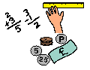
Learning Grid 5
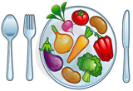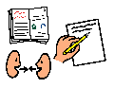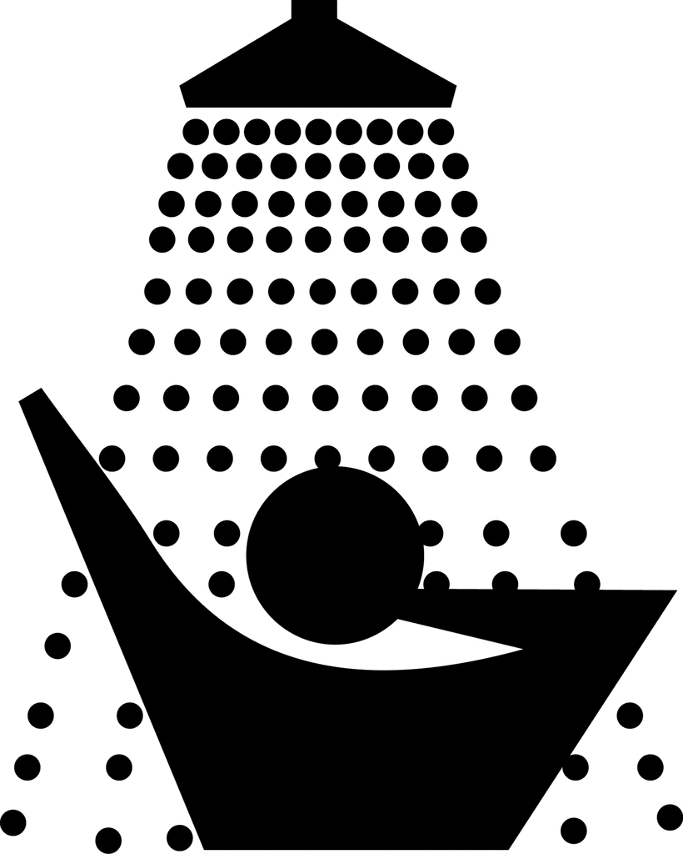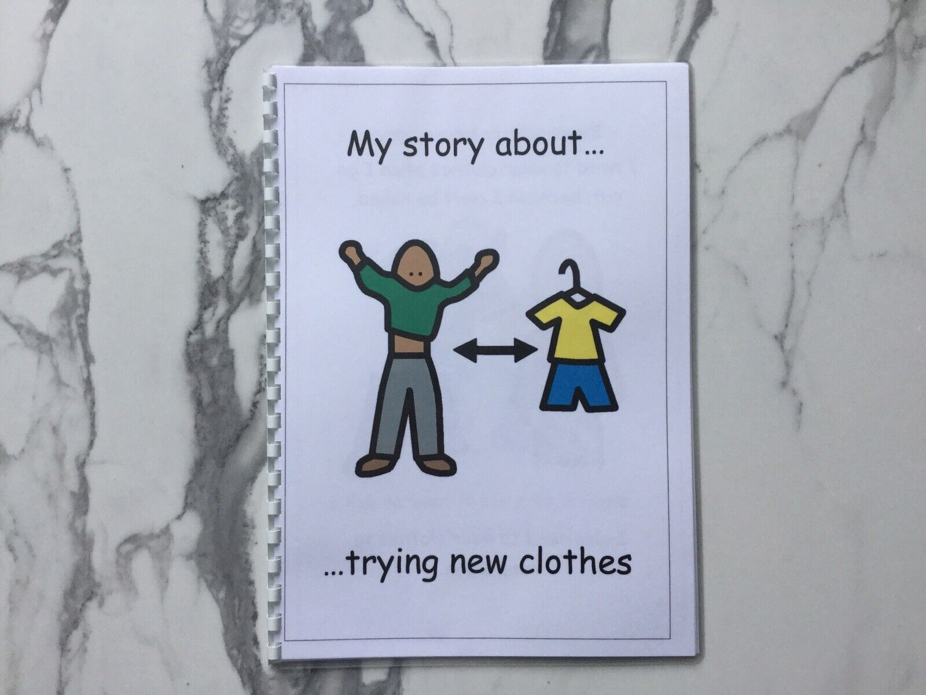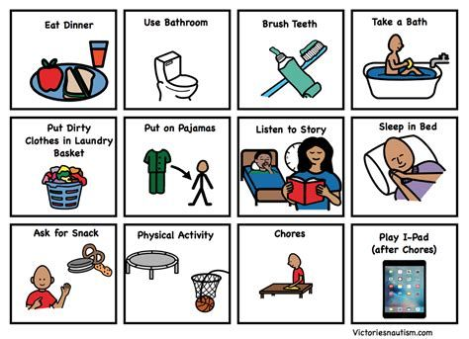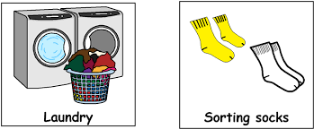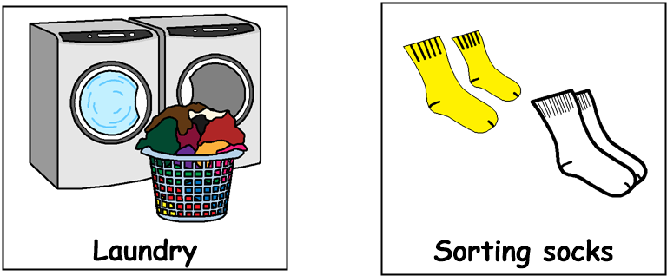

Good morning!
Get dressed, have something to eat and drink for breakfast then brush your teeth. Choose one or two tasks from each of the following sections,
through the day:
9am – 10.30am Literacy

- Find items in your house that begin with the letter ‘s’ e.g., saucepan, socks etc
- Write a thank you note to someone who has been kind to you
- Look out your window. Say or write down 5 things that are moving and 5 things that are not moving
- Keep a diary for the day and write down what you do, eat and drink
- Create a list of food which begins with each letter of the alphabet. Draw pictures of the food
12.30pm – 1.30pm – Lunch time
1.30pm – 3pm Health & Wellbeing
- Find a space in your home to do some exercises. Do 10 star jumps, jog on the spot for 20 seconds then do 10 bunny hops
- Do something nice for someone in your home without expecting anything in return
- Make a fruit or vegetable kebab. Find out where each ingredient comes from
- Hold a karaoke session with your family. Sing your favourite song together!
- Draw some emoji faces and make each one a different emotion e.g., sad, happy, worried, excited etc
11am – 12.30pm Numeracy
- Ask a member of your family to call out a shape. Walk around the house or garden and tap everything that is that shape
- Ask someone to give you a random number. Practise saying the number before and the number after
- Draw a game on a piece of paper in which you roll a die to move along the board. It could be a snake or a train track. Play with someone in your family. How many times can you win?
- Guess how many cupboards or drawers you have in the home – then count them!
- Using some dried spaghetti and some playdoh or plasticine, can you make a 3D shape, e.g, a cube, a pyramid or a cuboid?

