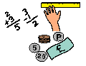
Learning Grid 4
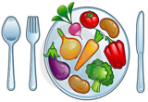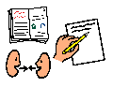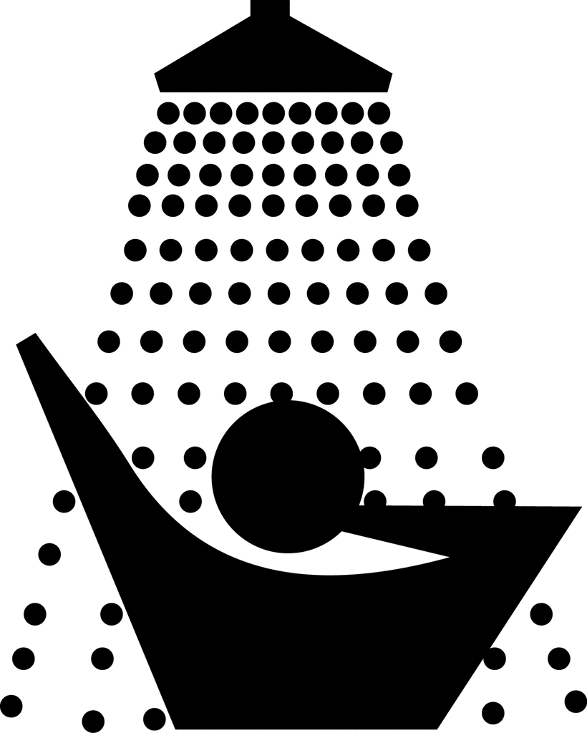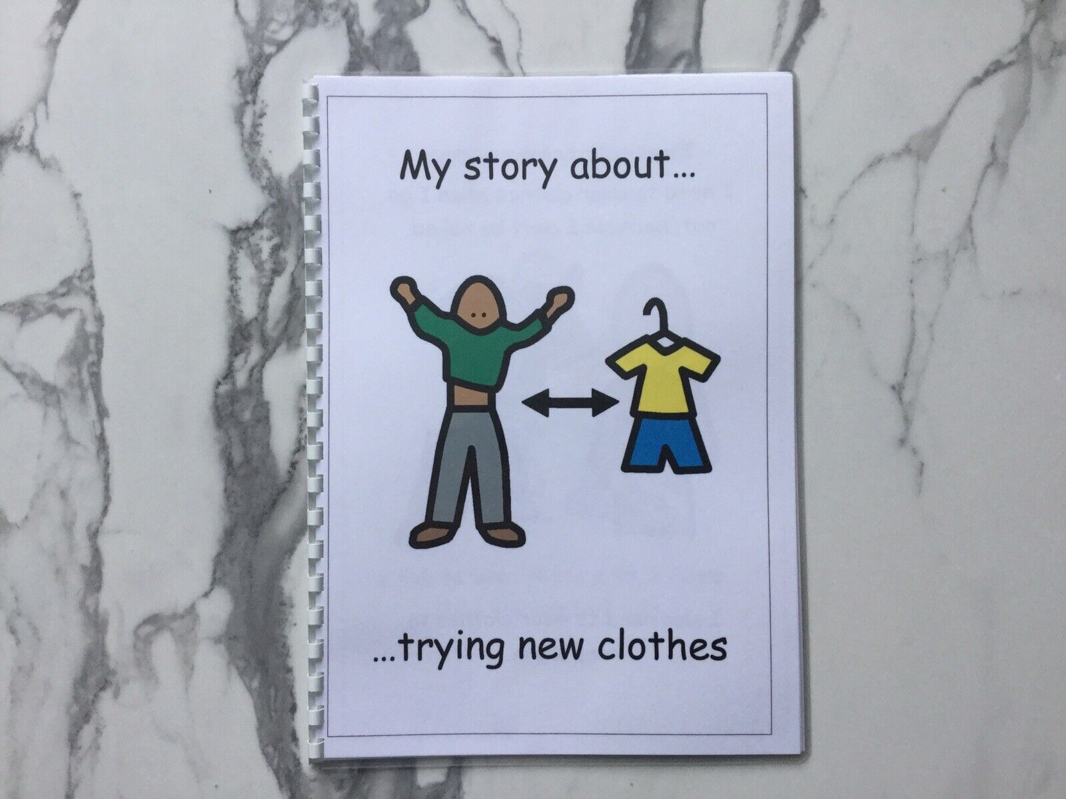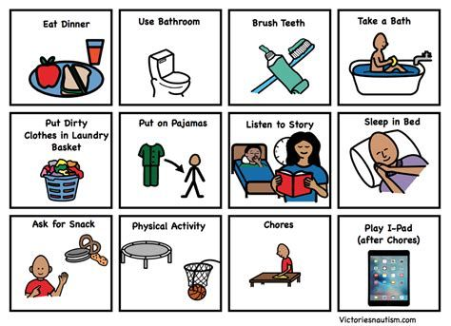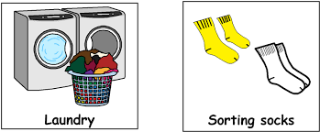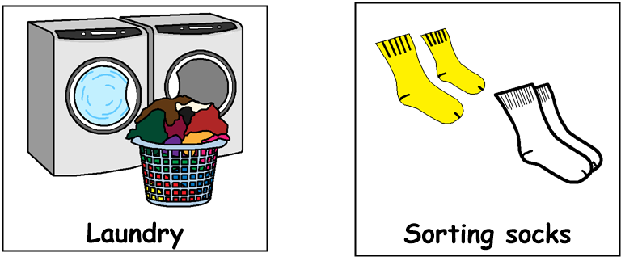

Good morning!
Get dressed, have something to eat and drink for breakfast then brush your teeth. Choose one or two tasks from each of the following sections,
through the day:
9am – 10.30am Literacy

- Make a video of you or someone else in your family, reading a story out loud
- Perform a role-play based on your favourite story or film. Ask some family members to act with you
- Draw or write 10 words that rhyme with each other
- Have a game of ‘I spy’. Try playing it in different rooms in your home
- Choose an item in your home and describe it to someone else, without showing them what it is – can they guess the object?
12.30pm – 1.30pm – Lunch time
11am – 12.30pm Numeracy
- Find as many different examples as possible of numbers in your home
- Gather some objects in your home. Sort them from lightest to heaviest
- Build a tin foil boat. Then place it in a basin of water. How many objects can you put in the boat before it sinks?
- How many people are in your home? How many hands? How many eyes?
- Look through a catalogue or a website and find as many special offers as you can. E.g., 25% off or Buy One Get One Free. Work out if the offer is a good deal

1.30pm – 3pm Health & Wellbeing

- With an adult, help make a cup of hot chocolate.
- Role play a shop at home. Label everyday items with prices and then ask your family to be the customers!
- Have a spring clean in your bedroom! Are there toys, books or games you could donate to charity?
- Build a tower from using objects you find in the house – how high can you make it?
- Call a relative or a friend who is far away and have a chat with them

