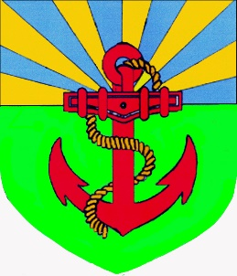
Pilrig Park School
Child Protection Procedure
Session 2024 /25

Contents
1. | Purpose
2. | Introduction
3. | What is Child Protection?
4. | Responsibilities for Child Protection
5. | What to do if a child or young person makes a disclosure or allegation?
6. | Worried about a child or young person?
7. | Response Flowchart
8. | Allegations Against Staff
9. | Visitors to the school
10. | Safe Working Practices
11. | Further information
12. | Relevant Policies and Procedures
 | Poster to be displayed in all settings

- Purpose
The purpose of this policy is to outline the procedures and guidelines to ensure the safety and well-being of children and young people in Pilrig Park School. All members of the school community should understand their role and responsibilities with regards to child protection and safeguarding.

- Introduction
Within our School we aim to create an environment in which all of our children and young people feel safe, well cared for and where they are able to flourish.
The following rights of children, outlined in the United Nations Convention on the Rights of the Child, are reflected in this policy:
Article 3
All adults should do what is best for you. When adults make decisions, they should think about how their decisions will affect children.

Article 19
You have the right to be protected from being hurt and mistreated, in body or mind.

Article 27
You have the right to food, clothing, and a safe place to live and to have your basic needs met. You should not be disadvantaged so that you cannot do many of the things other kids can do.

Article 33
You have the right to protection from harmful drugs and from the drug trade.

Article 34
You have the right to be free from sexual abuse.

Article 36
You have the right to protection from any kind of exploitation.

Article 37
No one is allowed to punish you in a cruel or harmful way.

Article 39
You have the right to help if you have been hurt, neglected, or badly treated.

Adults working in our setting know and understand the indicators that may suggest that a child or young person is suffering or is at risk of suffering harm. Arrangements for making a child protection or safeguarding concerns are well-publicised and understood by all partners, learners and parents.
As part of The City of Edinburgh Council, Pilrig Park School follows the Edinburgh and Lothian Multi-Agency Child Protection Procedures (2023):
https://www.edinburgh.gov.uk/downloads/file/23055/edinburgh-and-the-lothians-multi-agency-child-protection-procedures

These procedures align with the themes of, and practice within, the National Guidance for Child Protection in Scotland 2021 (updated 2023).

- What is Child Protection?
Child Protection refers to the processes involved in the consideration, assessment and planning of required action, together with the actions themselves, where there are concerns that a child may be at risk of harm.
Child protection is part of the Getting It Right For Every Child (GIRFEC) continuum of collaborative duties placed upon agencies working with children.
Child protection applies to all children up to the age of 18 years of age. Concerns about a 16 or 17-year-old should be raised under the same process.

- Responsibilities for Child Protection
All members of the Pilrig Park School community have a key role in the support and protection of children. The protection and wellbeing of the child must remain at the heart of all considerations and decisions.
All members of our school community should have a clear understanding of our child protection procedures. This includes children and young people.
Information on our child protection procedures are shared with visitors when they arrive in Pilrig Park School. Visitors will be directed to the sign in book which will direct to key information relating to the school’s child protection procedures.
All staff, partners and volunteers in our school are suitably trained in how to respond to safeguarding matters appropriate to their role. They take part in an annual update in August of each year.
Most staff are trained as a Specific Workforce (previously Level 2). This is refreshed every 3 years. Supply or temporary staff in our schools are inducted by our Child Protection Coordinator.
Those members of staff who lead on Child Protection are trained in Managing Child Protection in a School/Early Years Setting (Intensive Workforce, previously Level 4). This is refreshed every 3 years and booked via MyLearningHub.
In Pilrig Park School they are:
- Ann O’Hagan – Head Teacher
- Keith MacKay – Deputy Head Teacher
- Catriona Ferguson – Principal Teacher and Year Head for S5 & S6
- Farida Ali - Principal Teacher and Year Head for S3 & S4
- Ruth McLarty - Principal Teacher and Year Head for S1 & S2

If asked, the Child Protection Coordinator will provide relevant information to assist any Child Protection concern.

- What to do if a child or young person makes a disclosure or allegation?
We understand that schools/ELCs are usually a protective factor in a child or young person’s life. Children and young people may form strong and trusting relationships with key adults, and then feel confident to make a disclosure relating to their life.
It can be very hard for children and young people to speak out about abuse. Often, they fear there may be negative consequences if they tell anyone what’s happening to them. Even if a child doesn’t tell someone verbally what’s happened to them, there may be other indicators that something is wrong. People who work with children need to be able to recognise the signs and know how to respond appropriately.
It is vital that children and young people feel safe and can speak out. They should know that whoever they tell takes them seriously and acts on what they’ve been told.
- Give them your full attention and keep your body language open.
- Do not agree to keep anything confidential. It is important that the child or young person knows that you may have to share information with the Child Protection Coordinator who may take further action.
- Use open ended questions, and avoid leading questions, to gather the basic facts.
- Use ‘wh’ questions such as where, when, who and what. Do not ask ‘why?’.
- Reassure them that they have done the right thing.
- Let them speak at their own pace and don’t interrupt them.
- Show you understand by reflecting back what they have said. This also checks your understanding.
- Take a non-biased approach.
- It’s important to keep a note of any information so that you can share this with the Child Protection Coordinator. Any description of physical gestures or behaviours should be recorded accurately using correct anatomical terminology. In Early Years it is essential to note any vocalisations accurately.

- Worried about a child or young person?
If you have a concern about a child or young person, or if a disclosure has been made to you, you must speak to the Child Protection Coordinator in your establishment. You should do this as soon as possible. You should also complete a Wellbeing Concern Form summarising your concerns.
If your concern is urgent, and you are unable to contact the Child Protection Coordinator, or another member of the school leadership team, you must contact Social Care Direct. This is the City of Edinburgh Council’s Social Work duty team. Their number is 0131 200 2324.
It is not your job to investigate any child protection concerns. It is your duty to report.
If in doubt, check it out.

- Responsibilities to report to Social Care Direct
We recognise that intervention in a child and family’s lives can be traumatic events in themselves, and every action taken will be underpinned by an understanding of the impact of trauma and how to minimise this.
The protection and welfare of children must be at the heart of all considerations and decisions. Children and their main care givers should be involved and included at every stage of the child protection process unless there is a clear and demonstrable reason why this would increase risk to a child.
In appropriate situations a referral may be made to one of the core agencies – Social Work, Police or Health.
Sharing relevant information as soon as possible is essential to protecting children from harm. Information sharing should be lawful, fair and transparent. Staff and volunteers do not need to be certain that a child has been harmed or is at immediate risk before sharing information. Where someone has reason to believe that a child may be at risk of harm, they must share relevant information with one of the core agencies to support analysis and decision making.

- Responsibilities to report to the Care Inspectorate

Our Early Learning and Childcare Setting is registered with the Care Inspectorate and has additional responsibilities with regards to notifications and record keeping. By law, we must inform the Care Inspectorate immediately if the following events take place:
- Accidents, incidents or injuries
- Outbreak of an infectious disease
- Death of a child
- Allegations of abuse
- Allegation of misconduct by a provider or employee
- Medication error or incident

- Information for Parents and Carers
If you are worried about your child’s safety, or the safety of another child, please speak to the Child Protection Coordinator in school.
The Child Protection Coordinator will also be able to provide information and support to families with regards to how Child Protection and Safeguarding is managed in Pilrig Park School including how it is addressed in the curriculum.
The Child Protection Coordinator has a responsibility for having clear policies and processes in place.
They must act upon concerns about risk of harm to a child or children. The priority will always be the safety and protection of children.
It may be deemed appropriate to share information about children with statutory services, such as Social Work. Sharing relevant information is an essential part of Child Protection. In most cases, consent will be sought before information in shared. If there is evidence that a child is at risk of significant harm, consent is not required.
The Child Protection Coordinator will be open and honest. Parents and carers should be given as much information as possible about the processes and decision making.
- Response Flowchart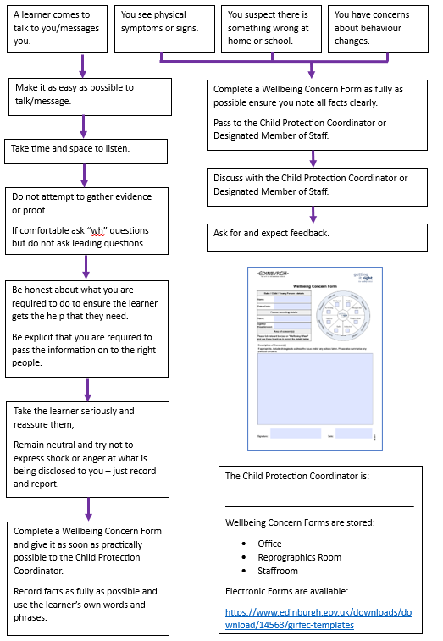
Classrooms
Ann M. O’Hagan, Head Teacher
If there is an immediate risk to the child, contact the police.

- Allegations of Abuse Against Staff
Occasionally, an allegation of abuse may be made against a member of staff.
Staff must report any information which raises concern about the behaviour of a member of staff towards a child or young person to the Head Teacher or Head of Centre. If the allegation is against the Head of Establishment, they should report this to the next tier in their line management structure. This will likely be the Head of Education for the locality.
If you are unsure of who to report a concern to, contact Social Care Direct.

- Visitors to the school
All visitors to school are informed of what to do if they have concerns, and who the Child Protection Coordinator is. This includes all supply staff. Details are also printed on the back of visitor badges and posters are displayed throughout the school.
Our Child Protection Procedure is displayed on our school website.

- Safe Working Practices
All staff, volunteers and partners are expected to behave in a manner that maintains appropriate professional boundaries and to avoid behaviour which might be misinterpreted by others.
Adults have a responsibility to ensure that an unequal balance of power is not used for personal advantage or gratification.

- Further Information
It is understood that Child Protection and safeguarding can be distressing. This may be if you have had lived experience of abuse, or if a child or young person has made a disclosure to you. Please discuss any concerns with your line manager or make use of The City of Edinburgh Council’s 24/7 employee assistance programme, PAM Assist.

- Relevant Policies, Procedures and Links
- National Guidance for Child Protection in Scotland 2021
https://www.gov.scot/publications/national-guidance-child-protection-scotland-2021-updated-2023/
- Edinburgh and the Lothians Multi-agency Child Protection Procedure (December 2023)
https://www.edinburgh.gov.uk/downloads/file/23055/edinburgh-and-the-lothians-multi-agency-child-protection-procedures
- The Handbook of Procedures for the Management of Pupils with Healthcare Needs in Educational Establishments (December 2023)
https://www.edinburgh.gov.uk/downloads/file/34341/handbook-of-procedures-for-the-management-of-pupils-with-healthcare-needs-in-educational-establishments
- UNCRC
https://www.unicef.org.uk/wp-content/uploads/2016/08/unicef-convention-rights-child-uncrc.pdf
- Managing Allegations of Abuse Against Staff
https://orb.edinburgh.gov.uk/directory-record/254689/allegations-of-abuse-against-staff
- MyLearningHub
https://mylearninghub.learn.link/login
- GIRFEC Materials
https://www.edinburgh.gov.uk/girfec/child-planning-folder/1


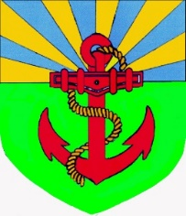
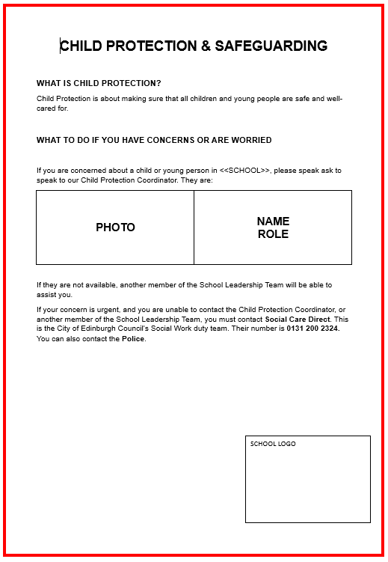
Ann M. O’Hagan
Head Teacher
Pilrig Park School

