
Now/Next Board Project – Green Class
Introduction Questionnaire – November 2024

Please circle the answers that best meet your experience of using visual supports at home with your young person.

- Do family members currently use symbols to communicate with your young person at home?
Yes
If yes, please share which…

No
If no, please help us to understand by giving us more information…

- At this point in time, do you feel confident using symbols to communicate to your young person?
Yes
If yes, please share which…

No
If no, please help us to understand by giving us more information…

- Do you feel there are any challenges towards using a Now/Next board to support an activity at home?
Yes
If yes, please share which…

No
If no, please help us to understand by giving us more information…

- Do you think a video explaining how a Now/Next board works would be useful to help use one more often at home?
Yes
If yes, please share which…

No
If no, please help us to understand by giving us more information…

- Please tick the symbols that would be most helpful to support your young person’s understanding of instructions at home.
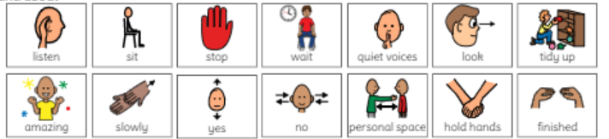
- Please give one area of home life would that you would like your young person’s Now/Next visual support to be tailored to, for example, travelling safety on a bus, going to the supermarket, bedtime routine, toileting, building independence in an activity such as making a bowl of cereal for their breakfast. Feel free to add in as much information that would be helpful for us to know when making the symbols for this home life activity.

