Edinburgh’s Vision for Inclusion
Inclusion should be at the heart of everything we do in our schools and learning communities. We’re committed to recognising diversity, minimising exclusion and supporting our children and young people to achieve their full potential.
A recent improvement project involving experts from across Scotland found that we have much to celebrate in our vision and approach, but also made recommendations for improvement.

We want your views on how we can make these improvements.

There are two ways you can share your views and get involved…

1. Attend a Vision for Inclusion locality or online event

At these events you will hear about the findings of the improvement project, share examples of good practice and take part in discussions on how to take forward recommendations.

Locality Events
For school leaders, learning and teaching staff, parents, carers and organisations who provide support to our learning communities:

- Fri 8 March 2024 1.30pm to 3pm @ Craigroyston High School
- Fri 15 March 2024 1.30pm to 3pm @ St Crispin’s School
- Fri 22 March 2024 1.30pm to 3pm @ Portobello High School
- Fri 26 April 2024 1.30pm to 3pm @ Forrester High School

Online Events
For parents and carers only
- Thursday 21 March 10am to 11am or Tuesday 26 March 6pm to 7pm

For colleagues working in schools or partner services
- Tuesday 23rd April 4pm to 5pm or Tuesday 24th April 4pm to 5pm

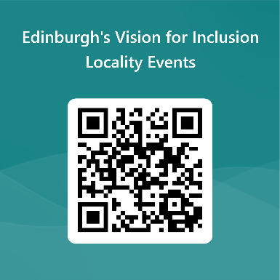

Sign up to an event at www.edinburgh.gov.uk/inclusionvision or use this QR code to take you to the registration form.

2. Complete the Edinburgh’s Vision for Inclusion Survey
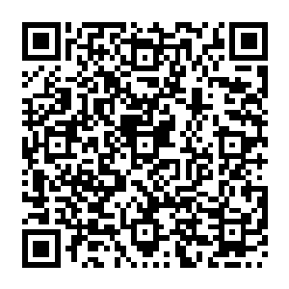

We are also gathering views via a survey on the council’s consultation Hub.

Complete the survey by going to
https://consultationhub.edinburgh.gov.uk/cf/inclusive-education
or use this QR code to take you to the form


If you have any questions or suggestions, please email: inclusion@edinburgh.gov.uk
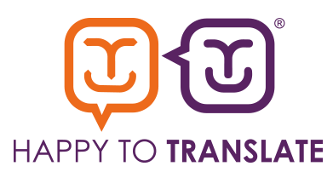
Please email the Interpretation and Translation Service at its@edinburgh.gov.uk quoting reference 24-9666

