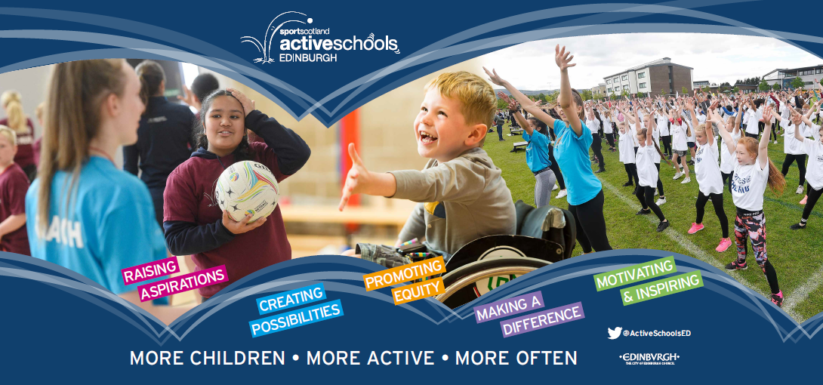

ASN Easter Swim Sessions

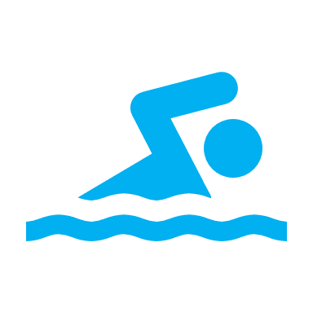

Dear Parent/Carers

Active Schools Edinburgh are excited to share with you our upcoming Easter ASN/ASD Swim Lessons.

These lessons are suitable for children with Autism and Learning Disability/Difficulty (Unfortunately we do not have the facilities for children with physical disabilities at this time).

We have sole use of the pool facilities with a staffing ratio of 1:2 and can accommodate 1:1 pupils. Our coaches and teachers will provide an opportunity for your child to learn new skills but most importantly we aim for them to have fun while taking part in sport and physical activity.

When signing up please select the swimming ability level that’s appropriate for your child.

Many Thanks,
Active Schools Edinburgh

BOOKING INFO BELOW

Easter ASN Swimming Session Information

Booking Opens – Monday 11th March Booking Closes – Monday 18th March

Easter ASN Swimming Lessons
Dates
Venue
Sessions
WEEK  1 | Session | Time | Date | Venue | Cost | Booking Link
WEEK  1 | P4-7 ASN Beginner Session | 10:00  -  10.45 | 2nd, 3rd & 4th April | Leith Academy Swimming Pool | Pay what you can.  Full: £10  Reduced: £5  No cost: £0 | LEI-54
WEEK  1 | P4-7 ASN Beginner/ Intermediate | 10:50  –  11:35 | 2nd, 3rd & 4th April | Leith Academy Swimming Pool | Pay what you can.  Full: £10  Reduced: £5  No cost: £0 | LEI-55
WEEK  1 | S1-4 High School Session (All abilities) | 11:40  -  12:25 | 2nd, 3rd & 4th April | Leith Academy Swimming Pool | Pay what you can.  Full: £10  Reduced: £5  No cost: £0 | LEI-56
WEEK  1 | ASN Open Family Swim Session (All abilities) | 10:00  -  11:30 | 5th April | Leith Academy Swimming Pool | FREE | LEI-57
WEEK  2 | P4-7 ASN Beginner Session | 10:00  –  10:35 | 9th, 10th, 11th of April | Craigroyston High School Swimming Pool | Pay what you can.  Full: £10  Reduced: £5  No cost: £0 | ROY-100
WEEK  2 | P4-7 ASN Beginner/ Intermediate | 10:45  –  11:20 | 9th, 10th, 11th of April | Craigroyston High School Swimming Pool | Pay what you can.  Full: £10  Reduced: £5  No cost: £0 | ROY-101
WEEK  2 | S1-4 High School Session (All abilities) | 11.30am – 12.05pm | 9th, 10th, 11th  of April | Craigroyston High School Swimming Pool | Pay what you can.  Full: £10  Reduced: £5  No cost: £0 | ROY-102

Any Questions please email.
WEEK 1 – Aidan.Haughey@ea.edin.sch.uk
WEEK 2 – Mathew.mclachlan@ea.edin.sch.uk OR sarah.2.murphy@ea.edin.sch.uk

