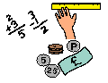
Learning Grid Pack Thursday 28th September
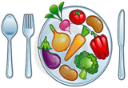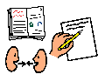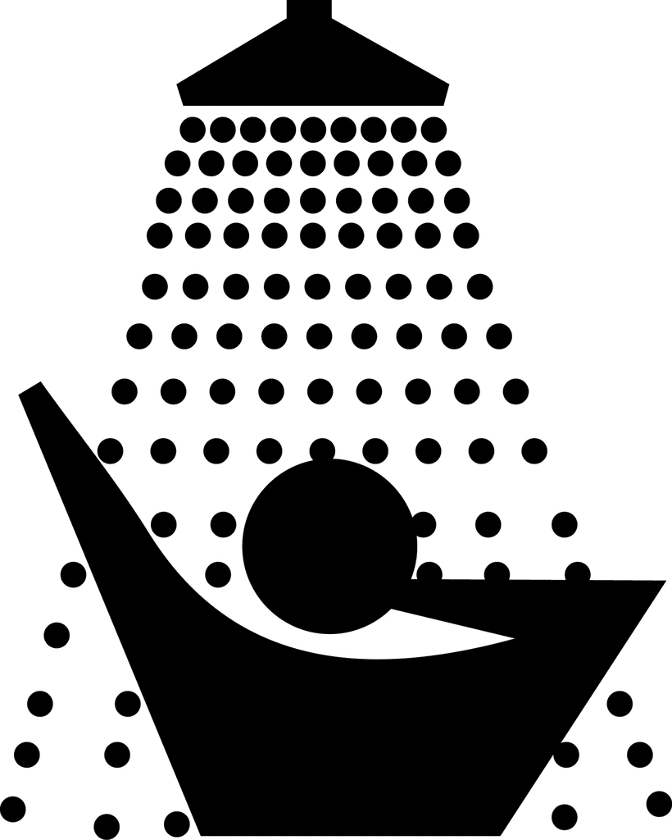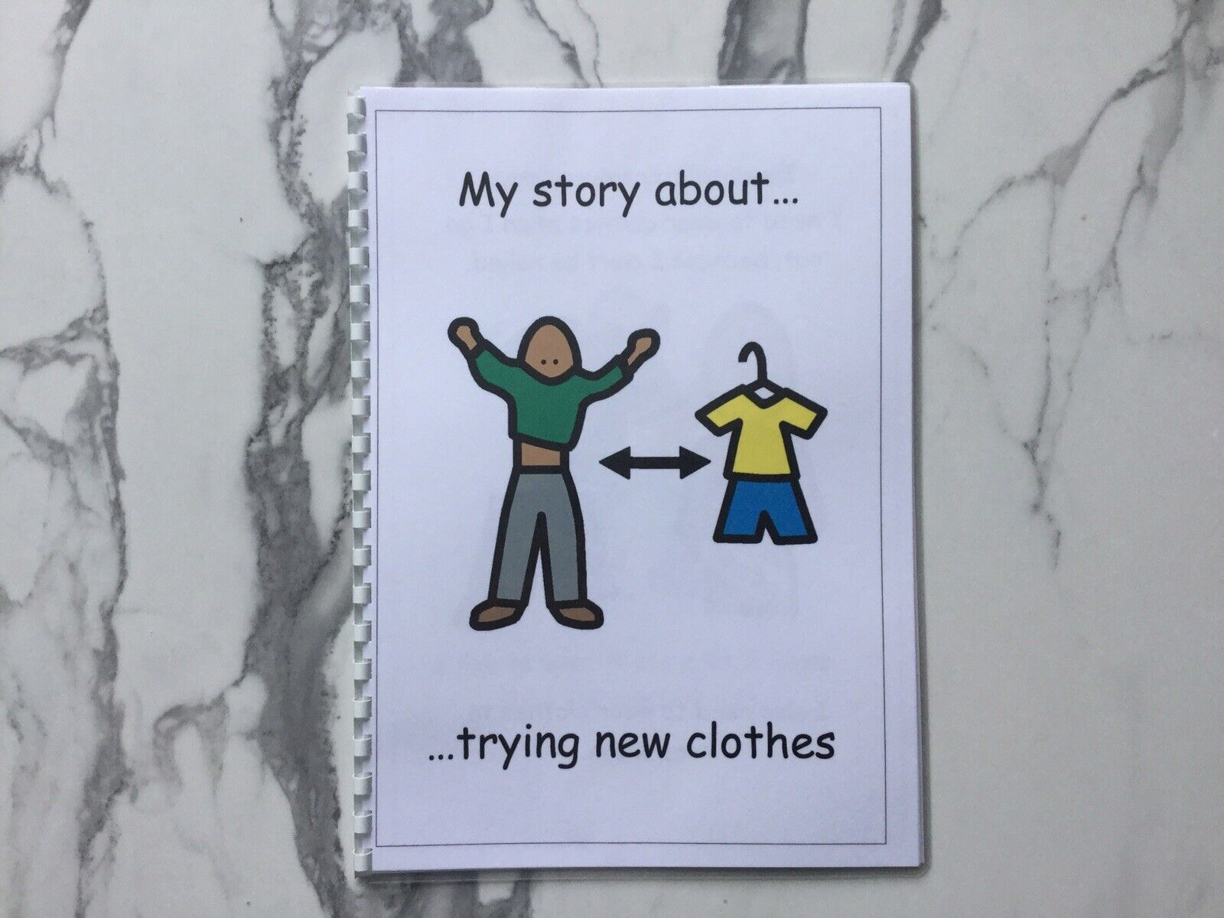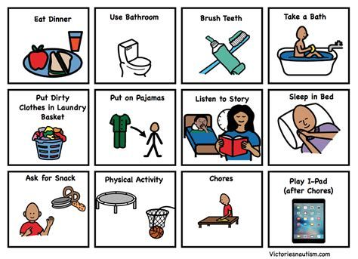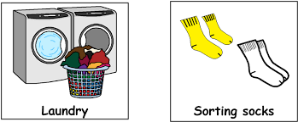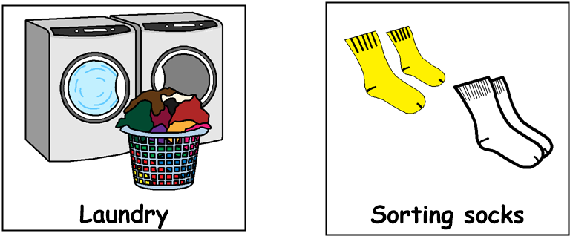

Good morning! Get dressed, have something to eat and drink for breakfast then brush your teeth. Choose some tasks from each of the following sections, through the day:
11am – 12.30pm Numeracy
- Count how many steps it is from your bedroom to each room in your house
- Practice the days of the week / months of the year
- Draw five clocks and mark what time you get up in the morning, have your breakfast, lunch, tea and go to bed.
9am – 10.30am Literacy
- Listen to / watch or read a news item
- Interview someone at home – ask about favourite food, TV program, dream holiday etc.
- Write / type your name and your address
- Follow a simple recipe which uses words or symbols
- Look for items around the house which begin with a particular letter of the alphabet, e.g., ‘b’ – ball, bag, bin, bed

12.30pm – 1.30pm Lunchtime
11am – 12.30pm Numeracy
- Name and find objects in the house which look like these shapes.

- Learn your birthday and age. Write or type your date of birth
- Using a measuring jug, measure out 3 different amounts. e.g., 100ml, 200ml, 500ml
- Using weighing scales, measure out 3 different amounts. e.g., 50g, 100g, 200g
- Pick 5 items on your home and arrange them in order of size from small to large

1.30pm – 3pm Health & Wellbeing
- Choose a favourite song and make up a dance routine
- Sort out dark & light-coloured clothes for washing
- Play a game with someone at home
- Go for a walk and collect some leaves to make a piece of art back at home
- Help to prepare the evening meal

