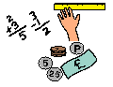
Learning Grid Pack Wednesday 27th September
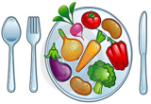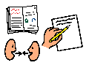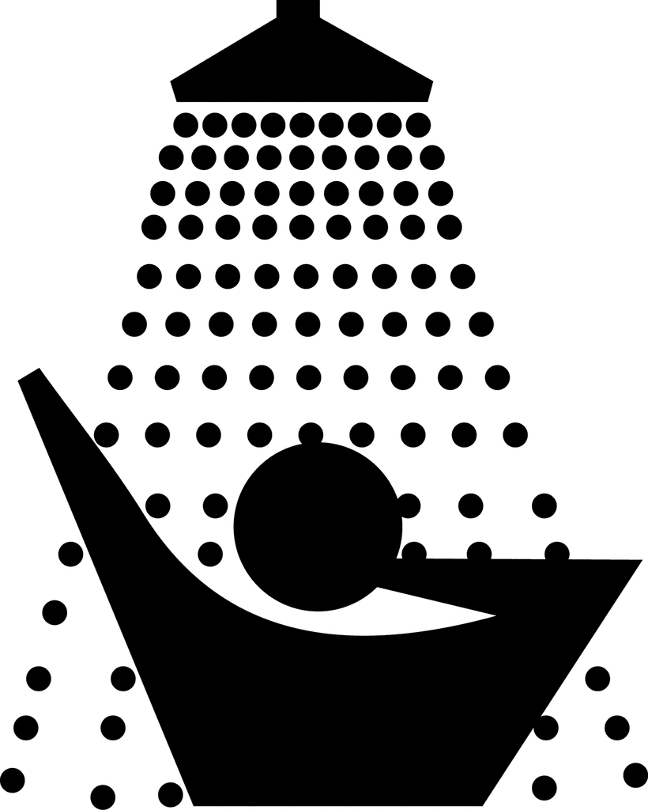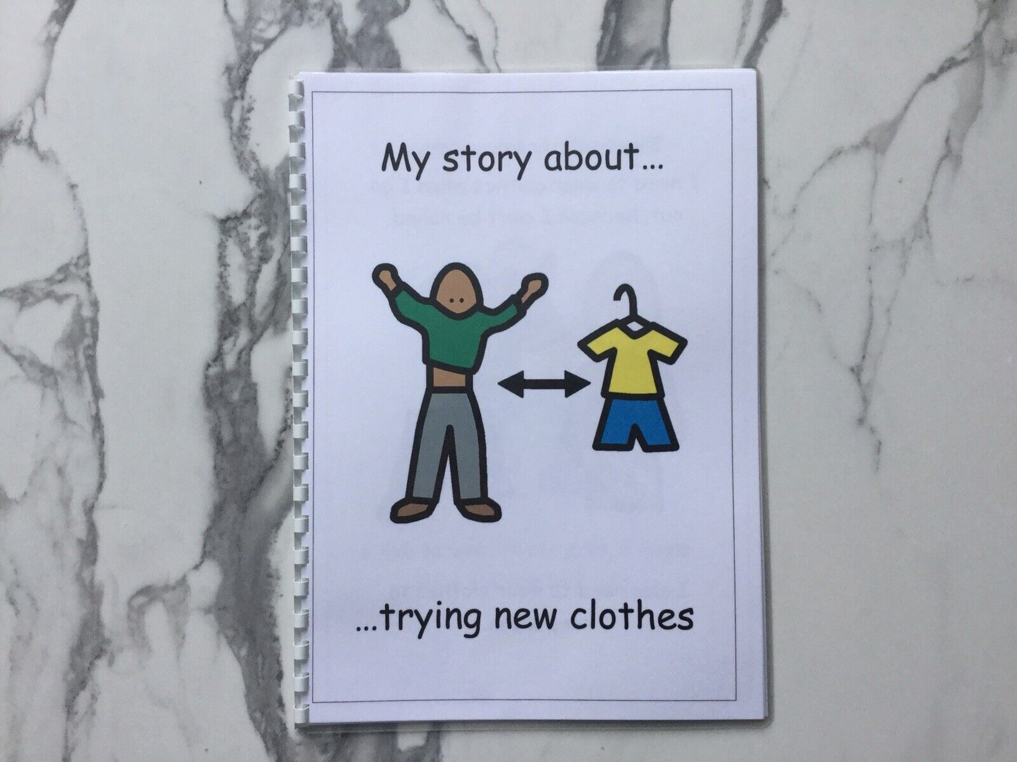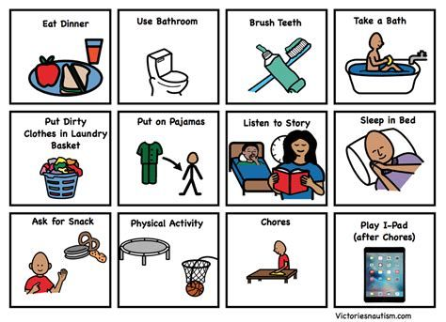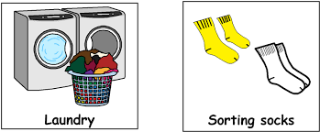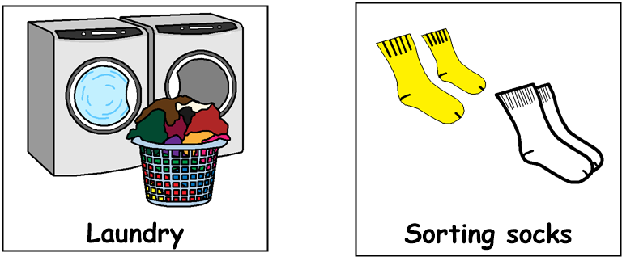

Good morning!
Get dressed, have something to eat and drink for breakfast then brush your teeth. Choose one or two tasks from each of the following sections,
through the day:
9am – 10.30am Literacy

- Find items in your house that begin with the letter ‘s’ e.g., saucepan, socks etc
- Write a thank you note to someone who has been kind to you
- Look out your window. Say or write down 5 things that are moving and 5 things that are not moving
- Keep a diary for the day and write down what you do, eat and drink
- Create a list of food which begins with each letter of the alphabet. Draw pictures of the food
12.30pm – 1.30pm – Lunch time
1.30pm – 3pm Health & Wellbeing
- Find a space in your home to do some exercises. Do 10 star jumps, jog on the spot for 20 seconds then do 10 bunny hops
- Do something nice for someone in your home without expecting anything in return
- Make a fruit or vegetable kebab. Find out where each ingredient comes from
- Hold a karaoke session with your family. Sing your favourite song together!
- Draw some emoji faces and make each one a different emotion e.g., sad, happy, worried, excited etc
11am – 12.30pm Numeracy
- Ask a member of your family to call out a shape. Walk around the house or garden and tap everything that is that shape
- Ask someone to give you a random number. Practise saying the number before and the number after
- Draw a game on a piece of paper in which you roll a die to move along the board. It could be a snake or a train track. Play with someone in your family. How many times can you win?
- Guess how many cupboards or drawers you have in the home – then count them!
- Using some dried spaghetti and some playdoh or plasticine, can you make a 3D shape, e.g, a cube, a pyramid or a cuboid?

