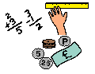
Learning Grid Tuesday 26th September 2023
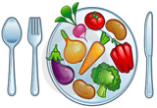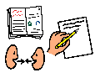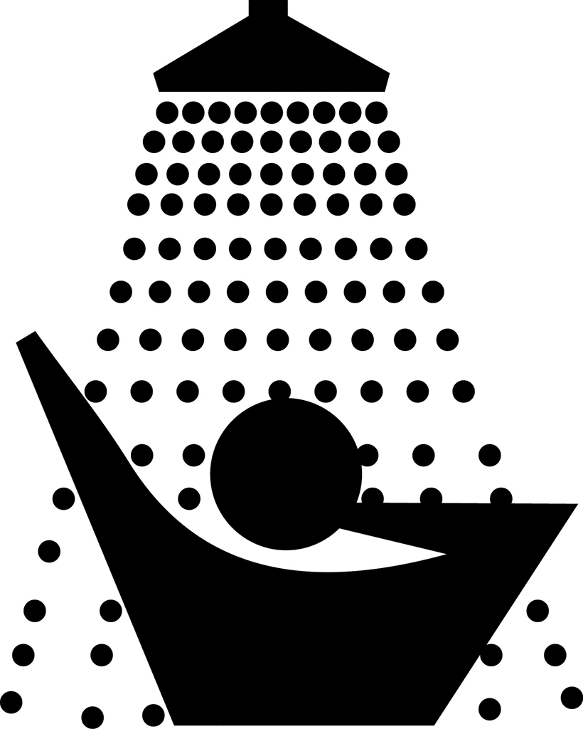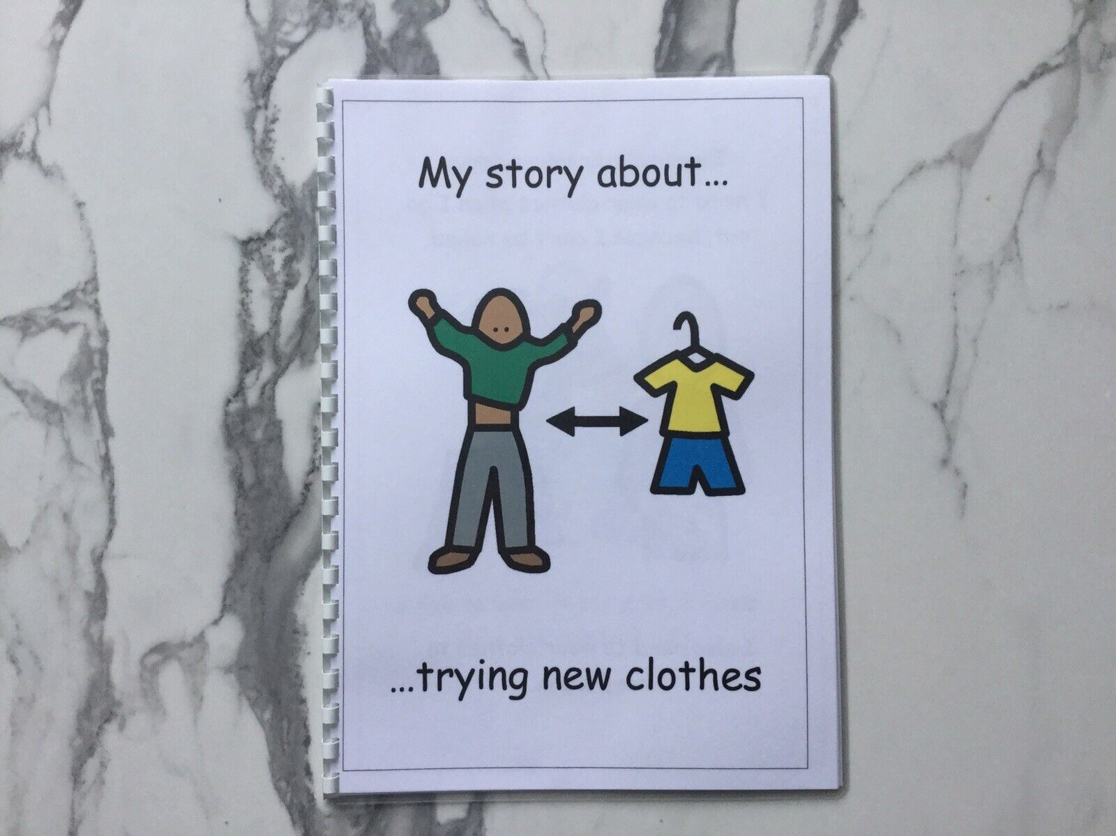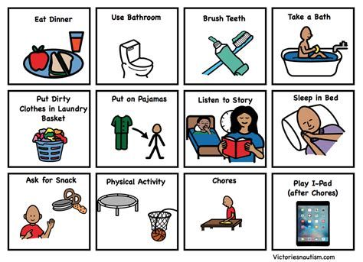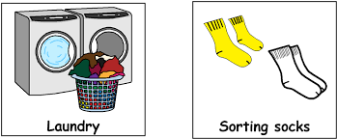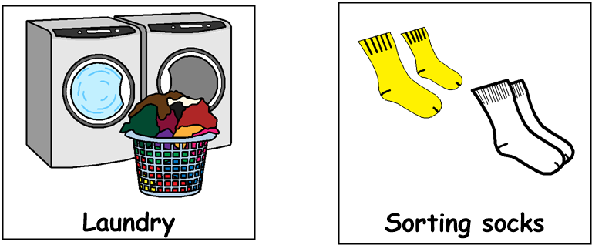

Good morning!
Get dressed, have something to eat and drink for breakfast then brush your teeth. Choose one or two tasks from each of the following sections,
through the day:
9am – 10.30am Literacy

- Make a video of you or someone else in your family, reading a story out loud
- Perform a role-play based on your favourite story or film. Ask some family members to act with you
- Draw or write 10 words that rhyme with each other
- Have a game of ‘I spy’. Try playing it in different rooms in your home
- Choose an item in your home and describe it to someone else, without showing them what it is – can they guess the object?
12.30pm – 1.30pm – Lunch time
11am – 12.30pm Numeracy
- Find as many different examples as possible of numbers in your home
- Gather some objects in your home. Sort them from lightest to heaviest
- Build a tin foil boat. Then place it in a basin of water. How many objects can you put in the boat before it sinks?
- How many people are in your home? How many hands? How many eyes?
- Look through a catalogue or a website and find as many special offers as you can. E.g., 25% off or Buy One Get One Free. Work out if the offer is a good deal

1.30pm – 3pm Health & Wellbeing

- With an adult, help make a cup of hot chocolate.
- Role play a shop at home. Label everyday items with prices and then ask your family to be the customers!
- Have a spring clean in your bedroom! Are there toys, books or games you could donate to charity?
- Build a tower from using objects you find in the house – how high can you make it?
- Call a relative or a friend who is far away and have a chat with them

