Sunshine in Leith!
Vision: As a dedicated school community, we are committed to maintaining a caring and supportive working environment, acting with integrity, motivation, and flexibility at all times. Our vision is to provide safe, effective, holistic education ensuring equity and inclusion for all our pupils through seamless, compassionate, and dignified specialised provision.

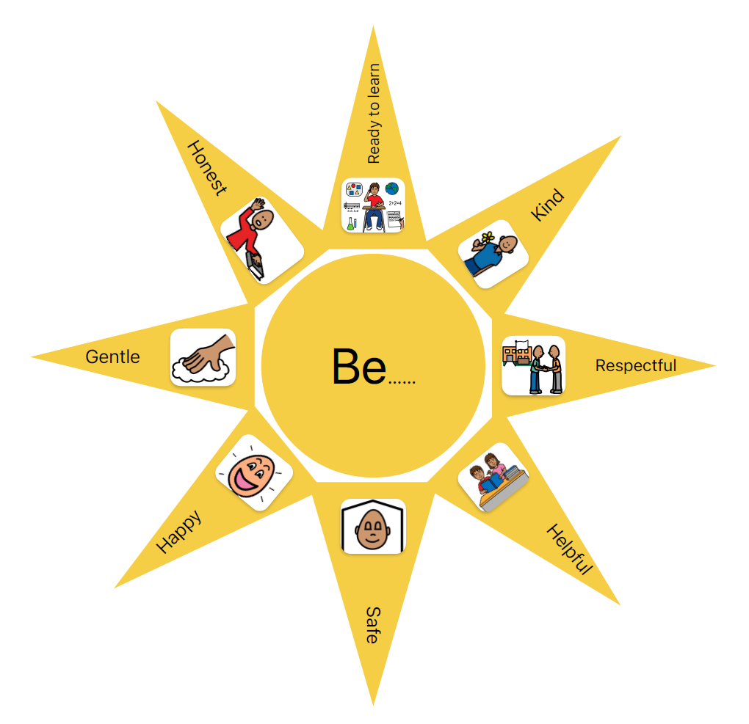
Values: Our Pupil Council, after extensive consultation, identified that the values of Pilrig Park School are to:

Aims:

Partnerships which provide us with opportunities to develop relationships within our community to inspire an….
Inclusive learning environment;
Life Skills to prepare our pupils for their futures beyond Pilrig Park School which sparks and embeds the values of a….
Rights respecting cultural ethos;
Independence engrained, through learning and teaching, to enable our pupils to be….
Gallus!

