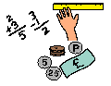
Learning Grid Pack 2
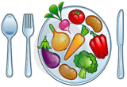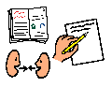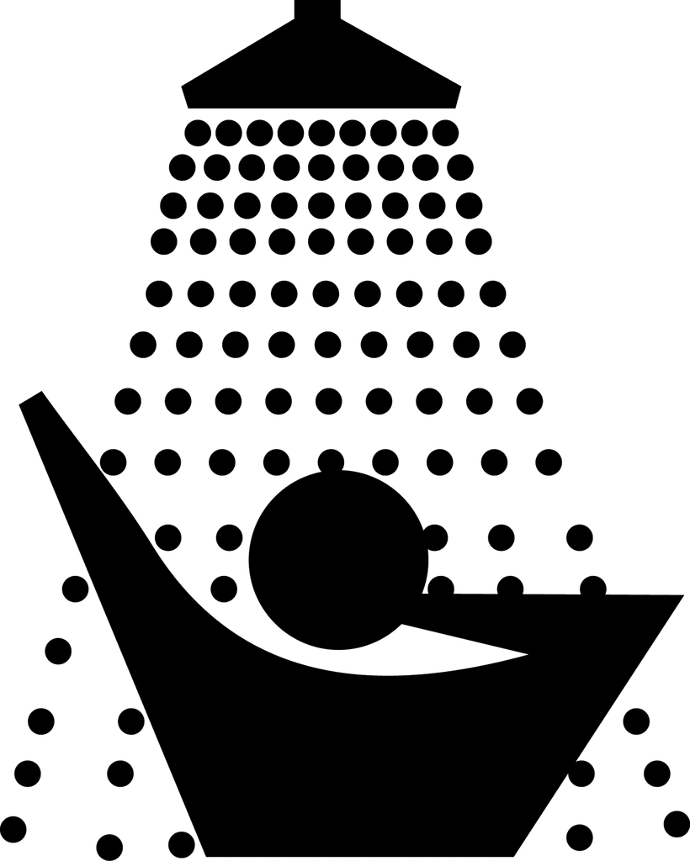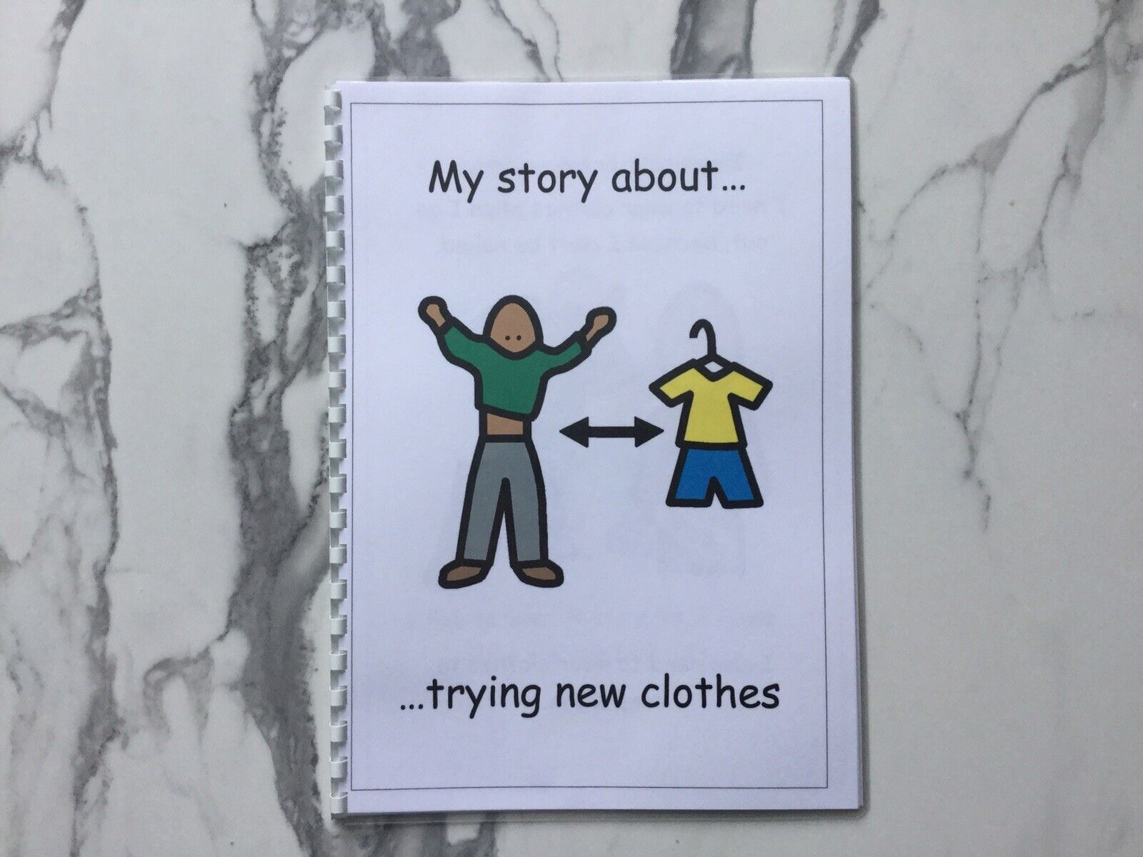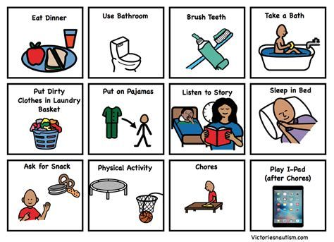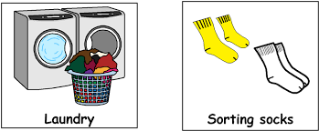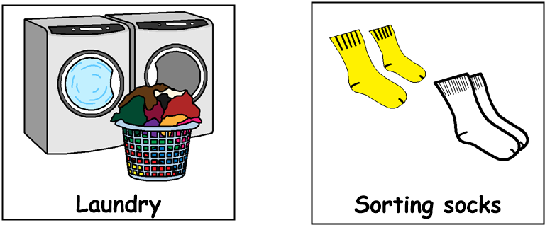

Good morning!
Get dressed, have something to eat and drink for breakfast then brush your teeth. Choose one or two tasks from each of the following sections,
through the day:
9am – 10.30am Literacy

- Watch a TV / Film adaptation of a book, then tell someone two things you liked / disliked about it.
- Read an article from a newspaper or watch ‘Newsround’ and then write or tell someone, a short summary on one of the articles.
- Find out the birthdays of all the members of your family and make a birthday calendar
- Read a poem out loud then make one up yourself!
- Read a recipe and help to make something tasty!

12.30pm – 1.30pm – Lunch time
1.30pm – 3pm Health & Wellbeing
- Go outside and do some exercises in the fresh air (eg running on the spot, star bursts, touch your toes, reach up to the sky)
- Using some magazines or newspaper, cut out healthy food items and make a poster
- Choose a fast song and make up a dance then choose a slow song and make up a dance routine
- Find some kitchen utensils and create some music using them
- Send someone you have not seen in ages, a letter or a postcard
- Draw a picture of your favourite meal. Include your favourite drink and favourite pudding
11am – 12.30pm Numeracy
- Go to the supermarket or look online and find out the cost for 5 items of your choice. Make a list and add up the total cost
- Write down numbers 1 – 20 then cut them out and put them order
- Throw a die 20 times, write down the numbers each time. How many times did you roll a 6?
- Look out the window and count how many cars, lorries and people walking dogs go past in 10 minutes. Try this at a different time of the day and see if the numbers change
- Go outside and find 10 sticks or stones. Order from smallest to biggest

