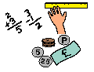
Learning Grid Pack 1
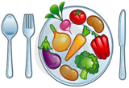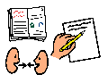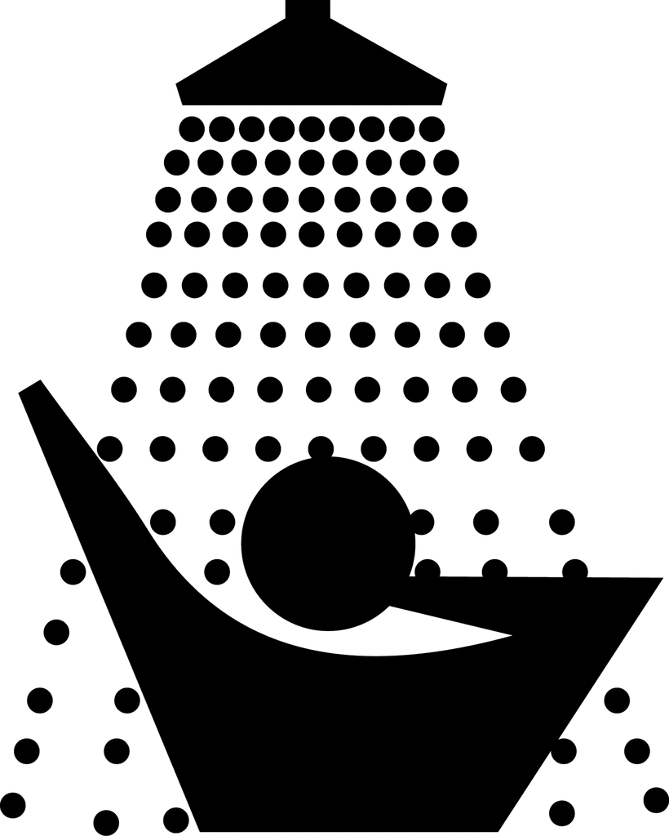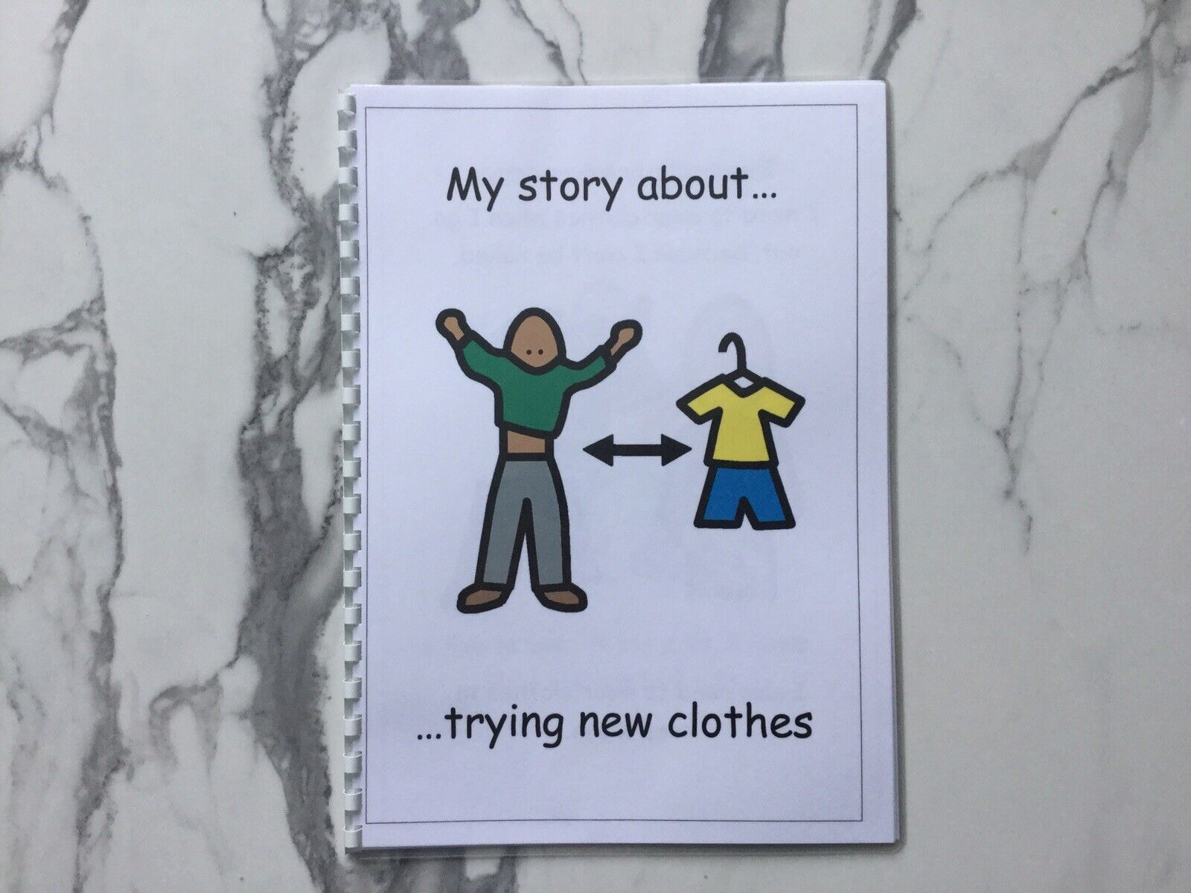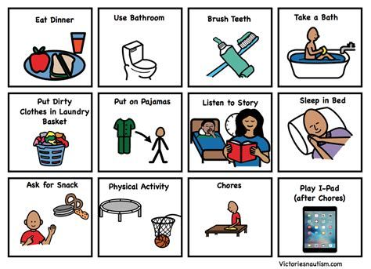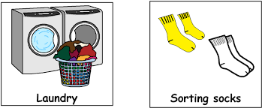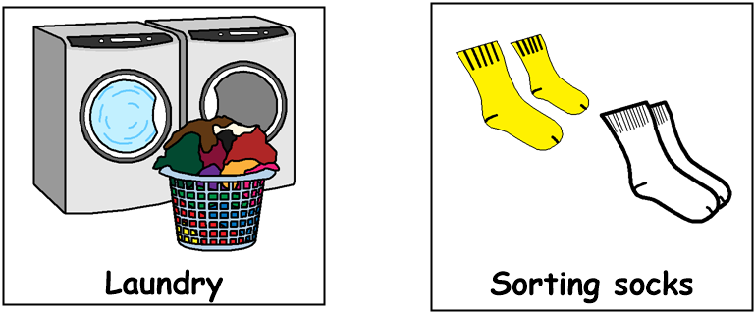

Good morning!
Get dressed, have something to eat and drink for breakfast then brush your teeth. Choose one or two tasks from each of the following sections,
through the day:
9am – 10.30am Literacy

- Read the instructions for a game and then play it with someone!
- Call a friend or relative and tell them what your favourite book / TV program is
- Make up a quiz on a topic of your choice
- Read a magazine, comic or a newspaper
- Read a recipe and help to make something tasty!

12.30pm – 1.30pm – Lunch time
1.30pm – 3pm Health & Wellbeing

- Lay out appropriate clothing for a rainy day, a hot day and a snowy day.
- Help someone in your family to do a task
- Make a bird feeder using an apple spread with peanut butter and coated in bird seed
- Make a healthy snack
- Help to hang up the washing
11am – 12.30pm Numeracy

- Wash the dishes in 10 minutes, using a timer
- Count how many doors / windows in your home
- Go on a shape hunt around your home or garden. Make a list of the 2D and 3D shapes
- Look at a calendar. How many months have 30 days? How many months have 31 days?
- Make a list of items in your home which are long and short

