

Is that my first year at Pilrig Park School really over?! What a year it has been! It began with many Covid restrictions still in place and, thankfully, finished with our first school show in a number of years, parents and carers being back in the building, a whole-school celebration assembly, and events for our AMAZING leavers! I would like to say a heartfelt thanks to all the parents and carers, staff and pupils who have made me feel so welcome at the school throughout the year. It has been a joy getting to know everyone and I look forward to creating new memories together next session.
I hope you enjoy reading the bumper edition of our end of year newsletter. A massive thanks goes to Mr McPhillips for all his hard work in putting it together.
At this time of year, schools find themselves saying goodbye to colleagues and pupils and waiting in anticipation for new starts – both staff and S1 pupils! At our end of year assembly we said a fond farewell to colleagues and friends who are leaving us for either new jobs, new adventures and even teacher training! We also said a very sad goodbye to our leavers. The school will just not be the same without them.
And what will my lasting memory of this year be? Easy! As one young man left the Leaver’s Ball on Wednesday night, I heard him say to a fellow pupil “I hope our paths cross again”. The spirit of Pilrig Park School was captured perfectly through these six words.
I leave you now with a picture of our Leavers. I wish everyone a very restful and peaceful summer with hopefully plenty of Scottish sunshine!
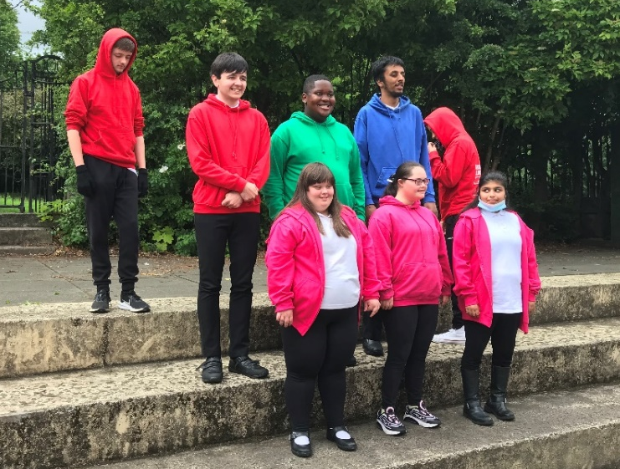
Take care, keep safe and I look forward to welcoming all our pupils back to school on Wednesday 17th August.
Ms Ann M. O’Hagan
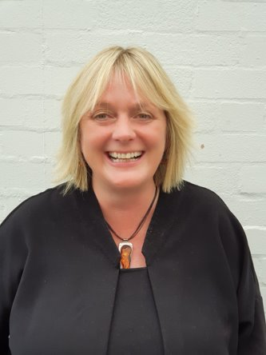
Extremely proud Head Teacher

Arran Class
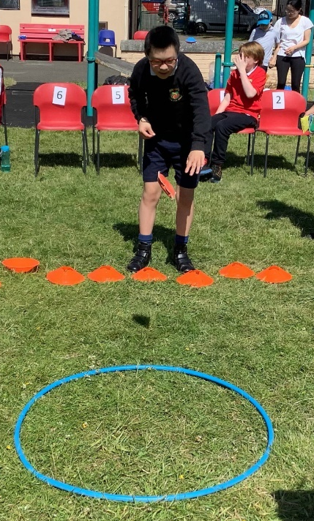
Pupils in Arran enjoying Sports Day.
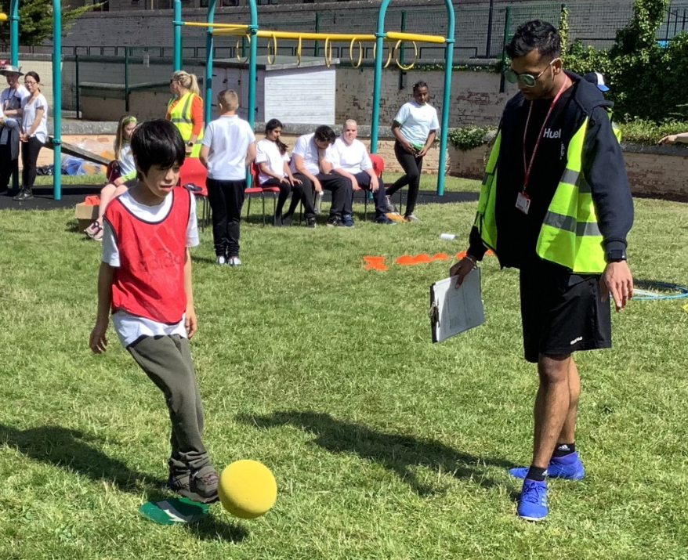

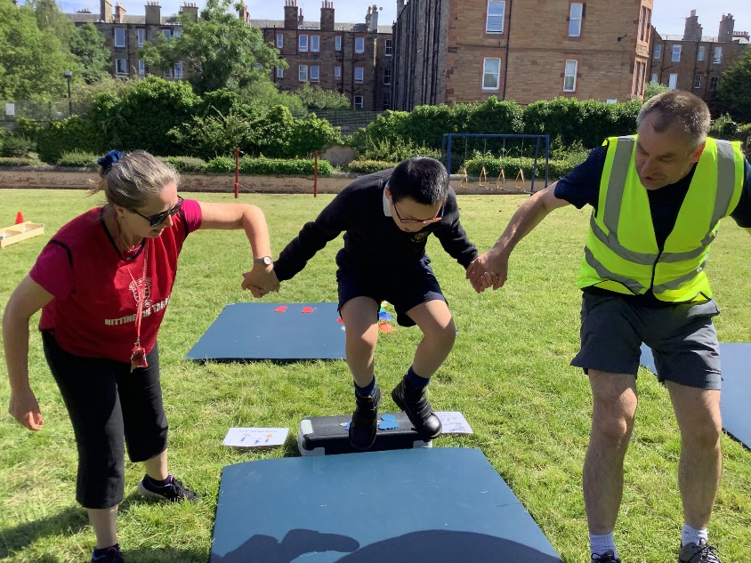
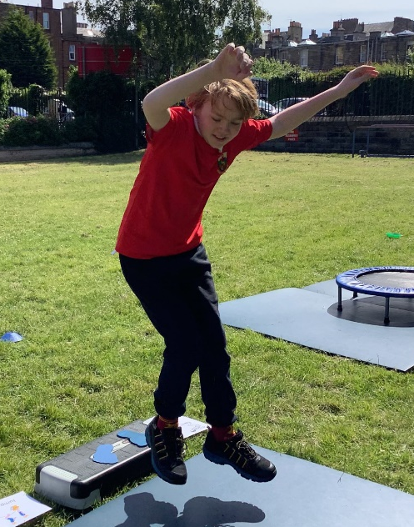

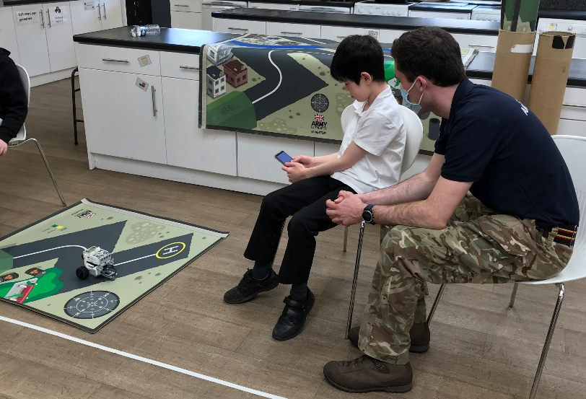
Oliver using a robot as part of
Army Day.

Skye Class
Skye Class have been busy this year and enjoyed many different activities.
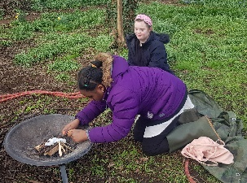
Well done Skye for all your hard work!

We had some great times with Margon
from Green Team building our confidence
and resilience in the outdoor environment.
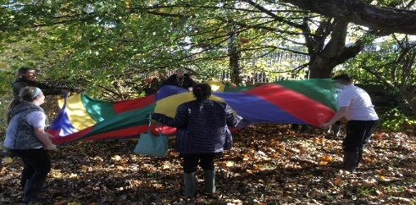
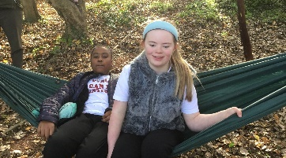

H.E has been a lot of fun and we have been trying out many new recipes.
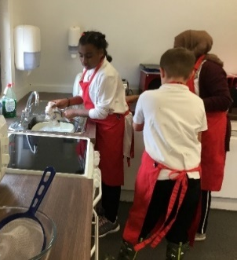
We have been learning to work together, tidying up.
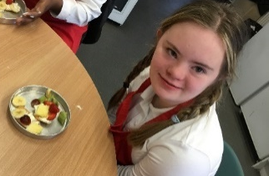

STEAM- Science, Technology, Engineering, Art and Maths
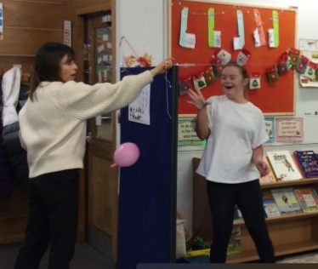
We had to use our knowledge
in all these areas to help us to
develop skills and solve problems.
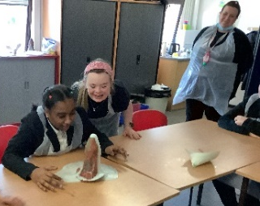
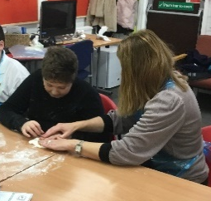

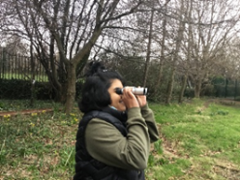
Orkney Class
Our amazing outdoor learning adventures.
- Days out with Park Rangers.
- Hanging birdfeeders on trees.
- Birdwatching.
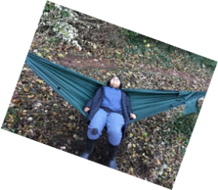
- Relaxing with the Green Team.
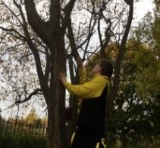

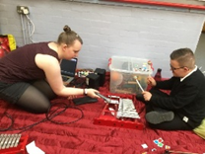

A year full of fun and learning experiences
- Having fun making music with Drake Music.
- Cooking our favourite dishes.
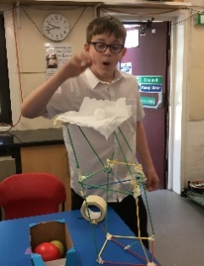
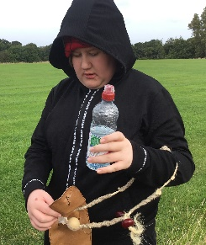
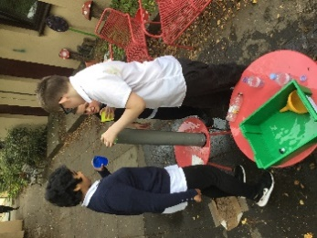

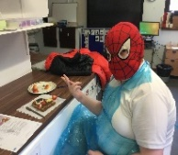
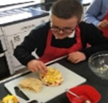
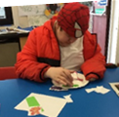
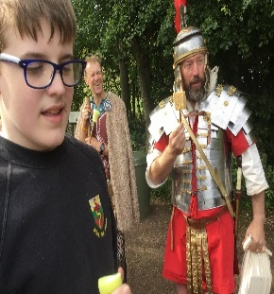

Lewis Class
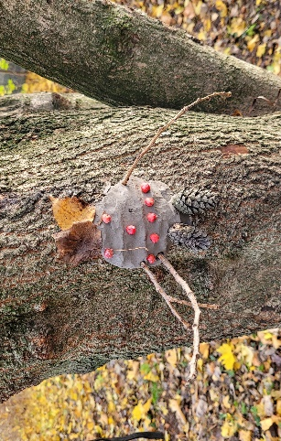
This year Lewis class have had lots of exciting learning experiences, from trips out to fun lessons in school. It’s been a busy year and we have all played our part in making it brilliant!
Each of us has chosen an activity of the year to highlight in this newsletter.
We really enjoyed outdoor learning with Margon
and the Green Team.
We did arts and crafts and got to hang
out in the hammocks.
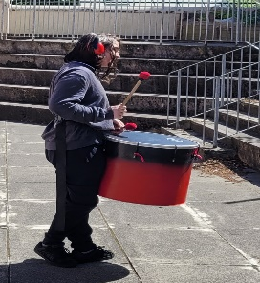

Learning to drum with Pulse in the Place has been brilliant! It’s great fun getting outside and dancing to the beats.

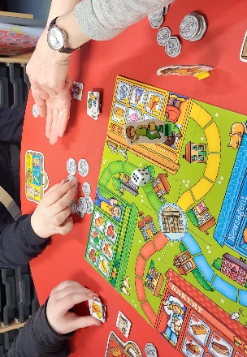
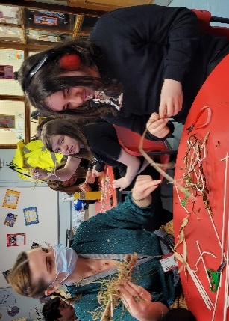
We did lots of fun science experiments, we really enjoyed making nests and learning about bird beaks.
We have worked really hard on Maths this year.
We played lots of games to support our learning.

Going to Park Rangers was a really exciting learning experience.
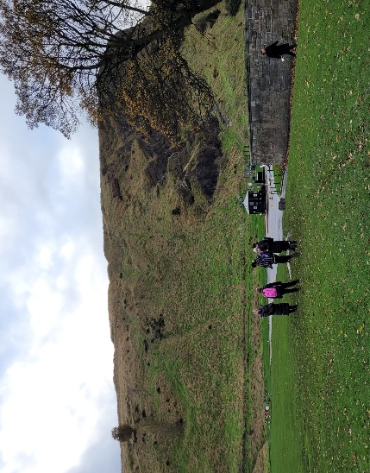
Lily the Park Ranger did lots of different outdoor learning activities that brought history, science and geography to life!

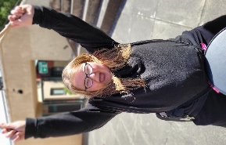
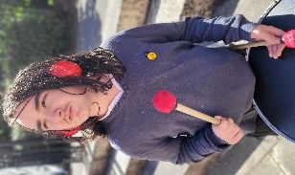
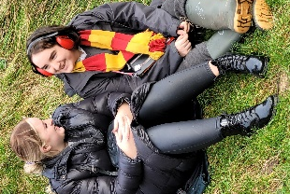
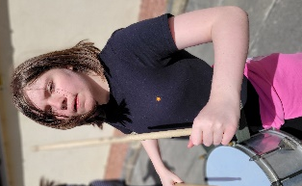
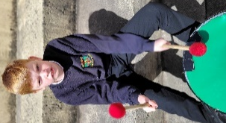

It has been such a busy year, we have managed to fit in a lot of learning and a lot of fun.

Harris Class
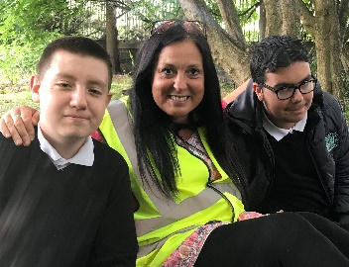
We have loved working with Margon from the Green Team. In the final session we learned how to safely light a fire and we toasted marshmallows. They were delicious. We used magnifying glasses to identify minibeasts, went on a leaf hunt and learned how to identify different trees from leaves. We enjoyed planting daffodils and pansies in the garden area. We had great fun building dens and playing with the parachute, the hammocks and the streamers.
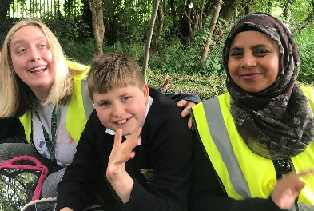
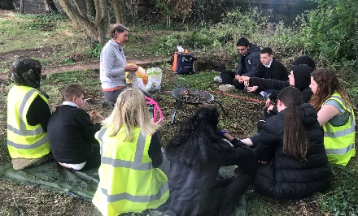
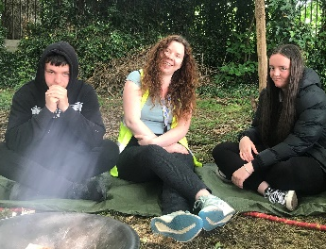

Our Assembly was on Being Active. We made a video of us Zumba dancing, playing football, enjoying circuits and activities in PE and lots of outdoor adventure with the Green Team.
We loved going to Park Rangers. We did a lot of walking and climbing. We fed the birds and swans and got very close. We made bread. We learned about the land at Arthur Seat and that it is an extinct volcano. We learned that in prehistoric times dinosaurs would have been there. We all got Heritage Hero Awards.
We enjoyed making our Christmas Video to Last Christmas. We did brilliant signing and dancing. We loved watching everybody’s videos for Christmas Festivision and doing class Assemblies online.
It was brilliant being involved in the school show and all our families and carers came to see it and loved it. We were so proud of ourselves. Great acting, dancing, editing, filming, music, costumes etc.
We loved Sports Day, it was the sunniest day. We had great fun, worked really hard and all got medals.
We have had a brilliant year in Harris. Cameron has had a brilliant time with Harris since joining us 3 weeks ago. We had to say goodbye to Grace which was sad but we know she is happy at her new school. We are all sad to say goodbye to each other as it’s been such a lovely year but we wish everybody well on the next part of their journey at Pilrig Park and beyond.
Chris says ‘Positivity, Progress, raised Self Esteem have all happened in Harris this year. You Guys Rock!’ Thank you Chris.
Barra Class
Barra have had a fantastic year learning how to look after themselves and the environment and having lots of fun along the way.
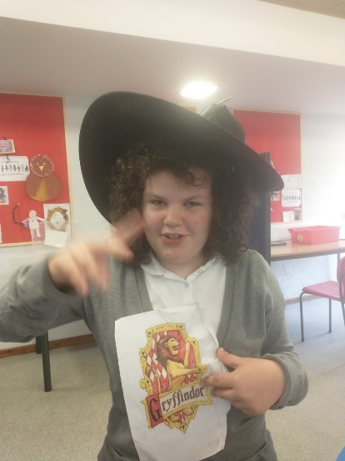
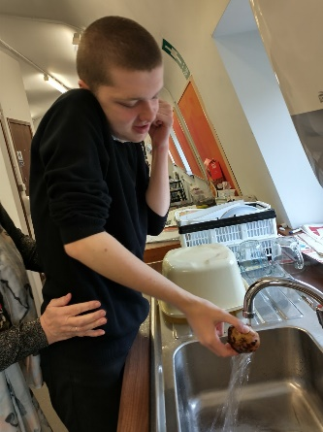
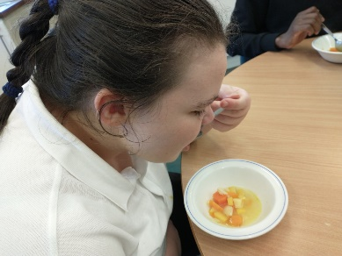
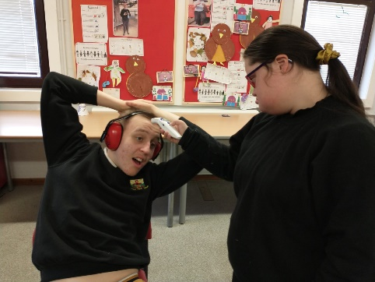
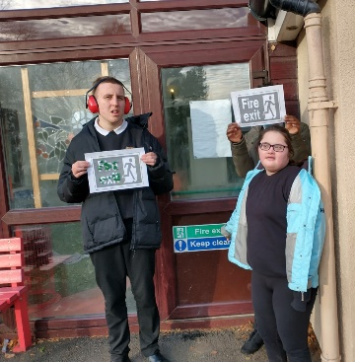
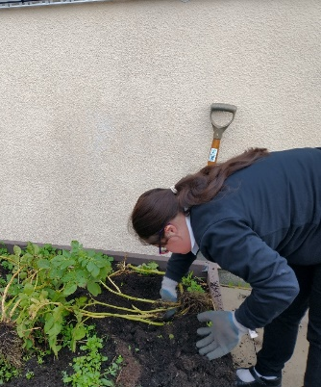
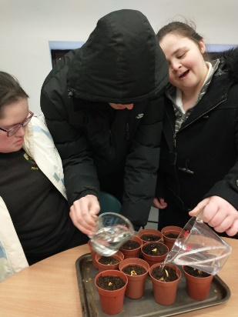
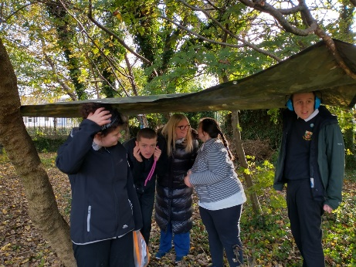
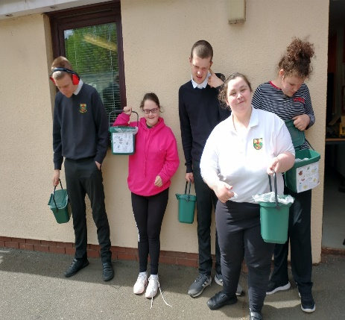
Here are some of the highlights:
Setting up their own compost collecting service within the school to improve the school environment and to cut down on waste.
Learning about the Outdoors with GreenSpace; building dens, planting bulbs, harvesting potatoes and turning them into soup.
Gaining S.Q.A. awards in First Aid and Understanding Signs in the Community.
In English we have enjoyed exploring the characters in Harry Potter.
In Maths we have done amazing work on coin recognition and gained another S.Q.A. award.

Well done Barra!

Clyde Class
We talked about our highlights of the year. Here are the things that stood out.
We liked the visits from the army and navy. There were mini helicopters flying round the PE Hall, and iPad-programmed robots finding their way round the Life-long Learning Base. We feel well prepared for any zombie apocalypse.
Some of us were learning to play musical instruments this year – the pipes and drums, or at least the chanter and drum pad. None of these musical skills were evident in our Christmas video to the tune of Leona Lewis’s “One More Sleep”, but no one could have predicted the dance moves we came up with.
Some of us were involved in a group learning to grow vegetables in the Botanic Gardens. That group ended up taking part in filming for a TV programme involving Chuck Berry.
In the summer term, all of us were involved in the school show. We divided ourselves among dance, drama, props, costumes and media. Basically, we carried the show.
Speaking of being carried, we all want to say that Isabel single-handedly kept our ship afloat all year.
Interestingly, for a number of us, our highlights of the year were simply being in individual teachers’ classes, but we won’t name names in case anyone missed out takes revenge on us.
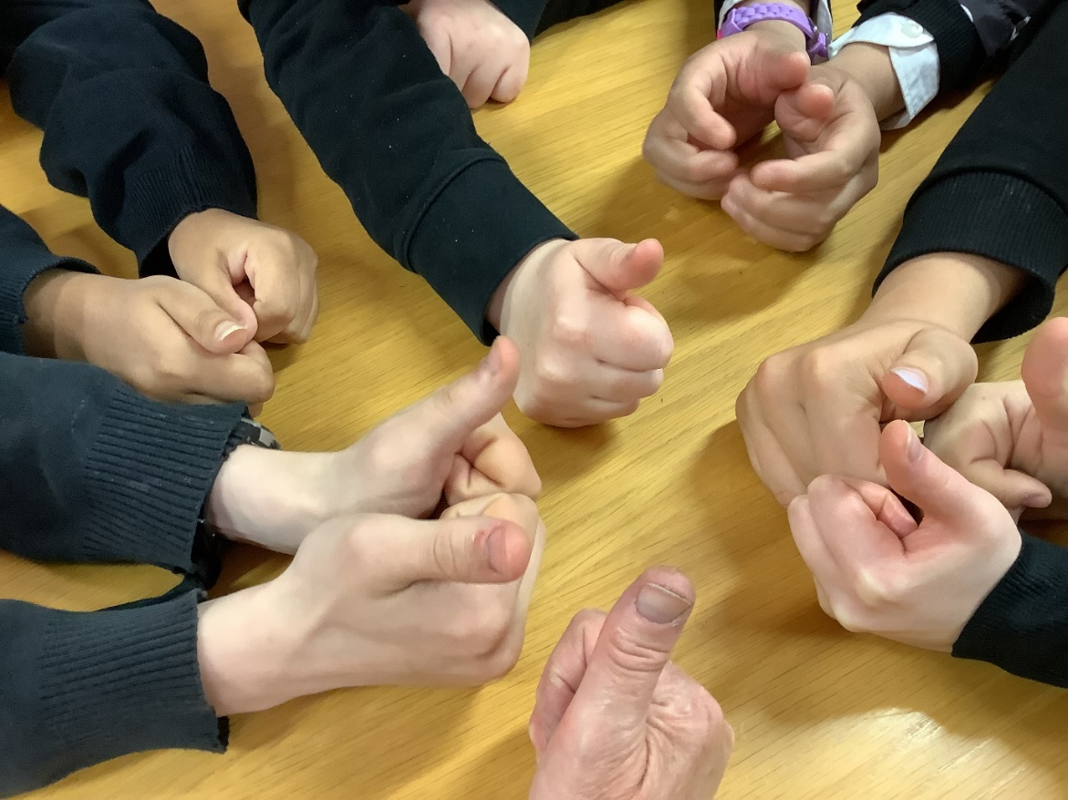

Ness Class
Siaka – ‘For me the best part of school has been in Spartans and school show as a villain role.’
Bradley – ‘This year I really enjoyed the football tournament.’
Dylan – ‘This year I really enjoyed reading in English lessons.’
Jaime – ‘This year I ready enjoyed football.’
Ryan – ‘This year I really enjoyed sports day helping out.’
Sky – ‘For me the best part of school has been Spartans because of the tournament this year.’
Aidrienne – ‘I enjoyed learning to edit for the school show.’
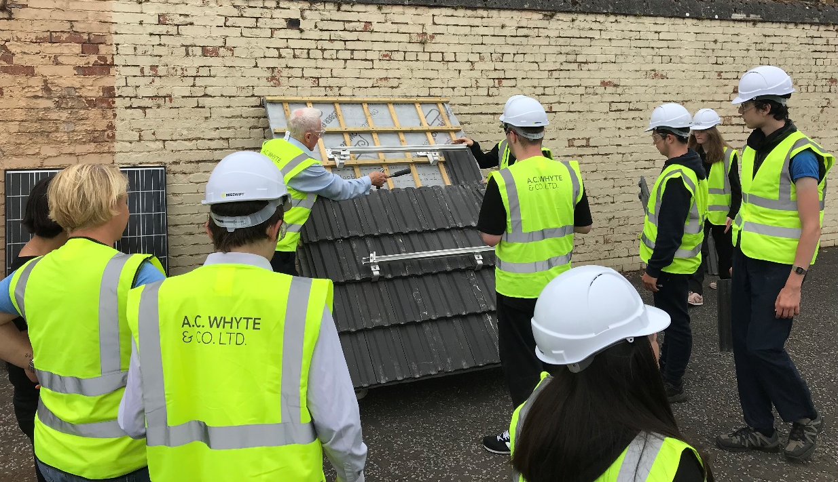

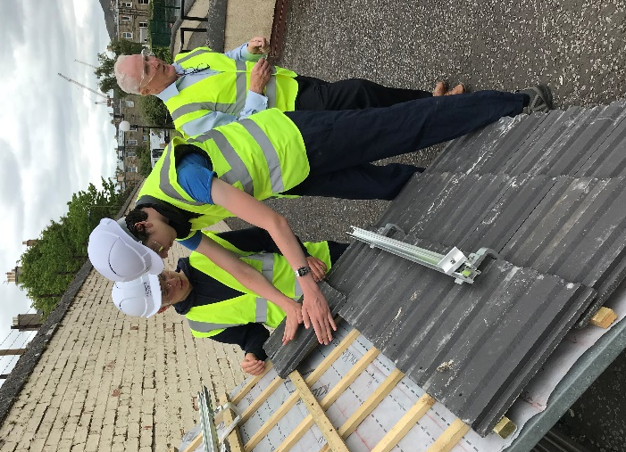
Tay Class
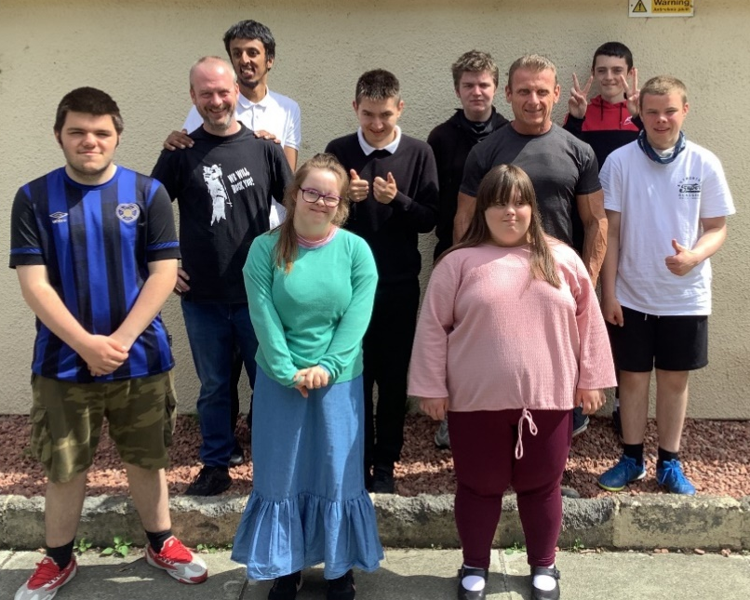
Tay class have had a fantastic year. We’ve all been glad that this year was a bit more ‘normal’ than the past couple.
We enjoyed presenting our Assembly on Being Active where we shared stories about how we keep active when we’re not at School. It was great hearing about David’s magnet fishing.

5 of the class go to Spartans on Thursday afternoons. There are always great stories of their heroics when they return and brilliant to hear about Adam scoring a lot of goals recently. David, Liam, Jamie and Kai are all a huge part of the School Team and have really benefitted from attending Spartans.
Jonathan and Taylor have been attending college 2 days a week this year as part of their transition. They have both coped brilliantly and have received a lot of praise for their work.
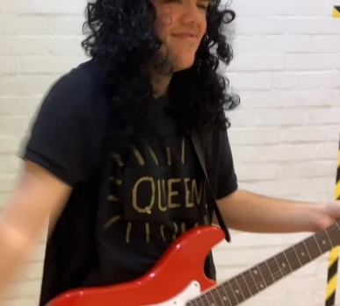
Pilrig Park Will Rock You! was a great way to end the year
and we hope there will be another film or show next year.

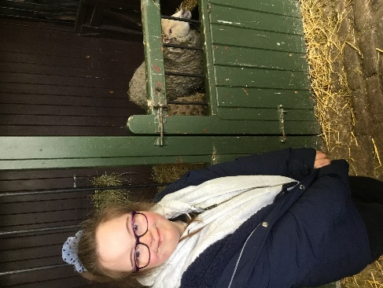
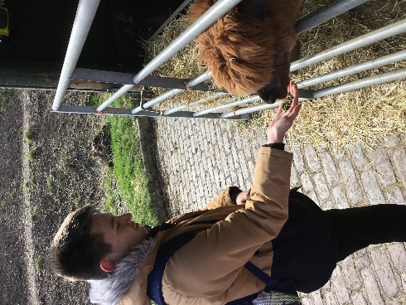
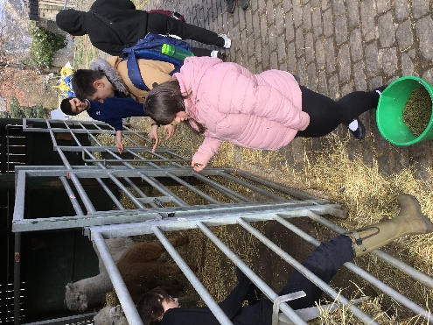

Recently Tay Class had a trip to Gorgie Farm with Miss Morrison as part of their Science topic. Everyone had a great time and enjoyed feeding the animals.

Tweed Class
What a term we have had with the Leavers class. We have been out and about linking with local employers and businesses, getting stuck into various Skills for Work activities.
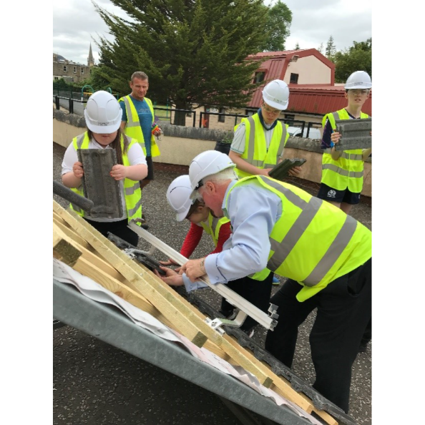
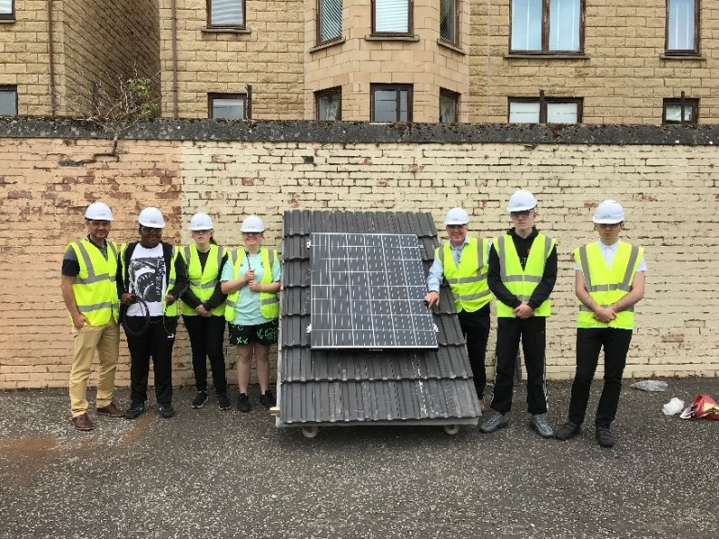

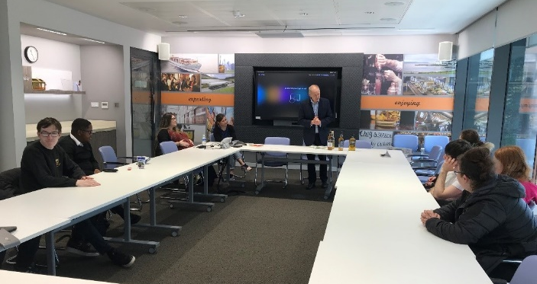
Employer visit and activity about
branding and merchandising with
The Scottish Whisky Association.

We also had a drone lesson on how to fly them and how they can be used in the world of work with Skills Development Scotland.
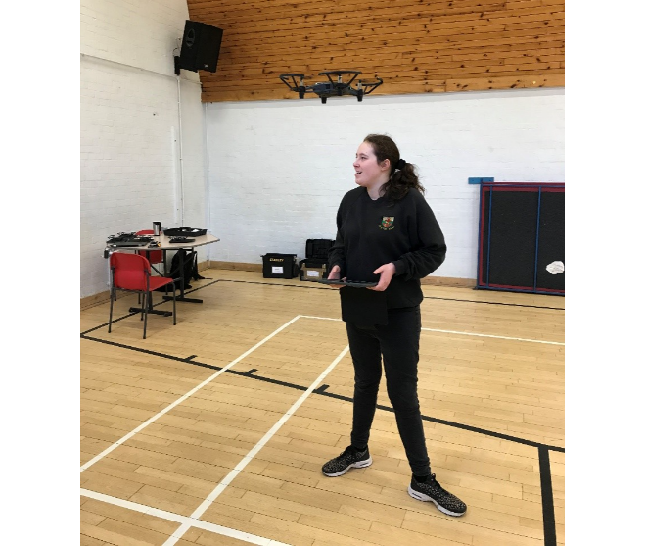
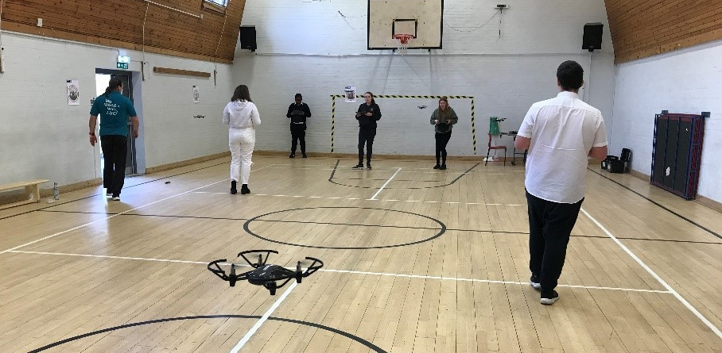

Employability
We had an Army Take over day for all the classes – They put our pupils through team building and problem solving activities.

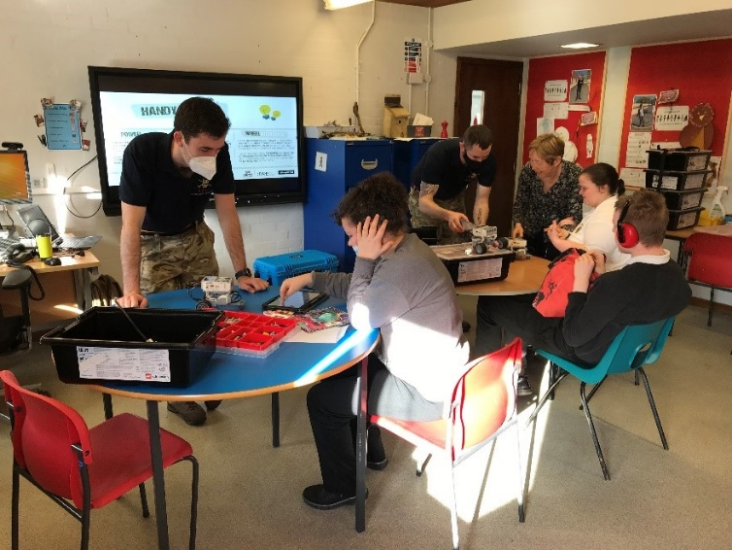
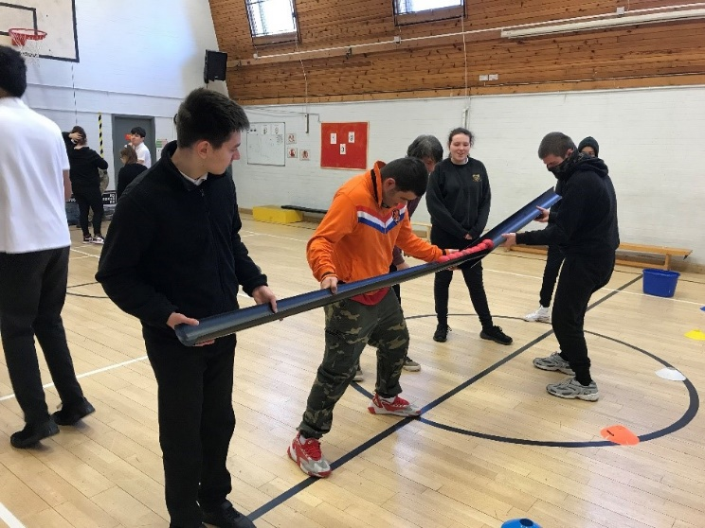

Employer visit to Fort Kinnaird Recruitment Services where we had to undertake interview techniques with the recruitment staff and then to visit one of the employers to find out about retail.
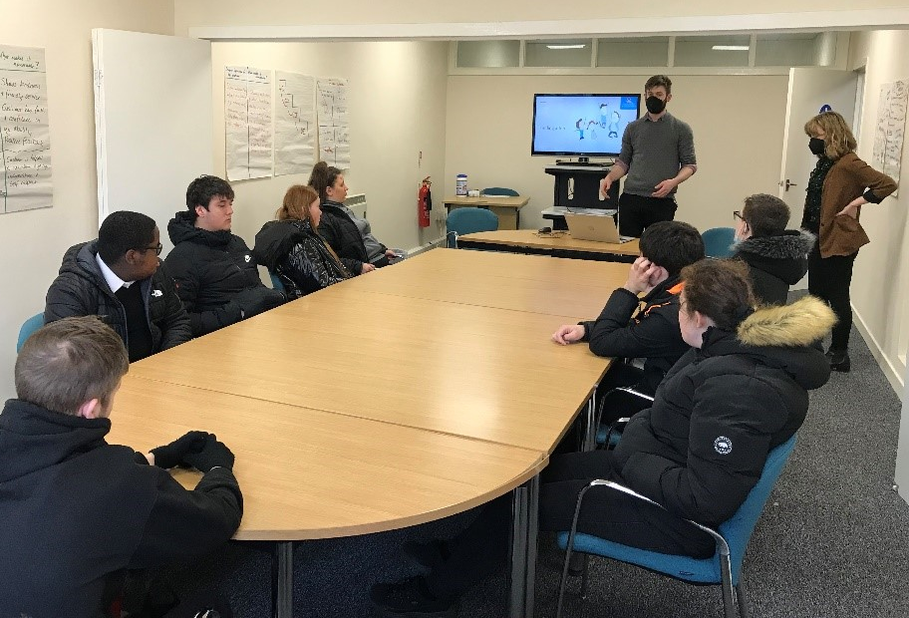

Sports Day
We were blessed with fantastic weather for Sports Day this year.
Some families were able to come along and enjoy the fun.
Everyone had a great day and no one got sun burnt, apart from Mr McPhillips a wee bit.
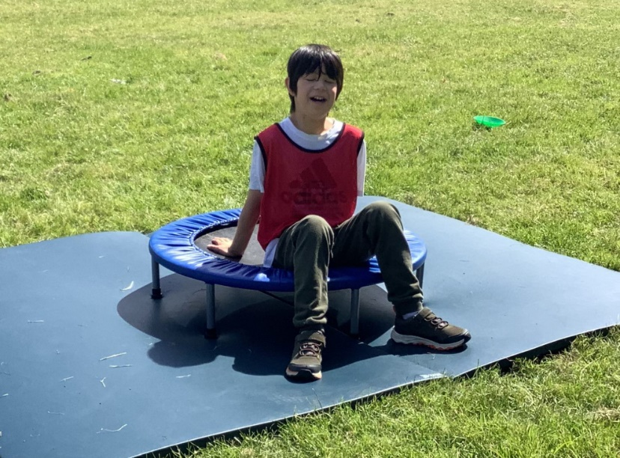
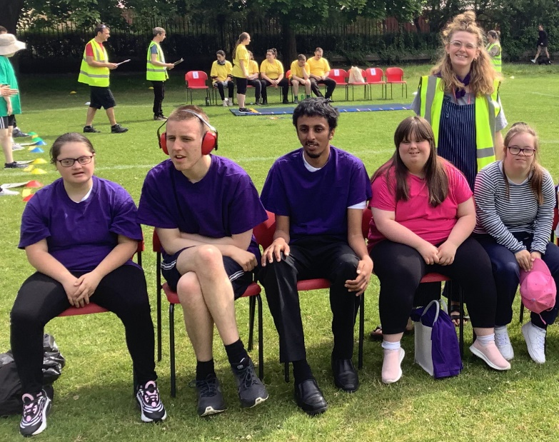
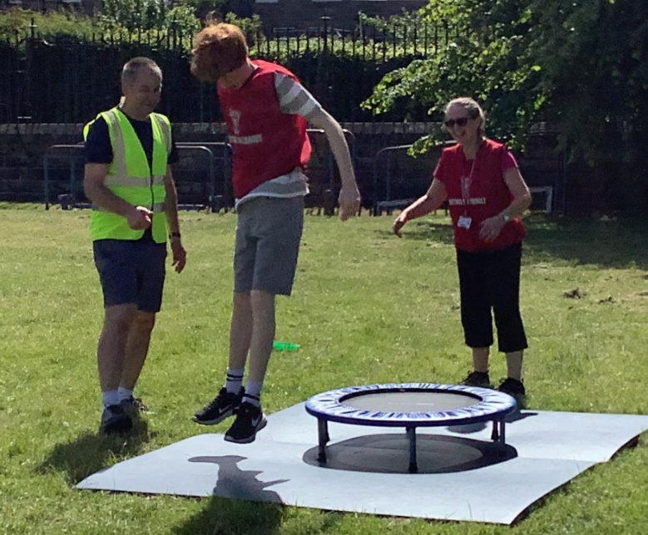
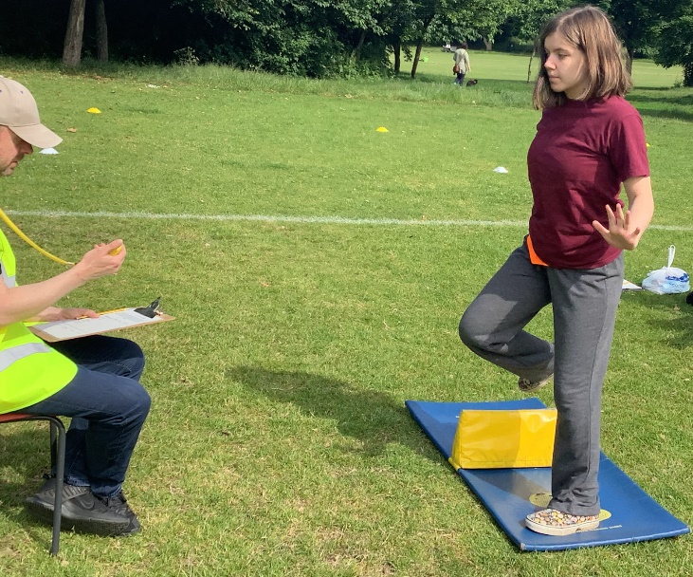

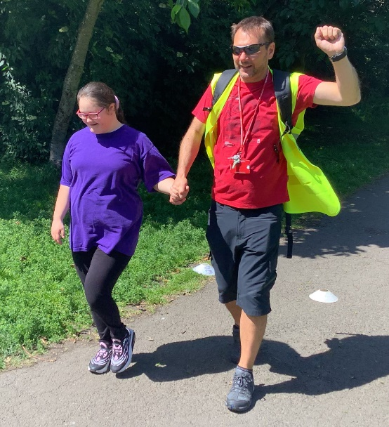
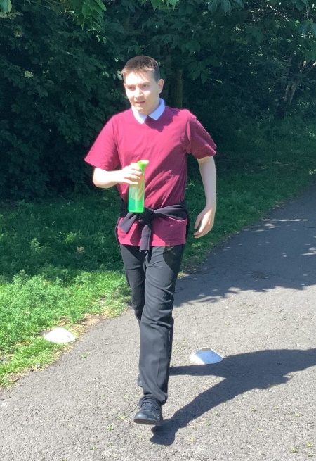
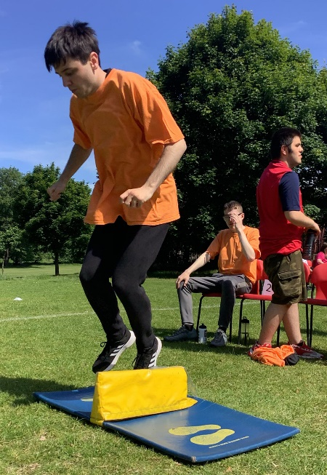
P7/S1 Transition
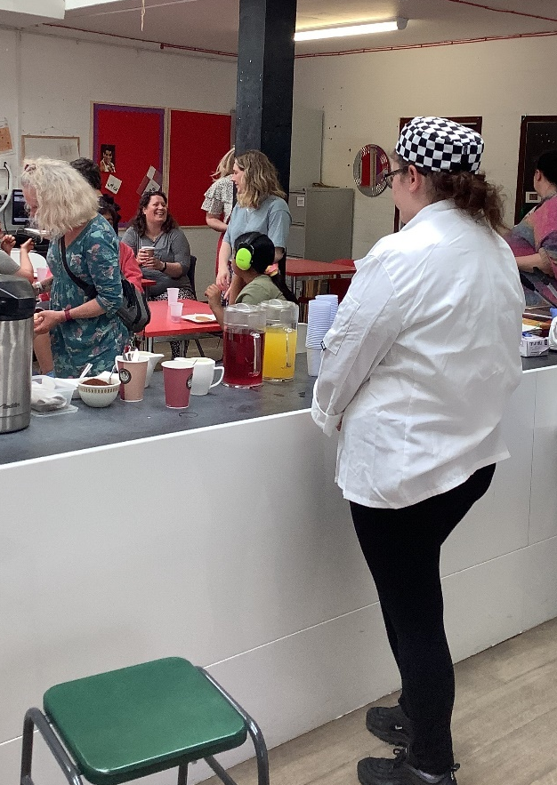
On the 14th and 15th of June we welcomed our new S1 students for two jam packed transition days. They spent the first day getting to know some of the staff at Pilrig Park School and took part in an Art class and a PE activity, they definitely went home tired. The second day was just as fun with Polish pasty making in Home Economics and planting of Sweet Peas, our school plant.
We finished off the transition days with a welcome café for our new parents which was supported by Mrs Foggo and Ms Carr from the parent council.
It was a very successful transition experience for all involved and we look forward to August when our new S1’s will be with us full time.
Pilrig Park Will Rock You!
This year all pupils participated in some aspect of making our school show film.
S1, 2 and 3 pupils used their participation to count towards their JASS award, they were working towards silver or gold level.
In the senior school all pupils worked towards an SQA qualification.
- 4 pupils were entered and passed Performance Arts: Contributing to a performance Nation 1 level.
- 11 pupils were entered and passed National 2 Using Performance skills
- 19 pupils were entered and passed National 2 Contributing to a performance
- 4 pupils were entered and passed National 3 Drama Skills

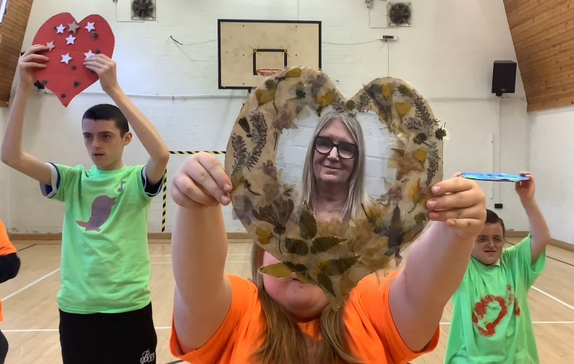

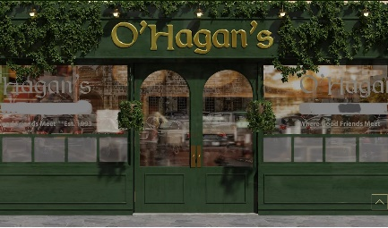
Green Team
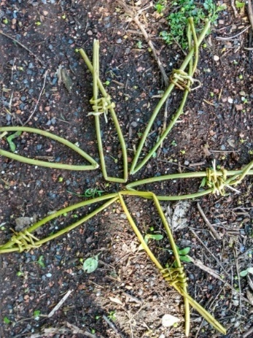
Over the last few months, the BGE classes have enjoyed being out in the school garden with Margon from Green Team. Margon has shown us how to make dreamcatchers using willow and natural materials found in the garden, shelters to hide from the rain (it only rained heavily, once!) mandalas using wild flowers and willow fish using wool and flowers. The highlight was this week when each class enjoyed a fire bowl session and toasted some marshmallows! These sessions with Green Team have counted towards the Adventure section of the pupils’ JASS award. Well done everyone and thank you Margon! Outdoor learning at its best!
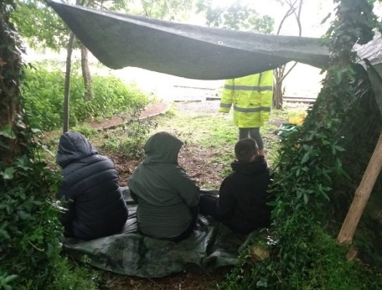
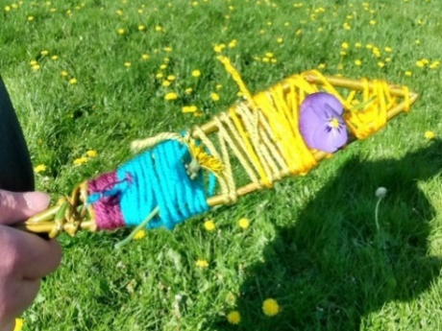

Holyrood Park Rangers
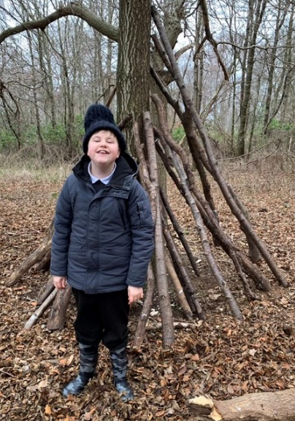
Since the start of the session, several S1-S3 classes have taken part in Holyrood Park Rangers and achieved their Heritage Heroes Award as well as their Me & My World section of their JASS Award. Pupils enjoyed learning how to make bread using ancient methods, discovering volcanoes, feeding the swans and even washing tractors! We are very grateful to Lily and the team at Holyrood for making our visits great fun and we learnt so much in the great outdoors!
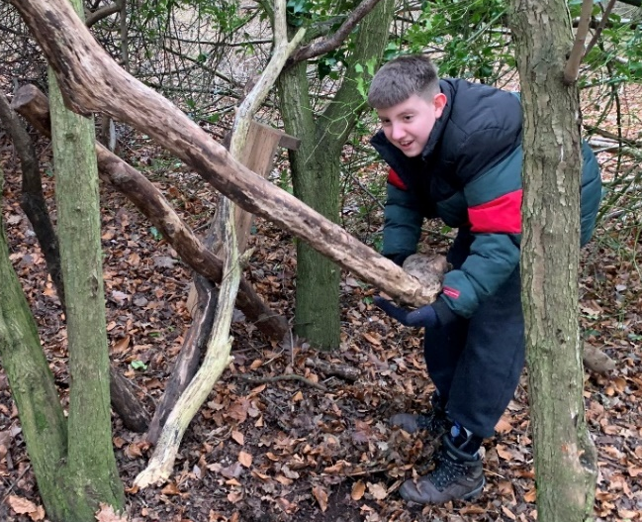

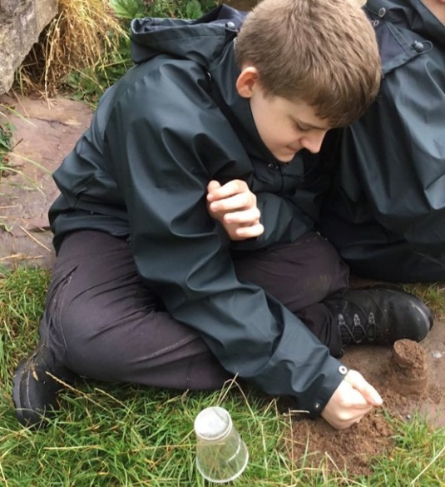

Music, in and out of School
There has been quite a lot of musical variety, lilting through the school corridors in the last few months.
Leah from Drake Music has been teaching some of our younger pupils all about making music with percussion instruments as well as sound beams and then recording the sounds.
David, our drum tutor, has continued to teach the drum pad and in March we welcomed Chris, to teach chanter pupils across the school.
In addition, Jenny has seen several pupils for Music Therapy and the Samba Band, Pulse of the Place, have been in school teaching Lewis Class. Just recently, one of our Senior pupils (who has played Samba drum for several years) had the opportunity to play in a mass band on the Mound, as part of Make Music Day UK. He was one of 100 pupils from across the city to take part in this first ever musical feat!
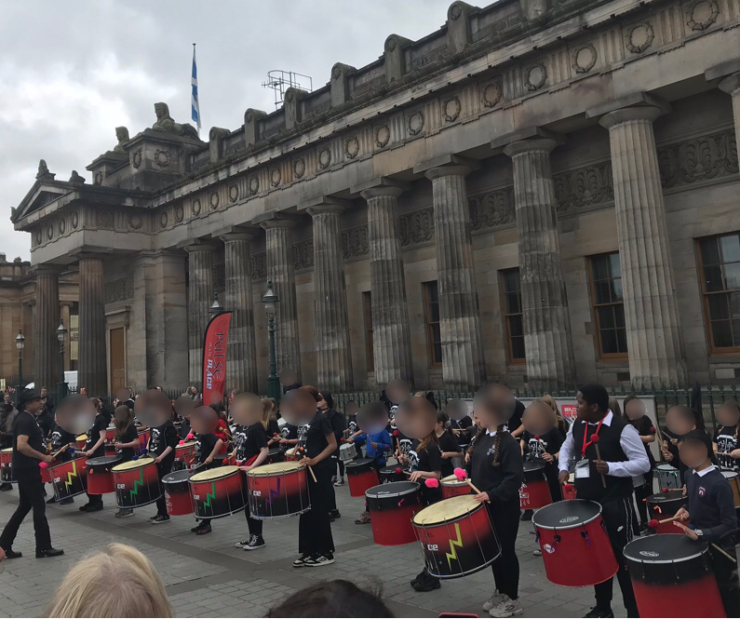
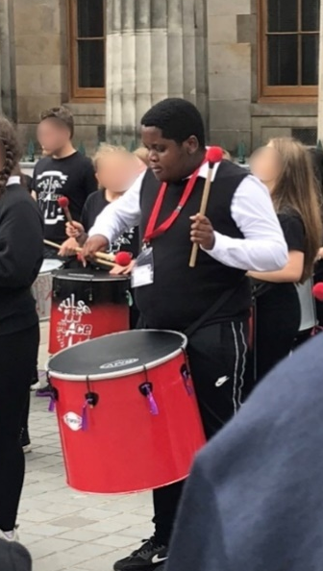

Active Schools
It’s been another positive term for the Active Schools Multi-sport Club at Pilrig Park School which a partnership funded club supported by input from both school and Active Schools.
Club participants have been kept busy with a range of physical activities including cricket, basketball, rugby and football delivered by the brilliant Play2Learn.
A big thanks to PSA Chris, who has supported the club again this term and also Active Schools volunteer Sergio, both who have gone the extra mile and its very much appreciated!

Spicy Enterprise Group

The Spicy Enterprise Group have had an excellent and very productive year!
We started the session with card-making and produced a range of Happy Birthday and Get Well Soon cards which were very popular. Next, the group made Halloween Treat boxes which they decorated and filled with spooky treats. These were a ‘sell out’ with the ‘pumpkin box’ being the favourite!
In October, Asda very kindly gave the school a huge donation of daffodil bulbs, so the Spicy Enterprisers got to work and decorated around 50 plant pots, before planting the bulbs, making a Pilrig Park School label and donating the pots to St Columba’s Hospice and Marie Curie. We will stay in partnership with both hospices, who have very kindly invited us for juice and biscuits one day!
After Christmas, other projects included Chinese New Year table gifts and Valentines cards. Most recently, the group made around 60 keyrings in aid of the Ukraine Appeal. At the time of this newsletter going to press, we are about to hand over to the Appeal, a sum of over £75 from donations to the year’s enterprise projects.
Well done, Spicy Enterprisers! A hard-working group who worked well as a team.
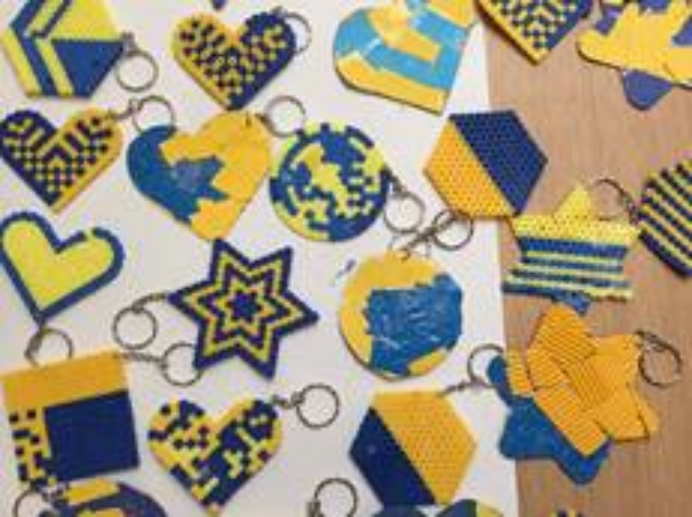
Mrs Ferguson
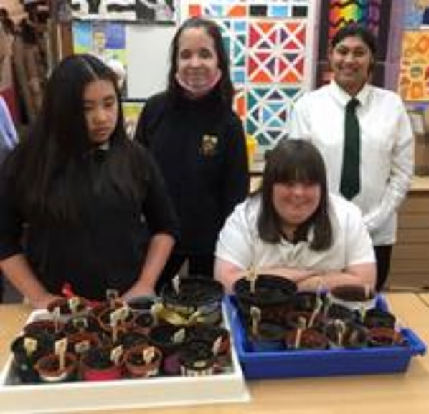
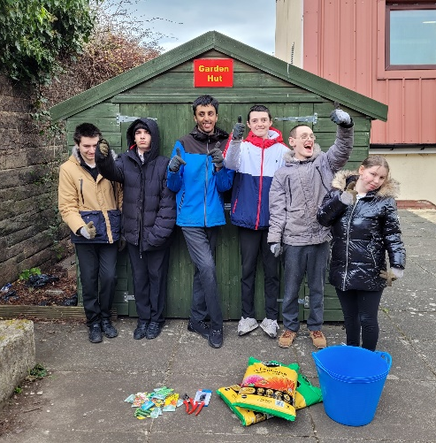
Pilrig Park Planters
The Pilrig Park Planters have had quite the year! We have
been lucky enough to receive two grants and equipment
this year.

We began the year by clearing areas around the school,
digging up weeds, cutting plants back and tidying up the
greenhouse.

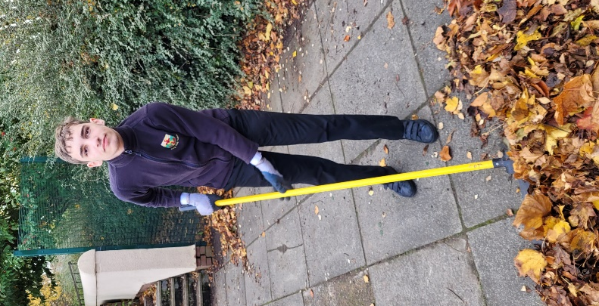
Mrs Bishop, Isobel and Pentland Plants all donated strawberry plants, which we re-potted and tended to, finally adding them to our rooftop allotment.

Talking of our rooftop allotment we are awaiting the delivery of veg trugs, plants, seeds and trees so we can really develop the upper terrace.

We also spent a number of weeks building a raised bed, that we planted up as a small memorial for Alice. The sweet peas, pansies and begonias are all growing beautifully.

Finally, a group of planters have been visiting the Botanical Gardens weekly to work with staff there, growing radishes, lettuces, peas, beans and potatoes. It has been a brilliant experience. We were also involved in a secret project that we will let you all know more about next session!

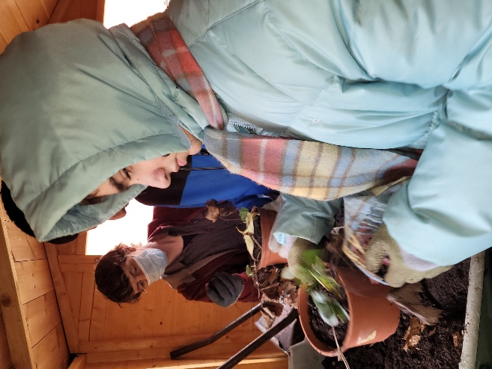
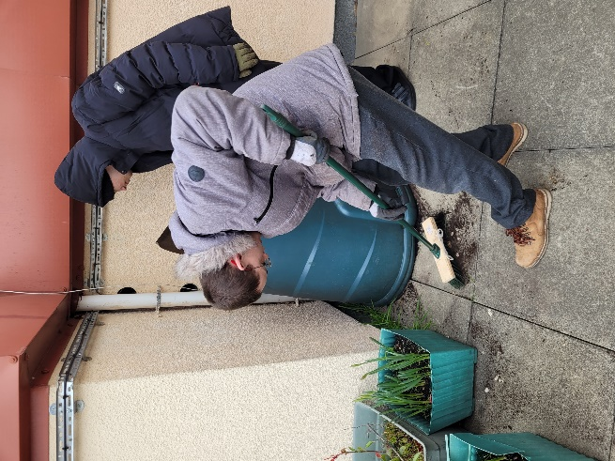
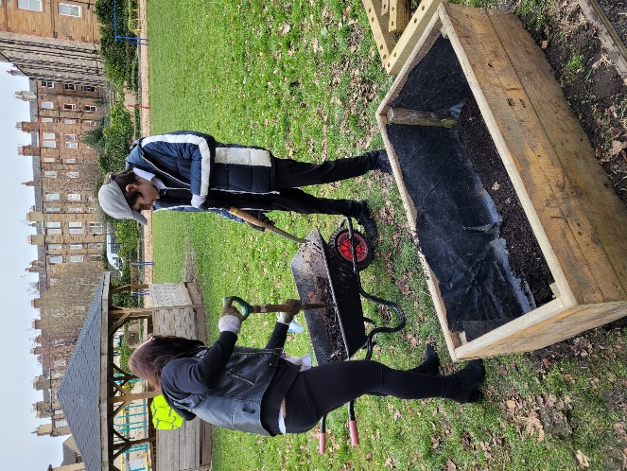

Parent Council
Well, what a year we have had in Pilrig Park School.
Pilrig Park School started 2021/22 by welcoming our new Head Teacher, Ms O’Hagan. It is fair to say Ms O’Hagan came to join us at a very interesting time as COVID restrictions were still in place, offering ‘unique challenges’.
As the academic year moved on we saw the gradual removal of the COVID restrictions and the school has now fully opened up to families.
I think it is fair to say that for many of our families our return to school activities has been long awaited and was marked by the excitement of coming together to see ‘We Will Rock You’. And what a performance! All our young people participated in some way with the production of this epic show. Thank you to the staff team for making this happen.
As the final term of 2021/ 22 draws to a close the Parent Council would like to thank the families and staff, including those no longer with us, for all you do in nurturing our amazing young people so they can continue to grow and thrive.
We will sign off by wishing the 2022 Leavers all the very best as they embark on their next chapter.
Have a fantastic summer, y'all.
Kind regards
Your Parent Council
pilrigpc@gmail.com

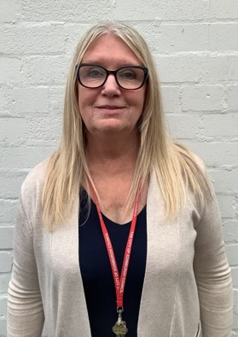
We include a wee message dedicated to Alice.

Please give our friend the best seat in Heaven
because she's absolutely the best person to sit
beside. Full of good advice, good sense and love.
We all are thankful for the blessing of her company
and her cheerful insightful and pithy statements.
The very essence of kindness, compassion and
natural empathetic behaviour. She built warm,
positive and sustaining relationships with some of
the hardest to reach pupils and people! She was a
queen of our hearts. Blessings on her and on us all.
Gone too soon.
Much missed.

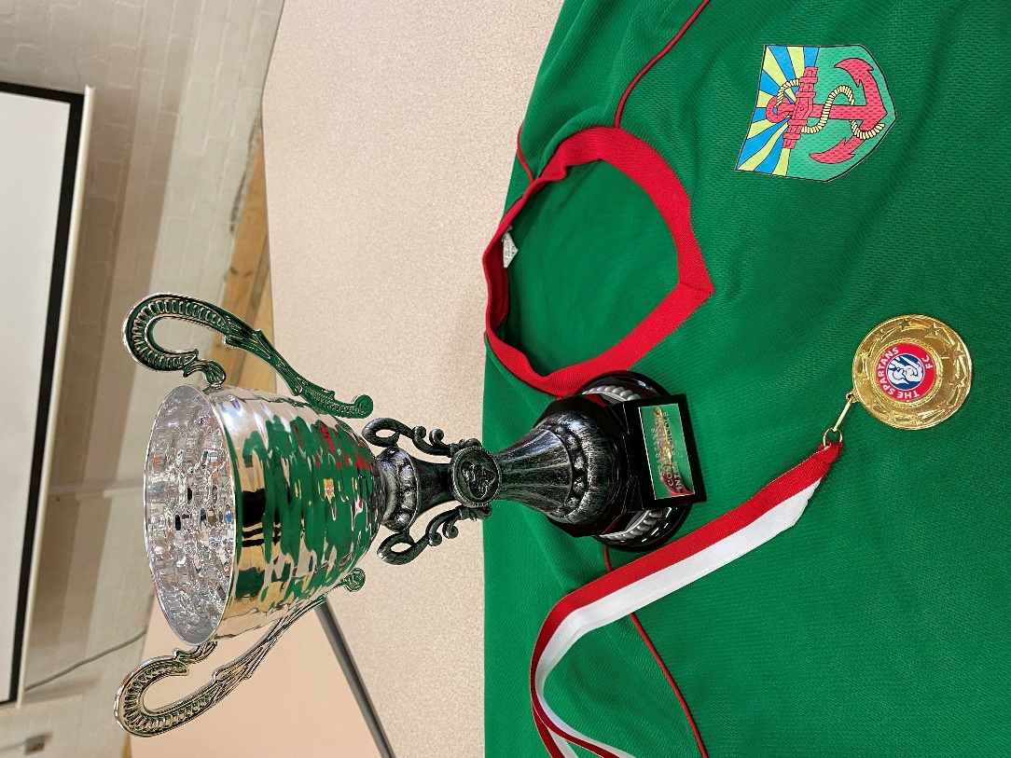
‘We did it for Alice Ms O’Hagan’, were the shouts from our talented football team as they came off the minibus from the Spartans Connections Inter Schools Cup clutching the silverware!

