

Bookings Open Wednesday 7 Sept
Bookings Close Friday 1 October

Due to financial support from school this is a free opportunity.

Pilrig Park School
After School Multi-sport Club Oct – Dec 2021

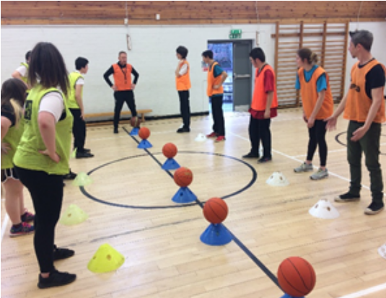
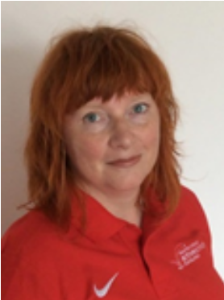

Jill Coleman
Active Schools Co-ordinator
Special School Cluster
T: 07920 768288
Email: jill.coleman@ea.edin.sch.uk
www.joininedinburgh.org/sports/active-schools/

After School Club for Pilrig Park Pupils this term

Activity | Age | Day | Dates | Times | Cost | Booking Code
Multi-sport | All Pupils | Tuesdays | 12 and 26 Oct  2, 9, 16, 23, 30 Nov  7, 14 Dec | 3.15 - 4.15 | Free | SEN-10

The club will be a multi-sport club. These sports will include basketball, athletics, cricket and spending 3 weeks on each sport. The sessions are suitable for any ability level whether you’ve played the sport before or not. The club is all about having fun and being active.
The club will be staffed by experienced coaches, pupil support assistant Chris and Active Schools volunteers.
The activity will take place at end of school day and take place in the PE hall.
We unfortunately cannot provide transport therefore parents/carers are required to collect child, arriving 5 minutes before end of session i.e. 3.10pm or parent/carer can make arrangements for their child to self travel if this is appropriate.

How do I book my child’s place?



Online by computer, tablet, smart phone. Go to www.joininedinburgh.org then put the short code SEN-10 in the
search box.
(if places are available this will guarantee your child a place)

If you cannot sign up online please telephone me, Jill Coleman,
On 07920 768288 and I will complete on line sign up for you.



Other Sport/Physical Activity Opportunities

Sport | Age/Target Group | Day | Time | Where | Contact
Athletics  Edinburgh Eagles | 8+  Athletes w. autism | Wed | 6.00-7.30 | Forrester High School | edinburgheaglesathletics@hotmail.com
Harmony Athletics |  |  |  |  | http://harmenyac.org/juniors/  Contact – Graeme Stewart harmenyclubdev@gmail.com
Lothian Disability Badminton Club | 8+, all ASN/disabilities | Tues | 6.00-9.00 | Musselburgh  Sports Centre | Lyndon Willaims  hbandnw@yahoo.co.uk
Boroughmuir Blaze ASN Basketball | 8+, all ASN/disabilities | Sat | 9.00-10.00 | Crags Sports Centre | Findlay Malcolm  findlay@cragsedinburgh.com  07475814940
Edinburgh Leisure Boccia Club | All ages, all ASN/disabilities | Tues | 6.00-8.00 beg  7.00-8.00 adv | Gracemount Leisure Centre | Roy Stewart  roystewart@edinburghleisure.co.uk  0131 658 1940
Spartan’s Football Academy | 16+  Players with a learning disability | Thurs | 10.30-12.00  4.30-6.00 | 94 Pilton Drive | Garry Betts  garrybetts@spartanscfa.com  01315527854
Jidel Judo/Judo Scotland | 5+  All ASN/disabilities | Tues | 6.45-7.30 | Engage Sports Centre, Napier University, Sighthill | Jo Imrie  jo@jideljudo93.com  07411722240
Murrayfield  Table Tennis Club | All ASN/disabilities | Mon | 6.00-7.30 | The Royal High School | Lindsay Muir  Lindsay@murrayfieldtt.com
Dalry Karate Group | All ASN/disabilities | Sat | 11.15-12.15 | Engage Sports Centre, Napier University, Sighthill | Andy Elliot  andyelliott@yahoo.co.uk
Advantage Disability  Tennis | All ASN/disabilities  Jnr wheelchair | Sun | 3.30-4.30  4.30-5.30 | Craglockart Tennis Centre | Michael Millar  Michael@advantagetennis.org  0131 444 1969
Climbing | All ASN/Disabilities | Thurs | 7.00-9.00 | Edinburgh  International  Climbing Arena,  Ratho | scottishparaclimbingclub@gmail.com
Dance | All ASN/Disabilities | various | various | various | Sharon Jones  sharon@kicdance.co.uk  for more info
Dance | All ASN/Disabilities | Sat | 4,15-5.00 | EDA HQ  St Johns Rd | Suzie Galloway  edinburghdance@aol.com  0131 334 4299

Sometimes contacts change so if you’re unable to contact club with information provided let me know.
There are lots more opportunities are available please contact me on jill.coleman@ea.edin.sch.uk and I’ll send you booklet!


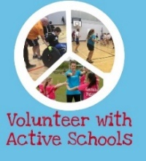
Volunteer with Active Schools! We are recruiting volunteers in a variety of roles to help us provide as many opportunities as possible for children to take part in sport and physical activity! We will provide full training and support. If you want to find out more please contact me jill.coleman@ea.edin.sch.uk

