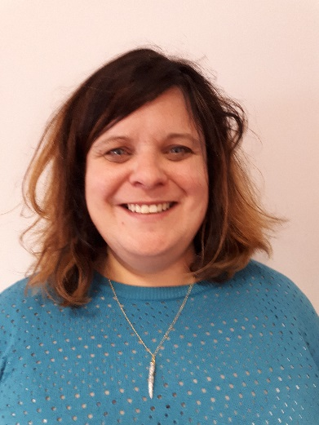 | 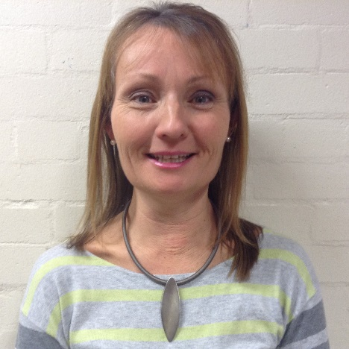
Ms Chad Headteacher | Mrs Ferguson  Principal Teacher (H & W)
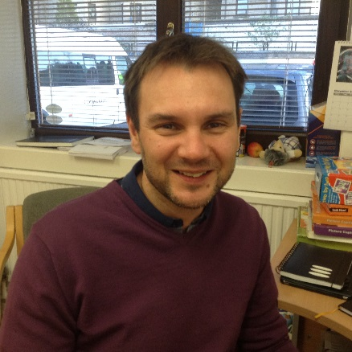 | 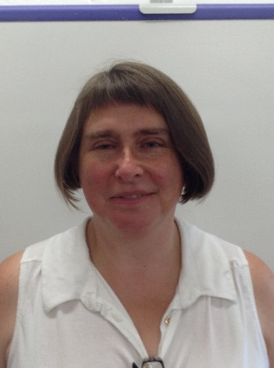
Mr Mackay  Principal Teacher (Numeracy) | Ms Laird Principal Teacher (Literacy)
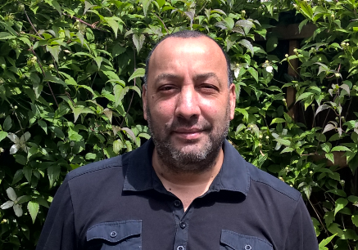 | 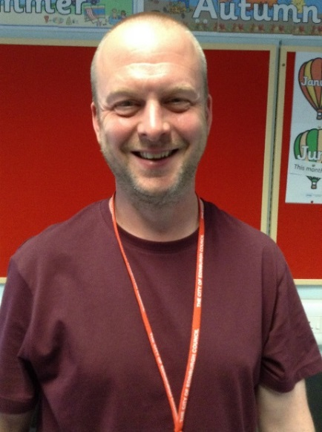
Mr Ouertani  ICT | Mr McPhillips Maths
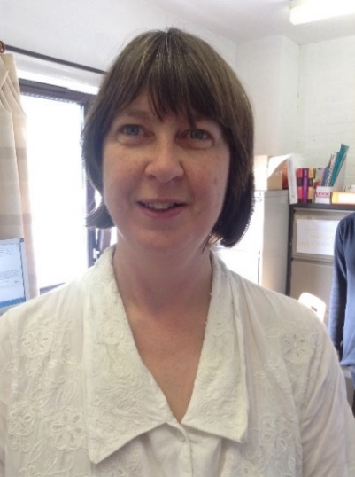 | 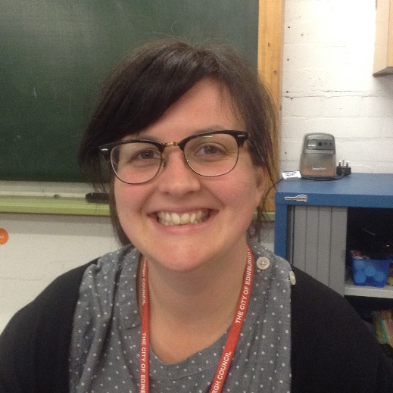
Clare Macaulay  Speech and Language Therapist | Mrs Sawyer  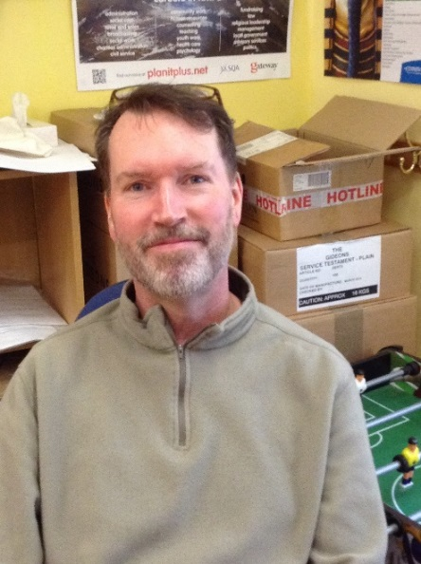  Science/Maths
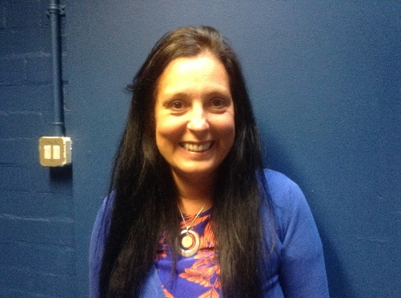 | 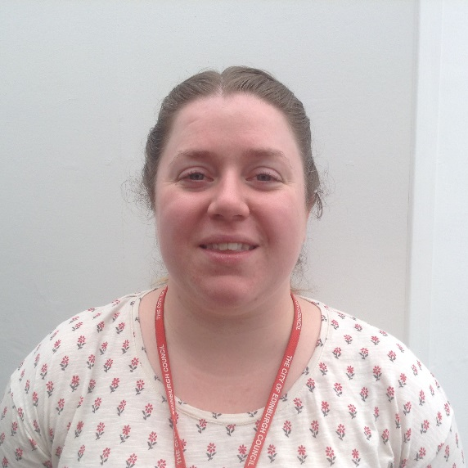
Miss Kirkwood Health and Wellbeing | Miss McLarty  Home Economics
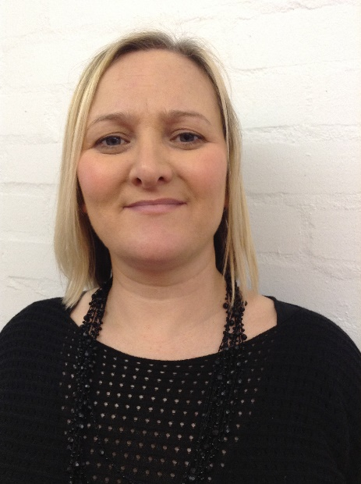 | 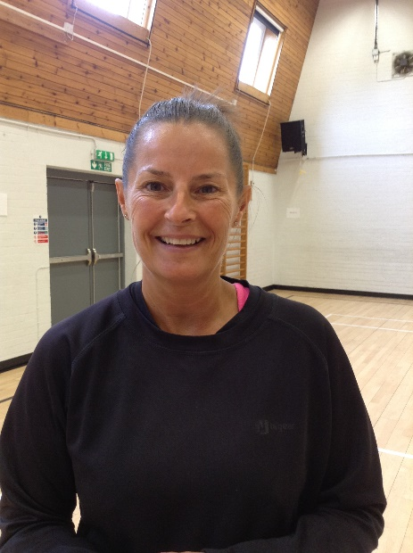
Natalie  Administrator | Mrs Lockie P.E.
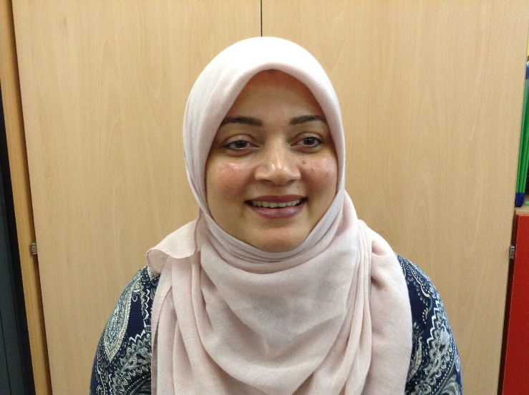 | 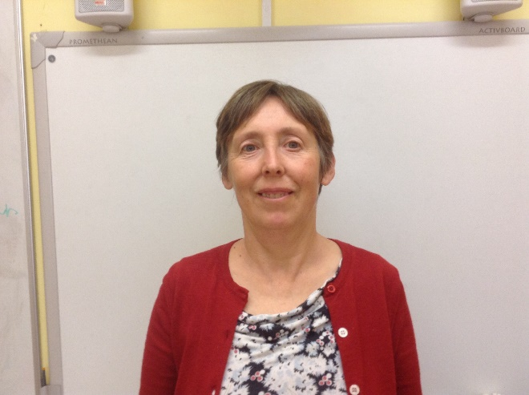
Mrs Ali  Art | Mrs Tupper Social Studies
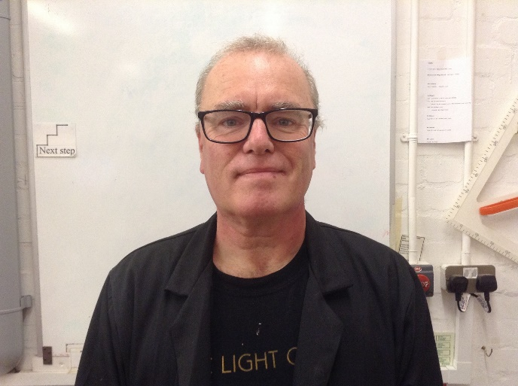 | 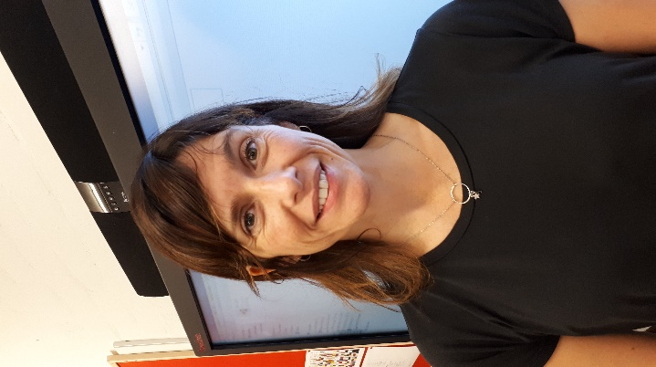
Mr McGuire  CDT | Mrs Eadie  English

